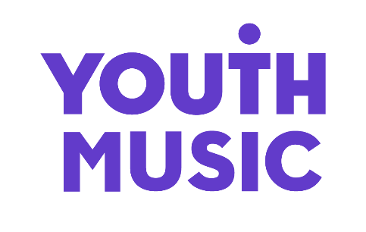

Application Form

When completed, the form should be emailed with your Applicant Details Form by the closing date stated in the advertisement to jobs@youthmusic.org.uk including the job title in the subject line.

1 | Application for the post of: (enter below)

Please complete this form and if there is insufficient space for your information, continue on a separate sheet. Please note that during the recruitment and selection process your application will be assessed against the selection criteria for the role. You are therefore advised to address these in your application.

2 | Work Experience
Duration of Employment (e.g. March 2022 – January 2023) |  | Name and address of employer (please indicate voluntary roles) | Position held and brief description of duties

3 | Supporting Statement  Tell us why you are applying for this job and how you meet the criteria outlined in the person specification. Please keep your supporting statement to 2 sheets of A4 or less.

Have you completed the anonymous Equal Opportunities Form (link in the job pack)?
Yes ☐ No ☐

Diversity & Equal Opportunities

Youth Music is an equal opportunity and Living Wage employer. We are committed to attracting, recruiting and retaining diverse candidates. It’s important that our team reflects the communities we serve.

We are currently under-represented by individuals from a working-class background, the Asian/Asian British community and wider Global Majority, Disabled people, the Trans community and people of faith.

YM is a Disability Confident Committed Employer and we are committed to making adjustments that would support disabled people to apply for and carry out this role. We operate a guaranteed interview scheme for any disabled applicants who meet the minimum criteria for the post, as outlined in the job description. If you are disabled and would like your application to be considered under the guaranteed interview scheme, please indicate so in the Applicant Details Form.

Please contact constance.dingri@youthmusic.org.uk if you have a disability and/or access requirements or if you wish us to consider any other reasonable adjustments to ensure the interview process is fully accessible.



THE NATIONAL FOUNDATION FOR YOUTH MUSIC
STUDIO LG01, THE PRINT ROOMS
164-180 UNION STREET, LONDON, SE1 0LH
REGISTERED CHARITY NUMBER: 1075032
LIMITED COMPANY NUMBER: 03750674

