

SOUND OF THE NEXT GENERATION

Contents

Contents 2
A NOTE ON LANGUAGE 3
Introduction 4
Summary 4
Is 2024 a good time to be young? 4
Music matters 4
Music belongs to everyone 5
Attitudes 6
MUSIC IS POWER 6
WHAT DOES MUSIC MEAN TO YOU? 6
Quotes by musicians from all star, Bradford 6
TIMES ARE TOUGH 7
COVID 7
MUSIC IS LIFE 7
IT ALL STARTS AT HOME 8
TWINKLE TWINKLE LITTLE ROCK STAR 9
OUT OF THE CLASSROOM 9
A MODERN MUSIC EDUCATION 10
LEARNING TO EARNING 11
Participation 13
Rewriting Music 13
Digital Forms of Music are Growing 13
UNEQUAL ACCESS 13
Class 13
Geography 14
Gender 15
Ethnicity 15
Age 16
Disability 16
Sexual Orientation 17
INTERSECTIONALITY 18
WHAT’S THE POINT OF DIVERSITY IF THERE’S NO INCLUSION? 18
Together or Alone? 19
A GRASSROOTS MUSIC CRISIS 19
Consumption 20
Pop Culture 20
Generation Airpod 21
Future 22
Will Genre Still Exist? 22
Fast Food Music 23
Will Robots Take Over? 24
A Word From Our Co-Chairs 26
THREE RECOMMENDATIONS FOR A THRIVING UK MUSIC SECTOR 27
#1 27
#2 27
#3 27
Appendix 28
With thanks to 28
Interviews 28
Methodology 28
Survey participant demographics 29
References 31

A NOTE ON LANGUAGE
- Young people: Babies, Children and Young People aged 0-25.
- d/Deaf and/or Disabled: Respondents who self-defined as having an impairment.
- Global Majority: People who are Black, African, Asian, Brown, dual-heritage, indigenous to the global south, and or, have been racialised as ‘ethnic minorities’.
- Social grade: Higher income backgrounds (ABC1) and lower income backgrounds (C2DE).
- Parents: We’ve used this as an umbrella term that includes the experiences of parents, carers, guardians, and other primary caregivers.
- Marginalised groups: People who face heightened risk of systemic inequality because of who they are, how they identify or where they come from.
- LGBTQIA+: We've used this as an umbrella term that includes people who self-identified as lesbian, gay, bisexual, transgender, queer or questioning, intersex, asexual and more.
- Music industries: we use the term ‘music industries’ not ‘the music industry’ to highlight the diverse ecosystem which generates employment, revenue and audiences through music.

INTRODUCTION
In 2024, Youth Music surveyed 2,100 children and young people to better understand their relationship with music. We asked how they were accessing it, how it made them feel, and what impact it had on their everyday lives. We then hosted interviews with young people, parents and industry experts to help us interpret the findings.
This report outlines our findings and recommendations. It describes the role young people’s background, education and talent play in shaping their relationship with music and explores whether – like generations before them – the nation’s love of music persists

Summary

Is 2024 a good time to be young?
Since our last report back in 2019, young people have lived through a cost-of-living crisis and a global pandemic that disrupted their education and social development. (1)
Under 25s are facing rising fees for education, dwindling employment opportunities and spiralling house prices. That’s on top of social media pressures, global conflict and a climate emergency. So, it’s no wonder children and young people’s mental health is worse than ever before.
To navigate the modern world, young people need to build resilience and develop confidence. Being socially connected, developing skills and exploring creative pursuits are all great ways to improve mental wellbeing and 70% of young people agreed that music ‘helps them feel connected to others’.

Music matters
Our research found that children and young people are turning to music over and above other interests. Making and listening to music now tops the list of activities that Gen Z and Gen Alpha do in their spare time. It’s more important than sport, social media, gaming, and other social, cultural and creative activities. And 78% associated music with happiness.
But young people’s relationship with music is changing. There are new ways of making and learning, whilst listening to music is becoming more bite-sized and fleeting. People feel less musical than before, and access to music – particularly in schools – has decreased.
Music is evoking fewer emotions and becoming a more isolated activity. On the plus side, there is a strong musical culture in many families, particularly those from the Global Majority. This creates a strong sense of musicality, which endures into adulthood.

Music belongs to everyone
While there are still inequalities, marginalised groups of children and young people are getting more access to music than before. But their education isn’t helping them to feel included or preparing them for a career in music. Those that do make it into the music industries often face discrimination, unsafe working environments and a glass ceiling.
Grassroots youth and community music projects play a vital role in supporting the diverse talent pipeline. Yet despite being a sector in crisis, grassroots lies at the bottom of the food chain when it comes to investment. Despite a National Plan for Music Education, there is no joined up strategy to ensure sustainability, innovation and inclusion across the whole ecosystem.
Young people want – and need – more music in their lives. As a society, we need to create a fairer, forward-looking, and thriving music sector that powers economic and social development. It’s our collective responsibility to make this happen

ATTITUDES

Music is power
Music is vital for babies, children and young people. Even though over half of young people play sport or play games, music is still their favourite activity. They’re twice as likely to enjoy listening to music than playing sport in their spare time.
When surveyed, 83% of young people had listened to music in the past week. We heard loud and clear how integral music is to their wellbeing and identity.
84% say music makes their worlds better.
71% told us that music is a big part of who they are.
68% feel like they couldn’t live without music.
70% say music helps them feel connected to others.

What does music mean to you?

Quotes by musicians from all star, Bradford
“It’s life. And I don’t think I’d be able to cope with life without music.”
“It’s a means of representation. When I feel like my identity is underrepresented, I look at the music that I listen to, and I feel seen, and I feel heard.”
“When you listen to music it can transform the way you are feeling, that’s why so many people use it as a vehicle. ”
“[Listening to music] helps my concentration ten-fold.”
“[Creating music] is speaking the unspoken, what you can’t say in normal conversation. When you can’t speak, you can say through a song exactly what you want to say. And you’ve got that complete creative freedom.”
“It’s a universal language”
“It’s in my blood, it’s in my genes.”
“Music is power!”

Times are tough
The past six years have been challenging for babies, children and young people. Compared with 2018, they feel they have fewer opportunities and are less likely to enjoy school. Loneliness hasn’t increased, but it’s at crisis levels for 18 to 25 year olds, with 48% saying they often feel lonely.
Young people are feeling less musical, especially girls and those from the north of England.
Just 55% of young people now say they are musical, down 9% from 2018.
Figure 1 – Do you think you are musical?
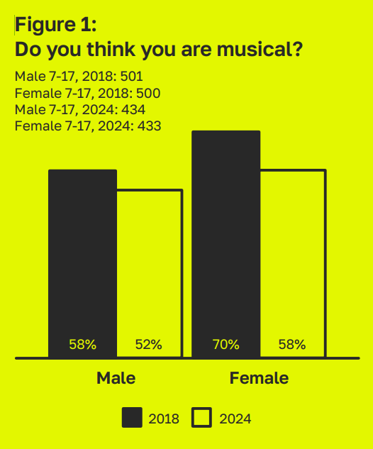

Covid
“I think it's something to do with being disconnected. You know, we had COVID and all that time when we were at home, the way that we made music and the way that we access music changed drastically … it changed the way we listen.” – Kemmi, young creative.

Music is life
59% of young people want more music in their lives.
Young people are listening to music regularly, but their musical needs aren’t being met. Only 58% feel supported with making music. This gets worse as they get older, with young people increasingly keeping the music they make to themselves. The biggest barriers to music are: Access + cost for 6-17 year olds. Time + ability for 18-25 year olds
Figure 2: You said you’d like music to be a bigger part of your life. Which of the below do you relate to?
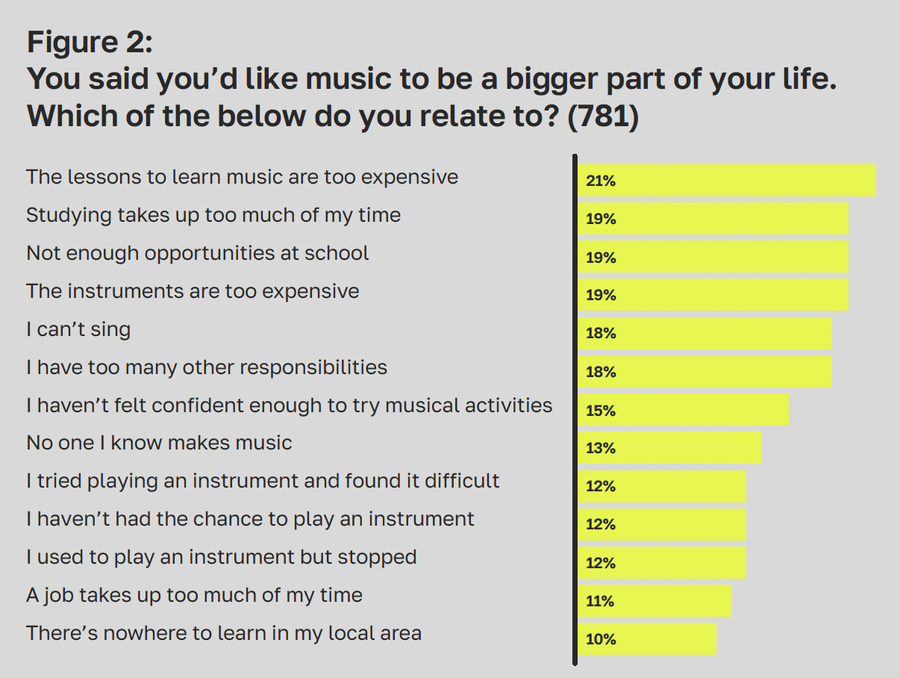
“I don’t think it’s equipping them with the right skills” Kemmi, young creative
We found that people become less satisfied with school music the older they get. “I don’t think it’s equipping them with the right skills,” said Kemmi. Higher education didn’t fare much better, “I think a lot of the issues with people not being taught the right musical skills, from my experience at least, is from higher education” Lucas, young creative, told us.
The importance of local grassroots, youth and community music scenes was also highlighted by Candice, young creative: “If I didn’t start my apprenticeship [with All Star] back in 2020, I would never have been able to learn how to DJ, and to just get to see how music is made.”
Mercury Prize winners, Ezra Collective attended a number of Youth Music funded projects as teenagers. In a Time Out Magazine article in December 2023, (2) their bandleader, Femi Koleoso credits grassroots youth and community spaces with allowing them to hone their talents: “I look at what youth clubs allowed me to have – that’s what makes me want to champion them,” writes Femi. “The schooling institution is under pressure to make sure that I can read and write. If you had zero funding, the saxophone is not going to be your highest priority. But a youth club is a building where my ability to read and write is irrelevant, and it’s giving me hope and something to occupy my mind.”

It all starts at home
Most parents believe that music will help their child’s development (89%). Early exposure to music at home plays a crucial role. Parents who are musically inclined are more likely to introduce their child to music from a young age.
“So she's been listening to all of that and playing the guitar with me. And she'll sit and she'll listen. And again, it's joy but also connectedness.” Sushila, parent to 3-year-old sunny
There is a strong correlation between musical households and musical young people. Across the board, 57% of young people identify as being musical, but this rises to 75% for those raised by musical parents
“When you have the cultural and the traditional injection inside you, from when you're at a very tender age (...) it sits with you. I think that's probably what the emphasis is about.” - Ebou, ceo of african night fever
This trend for inherited musicality and passion for music is particularly common in Global Majority households where around three in four parents make music, compared to half of White parents. They are more likely to support children learning an instrument, and champion listening to the music of their culture or heritage.
This strong musical foundation in Global Majority backgrounds leads to a higher proportion of children who consider themselves musical, imagine themselves in the music industries, write music, and make music across all forms.

Twinkle twinkle little rock star
77% of early years parents believe it’s important that children listen to a diverse range of music. They list pop (57%), rock (18%), hip-hop (17%), R&B (16%), and even grime (3%) as music their under 5s are listening to.
The vast majority of early years parents agree that nursery rhymes are important for a child’s development, but almost the same number think that any music is important. Nursery rhymes do provide a “common ground” for babies and children “to start making friends and to just feel included” in spaces outside of the home, shares Janessa, Volunteer at The Together Project and parent to Elwyn (5), Eris (3) and Effra (8 months)
However, nearly half of parents report that their child prefers other music to nursery rhymes (45%).
“When they were babies, I definitely didn't play them nursery rhymes (...) I might have sung them to them, but it was always just other music that was in the background and that they enjoyed.” - Sarah, team assistant at the together project and parent to Alma (7), and twins Etta and Obie (4)
Nursery rhymes are valuable for developing a child’s language and communication skills, but many historic tunes sung today have disturbing roots. It’s not surprising that 47% of parents believe that nursery rhymes need bringing up to date, even though the melodies are fine.
Sushila reflected that some of the lyrics in nursery rhymes feel uncomfortable to talk about: “Nursery rhymes at points have been those vehicles there for discrimination, in a way.” While she believes this has improved over time, nursery rhymes are still not representative and can feel “white, middle-class mainstream.”

Out of the classroom
Most school-aged children enjoy music lessons and really like their music teachers. However, access to music in schools has dropped. Parental confidence in school music is very low. Only 11% of parents of under 5s think their children will get enough of a musical education in school.
The squeeze in school music is well documented. Music exam entries have fallen rapidly since 2010, with the number of people taking music GCSE declining by 36% (3) and music A-Level entries falling 45%. (4)
Our interviewees shared many examples of music being pushed out and deprioritised.

Figure 3: School makes music feel important
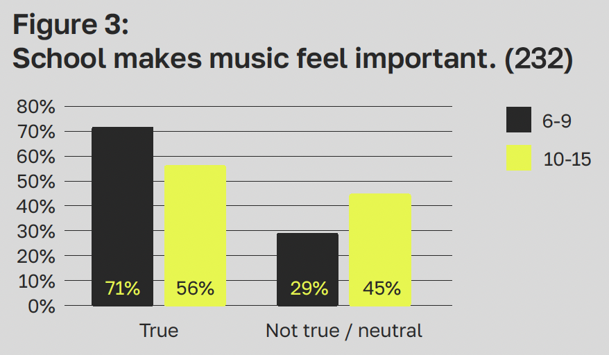
“I had singing lessons [at school]. And it was only for 20 minutes, once a week. And it used to get cancelled all the time because it wasn’t seen as a priority. But for someone like me, my singing lesson was a priority.” Femi, young creative
In today’s diverse society, music is being used by children and young people to support their mental health and wellbeing. But the education system doesn’t reflect that.
“One thing that should be included in the curriculum is the idea of the importance of music. How music stretches from the very earliest tribes, all the way through to today – and is connected with life, with religion, with all social rituals. Let’s make sure we include that: so people understand where music came from and how it’s so central to people’s emotional health, not just something commercial, competitive or throwaway.” – William, Futurist

A modern music education
Is the modern school system killing creativity? Young people feel least musical aged 16-17 – the time when they’re taking their GCSEs.
“Cultures in different parts of the world conceptualise music in many ways, offering many more harmonic, rhythmic and structural possibilities. Technology affords new ways to explore these, but this is rarely reflected in what we offer.” - Ben, project lead at mehem uprising! And curator of over the digital horizon
We need to diversify and decolonise the music taught in schools at a faster pace. The curriculum is slowly becoming more inclusive, representing a wider range of composers from around the world. This is crucial to ensure the next generation feel their cultural background is represented. It will also equip young creatives with the resources they need to broaden their musical knowledge in an increasingly interconnected world.
“Some of the melodies and the harmonies that you learn through Western classical music are great for helping people make music. So it’s definitely got a place. But I think there’s too much focus on that. Let’s teach children more about global ethnic music cultures: show them how important it is to people’s lives. Let’s talk about all the different ways different people make and consume music, let’s show them all the different rhythms, scales and instruments from around the world.” – William
Alongside this, rapid changes in technology over the past six years have changed perceptions around what it means to be a musician. Over 75% think you don’t have to play an instrument to be a musician, and 73% think you can be a musician without reading music.
“It’s all done through listening and inspiration between yourself and the improvisation. So you have the feeling and you go with it.” – Ebou

Learning to earning
Youth Music has also conducted research on improving employability outcomes for young creatives in music. Along with our 2020 Blueprint for the Future (5) research, the emerging findings suggest that:
- the current provision for education and work-based training beyond age 16 is not fit for purpose.
- advice and support within the music industries is too focussed on artist and performer roles.
- more attention should be paid to areas with skills shortages, like technical production and offstage roles, teaching, and digital technology.
- we need a greater focus on developing enterprise and business skills, to reflect a workforce dominated by freelancers and small businesses.

Figure 4: Proportion agreeing statements are true.
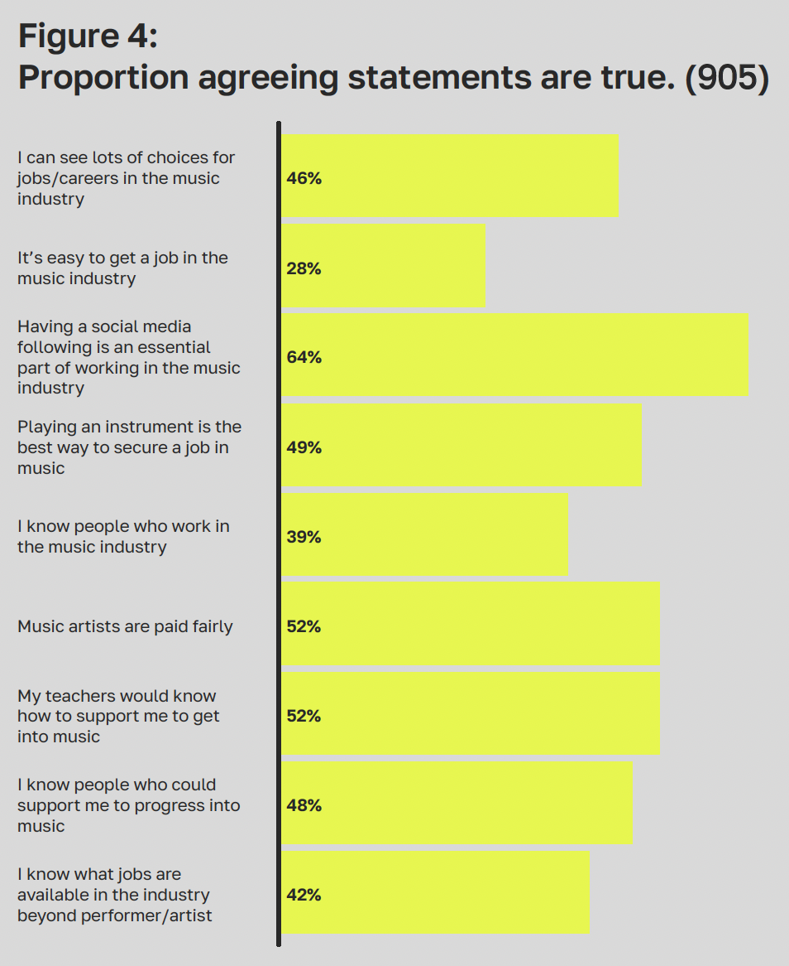
This report echoes these findings. Less than half of 18–25-year-olds know what career paths are available in the industry beyond performer or artist. 68% think that having a social media following is an essential part of working in the music industry, yet, this is not something that is commonly taught.
“I don’t think social media is appreciated enough in the teaching of music or even if you do a degree in music (...) there needs to be more teaching to use it as a professional tool, because it is a professional tool.” – Jennifer, Young creative
The cost-of-living crisis is also threatening to roll back the industry’s progress to become more diverse. Our Blueprint for the Future research found that 66% of young creatives would leave the music industry for alternative careers if they were unable to earn a sustainable income. And UK Music’s 2022 Diversity Report showed much greater diversity in lower paid, entry level and internship roles, which means the ‘glass ceiling’ needs to be tackled to see diversity in senior roles. (6)

PARTICIPATION

Rewriting music
66% of young people make some kind of music, which is broadly unchanged from 2018.
But HOW they make music is changing.
Singing and playing traditional instruments, such as the recorder, violin and flute, are all in decline. Playing an instrument has dropped to just under a quarter of children and young people.
Meanwhile, modern instruments like the keyboard, guitar and drums are on the rise.

Digital Forms of Music are Growing
‘Screen time’ can be a controversial concept for babies and toddlers, yet they appear to be using it to be creative with 48% of under 5s who are making music doing so on a tablet or phone. Overall, 11% of young people are making music on a computer or other device.
Plus, ways of learning are changing. There’s been a big drop in children learning instruments in 1:1 lessons, especially in school (19% in 2024 compared with 33% in 2018). Today, they are most likely to learn an instrument through group lessons in school, or from friends and family.

Figure 5: Please select all of the following you do.
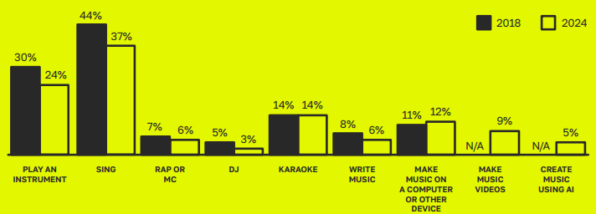

Unequal access
For today’s young people, who you are, where you live, and what you’re going through can have a big impact on how you engage with music.
The people most likely to be making music are:
- Female and from a higher social class
- From a Global Majority family, with a musical family background
- Attending an independent or fee-paying school
- Living in London or a large city in the South of England or Scotland

Class
Our research shows that only half of young people feel that music artists are paid fairly. So, it’s no wonder that the proportion of working-class actors, musicians and writers in the UK has halved since the 1970s to 2022. (7) It’s simply not affordable for everybody.
Young people from a working-class background are far less likely to know someone who can support them to progress into music. Meanwhile the term “Nepo Baby” (short for nepotism baby) was officially added to dictionaries in 2023. (8)
The cost of new equipment and learning their craft is a barrier for many young people, especially those from working-class backgrounds. They’re also less likely to play an instrument than their peers from higher income backgrounds. These barriers affect how young creatives see themselves, as children from lower income backgrounds are less likely to identify as musical (51% vs. 63%).
“How much does a saxophone cost, 800 quid? A lot more? [Her mum’s] not pulling out a grand to buy me a saxophone or even a couple of hundred to buy me a decent guitar. You know, where are the kids on the council estates, where are their parents finding this money? It just needs to change, the whole narrative.” – Kemmi, Young creative
Our research shows that children from a lower income background feel less supported to make music and less confident to share their music. They are more likely to make music alone, and less likely to picture themselves as a musical performer in the future, not just getting paid for it but even making and performing music in their spare time. These patterns are multiplied where a child’s parents are also from a working-class background, suggesting these barriers are harder to shift where multiple generations have had limited access to music.
“There’s a strong, sort of like, middleclass presence, especially in being classically trained. Even in piano, guitar, drums – it takes of lot of resources. It takes a lot of investment and time that a lot of young workingclass people don’t have.” – Lucas, Young creative

Geography
Young people in Yorkshire (49%), North West (57%) and North East (52%) are among the least likely in England (58%) to feel supported when making music.
“I just don’t think the north is funded properly for anything. We’re an afterthought.” – Femi, Young creative
The biggest drops in opportunities for musical engagement have been seen in the north of England*, where we saw the biggest fall in young people seeing themselves as musical. Those in villages and rural areas are least likely to be making music. Young people outside London are more likely to feel that music lessons are too expensive (23% vs. 13%) and were also less likely to feel that music lessons made them want a job in music (45% vs. 65%).
“People in the North get nowhere near the same opportunities than those in the southern part of the country.”- School age survey respondent
Wales is the only country in the UK where the majority of young people don’t feel musical (46% vs. England 57%, Scotland 58%, Northern Ireland 68%). They’re also least likely to feel that it’s easy to get a job in the music industry.
Young people in Scotland (76%), Wales (70%) and Northern Ireland (77%) are more likely to feel they couldn’t live without music than those living in England (67%).
*North East, North West, Yorkshire, West Midlands, East Midlands.

Gender
On the whole, girls and young women appear more passionate about music than boys and young men. A far greater proportion agreed with statements such as, ‘I couldn’t live without music’ (+15%), ‘music makes my world better’ (+7%) and ‘music is a big part of who I am’ (11%).
Overall, girls are slightly more likely to be making music than boys. However, there’s still a digital gender divide, with 10% fewer girls and young women making music on computers or laptops, and 6% fewer using DJ decks. When it comes to music making on phones there was no difference.
The gender imbalances seem to get worse as young women move from education into industry. A 2023 inquiry by the House of Commons Women and Equality Select Committee into misogyny in music concludes, “Women working in the music industry face limitations in opportunity, a lack of support, gender discrimination and sexual harassment and assault as well as the persistent issue of unequal pay in a sector dominated by self-employment and gendered power imbalances”. (9)

Ethnicity
Children and young people from Black, African, Caribbean, or Black British ethnic groups are 20% more likely to make music than any other ethnic group. This applies to instruments, digital creation and writing music.
The proportion of 18–25-year-olds from Global Majority backgrounds who see themselves having a career in the music industry (37%) is much higher than the average (28%). But the data suggests they become more aware of inequalities at this age, as they are less likely to think they have the same opportunities as everyone else. Perhaps it’s no wonder, with ethnic diversity appearing to have slowed within the music industries in the past few years, and representation concentrated in entry level and apprenticeship jobs.

Age
Our research surveyed the parents, carers and guardians of under 5s, offering a glimpse into the ways they engage with music. 53% of 0 to 2-year-olds like music ‘a lot’, increasing to 67% for 3 to 5s.
Almost a third of babies and toddlers are making music on a piano/keyboard, the most popular traditional instrument. Drum kits, acoustic guitars and hand percussion instruments are also popular. But a substantial 48% of 0-5 year old musicians are making music on a phone or tablet and 5% are even using DJ decks.
Babies and toddlers are far more likely to feel happy or excited by music than older ages. Young people aged 16-17 feel the least musical, yet that’s also the time they are most likely to turn to music for relaxation.
“She loves it when I put music on and I pick her up and we dance around the kitchen and I twirl around and she's cackling (...) It's like a really easy way to be silly together, and have fun, and connect, and to be both smiling and laughing, and it's fun for both of us. I think that's what we both love about it.” – Louse , founder and chief executive of the together project, her children are aged 7 and 4 years old.
Figure 6: Do you think you are musical? / Does your child like music?
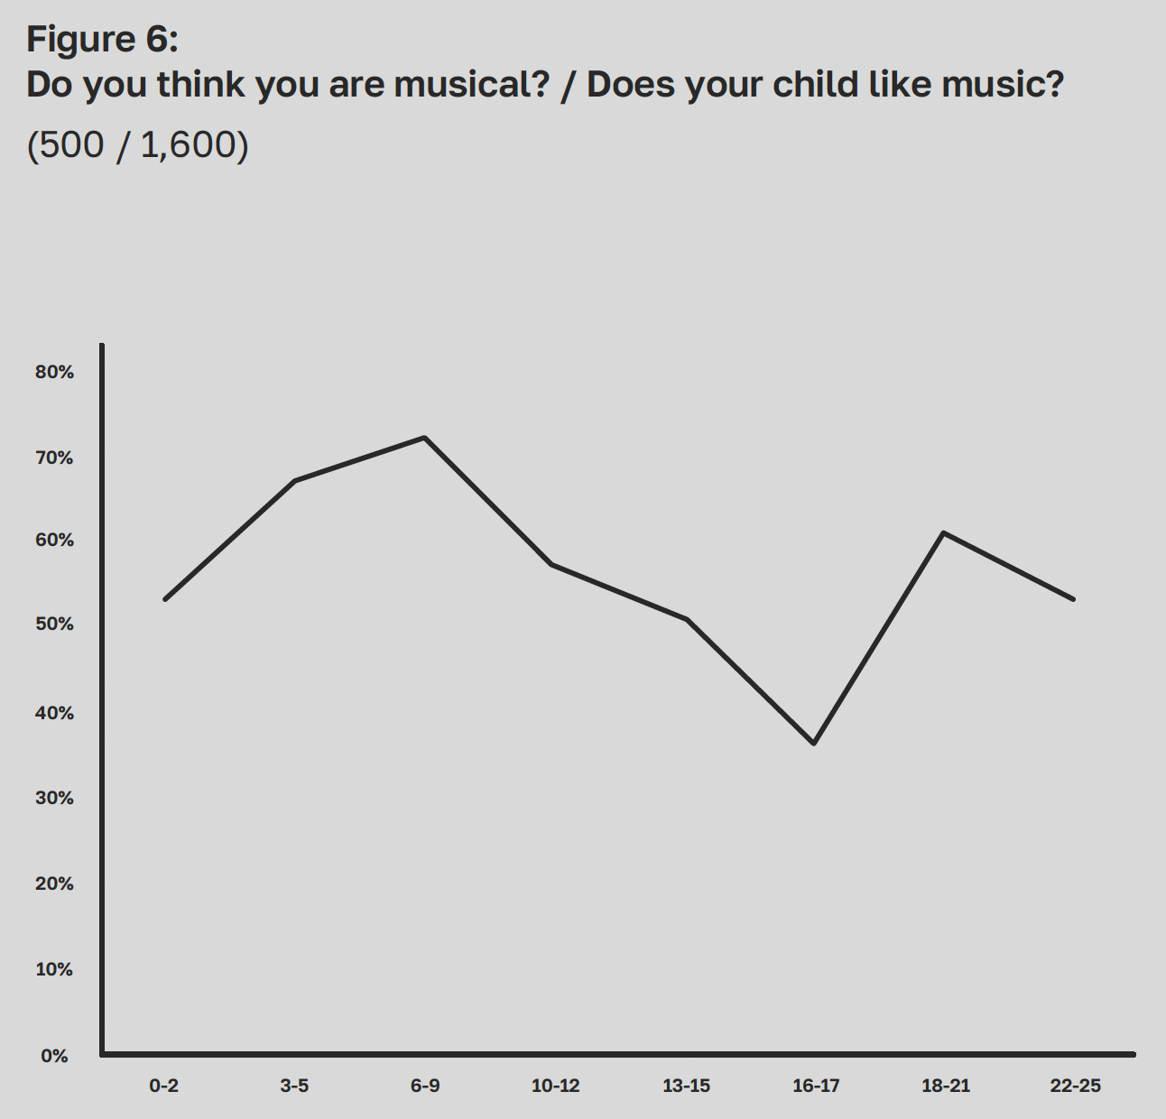

Disability
Our research paints a picture of music being absolutely central to the lives of d/Deaf or Disabled people, more so than their non-disabled peers. 55% feel obsessed with making music, 10% higher than average. 60% of Disabled young people want more music in their lives (vs. 49% average). They’re also more likely to consider themselves musical (66% in comparison to 57% average).
d/Deaf or Disabled respondents are less likely to feel they have the same opportunities as everyone else generally. However, they’re more likely to feel there is equal access to music opportunities. In fact, we found that d/Deaf or Disabled children and young people were, on average, more likely to make music, across all forms.
However, we must approach this finding with a note of caution. Our 2020 research report Reshape Music explored the lived experience of d/Deaf or Disabled musicians. (10)
It found that most were making music at home or in school, with significant barriers to accessing music groups and performance opportunities, which often take place in inaccessible spaces. It found that d/Deaf or Disabled learners were often forced into choosing an instrument that worked for them, not one that they wanted to play. And that they often struggled to find teachers who understood their needs and learning styles.
So, whilst great strides have been made to equalise participation in music amongst d/Deaf or Disabled people, priority should be given to making environments more accessible and inclusive, to improve their experiences.

Sexual Orientation
We also collected data about sexual orientation. As the overall numbers of LGBTQIA+ people were small, the findings may not be statistically significant. Of the 18-25 age group we surveyed, 67 identified as LGBTQIA+ and 418 identified as heterosexual. However, we did observe some trends...
LGBTQIA+ people are less likely to:
- feel that they have the same opportunities as everyone else (40% vs. 57% heterosexual identifying people).
- agree that ‘all children and young people have equal access to music opportunities’ (40% vs. 60%).
- feel supported with making music (37% vs. 54%).
- have enjoyed music lessons (42% vs. 54%).
- feel that music artists are paid fairly (29% vs. 53%).
- feel that artists/groups in the charts are from diverse backgrounds (61% vs. 74%).
If this provides an indication of the challenges and views faced by LGBTQIA+ people in music, it paints a depressing picture. A recent report by The Musicians Union and Come Play With Me suggests there are many challenges faced by LGBTQIA+ people working in the music industry. (11)
Yet those identifying as LGBTQIA+ are more likely to consider themselves musical than heterosexual identifying people (63% vs. 56%). They’re 10% more likely to want more music in their lives.
And they believe music is a great way to share political or activist messages (84% vs. 70%). That means there is a huge opportunity to engage with the LGBTQIA+ community. This poses an important question: How do we leverage this enthusiasm by increasing access and representation across education and industry?
“As a Black LGBT singer-songwriter-producer it’s disheartening to see these statistics, showing that people from both sides of that diaspora feel less encouraged to walk in their destiny of making music or working in music. It’s something I feel really passionate about changing, as I never want to see a young black person or a young queer person feel discouraged about being a part of this industry.” - MNEK, youth music ambassador

Intersectionality
The concept of intersectionality describes the ways in which systems of inequality intersect. Where people may have multiple characteristics (gender, race, ethnicity, sexual orientation, gender identity, disability, class and other groups at risk of discrimination), they can face prejudice on multiple fronts.
Whilst this research did not deep-dive on intersectionality, we know from other studies that people face greater discrimination where multiple barriers collide. A 2023 research report called Unseen. Unheard. from Attitude is Everything and Black Lives in Music (12) is a powerful example. 89% of Black Disabled music professionals reported facing some form of discrimination in the music industry. Similarly, the Misogyny in Music inquiry found that issues are “intensified for women faced with intersectional barriers, particularly racial discrimination”.

What’s the point of diversity if there’s no inclusion?
Diversity (noun): the natural differences between people in our communities, workplaces and around the world. There are many visible and non-visible dimensions of diversity to recognise and celebrate.
Inclusion (noun): creating an environment where all individuals feel valued, respected, and supported. Actively ensuring that everyone is able to thrive and contribute equally regardless of who they are, where they’re from, or what they’re going through.
Whilst progress has been made in some areas of diversity and access, there’s still a long way to go when it comes to inclusion.
This is especially true once people reach the music industries. The wider research all tells the same messages around poor practice, discrimination, and unsafe working environments for people from marginalised groups. The grassroots youth and community sectors that support the talent pipeline do a great job of creating inclusive environments, but once young people progress into the industry, their experiences may be vastly different.
A new Creative Industries Independent Standards Authority is being established, but the task is too large for them to solve alone. The industries need to come together, and commit to urgent action. (13)

Together or Alone?
70% of young people told us that music helps them feel connected, which is crucial in an increasingly digital and isolated world. Yet, we’re seeing a decline in young people playing instruments in groups (down from 48% to 39%).
Listening to music is often done in isolation. 29% of 16-17-year-olds only listen to music on their own. This figure jumps to 50% of 18–25-yearolds. We know that 18-25 is the age when young people are most likely to experience loneliness and it’s likely they’re turning to music to help. Our research into the wellbeing benefits of lyric writing showed that young people are almost three times more likely than older generations to use listening to, reading, or writing lyrics as a therapeutic outlet (16-24: 66% vs 55+: 23%). (14)
While we’ve seen massive benefits arising from increased digital access, nothing can beat the feeling of making music, together, in real life.
“That’s the one thing that digital can’t do: look you in the eye and get that feeling with you, and that’s so important for music because it’s a language. In this age of increasing isolation, music as a tool for connection is more important than ever.” – Ben
The WHO has declared loneliness to be a ‘pressing health threat’. (15) In these turbulent times, it’s vital that we continue to make the space for young people to make music together.
“I think I would make a prediction anxiety is higher and confidence is lower amongst younger generations (...) I find for groups - the numbers are always less consistent since COVID. Group sizes seem a little bit smaller and there’s more of a drop in and out nature than there used to be.” - Alex, freelance musician, and music leader at mac makes music

A grassroots music crisis
Over half of music projects reported a fall in income
The grassroots youth and community music sector is in crisis. These organisations use music to provide vital and lifeaffirming support for children and young people. They are also fuelling our talent pipeline. But they are in grave danger, and it’s rarely talked about. UK Music’s Manifesto for Music 2023 makes a strong call to improve music education, but there is no mention of the part the grassroots youth and community sectors can play. (16)
More than two-thirds of local authorities have cut, or plan to cut, their arts and cultural budgets as they struggle to balance their books. (17) Add to this over £1 billion cuts to youth services in the last decade and it’s clear that austerity measures have hit hard. (18) In our 2023 Feedback Survey to funding applicants, over half of respondents reported a fall in income, whilst 2/3rds reported increased costs and increased demand for services. (19)
Youth Music’s National Lottery income via Arts Council England has been the bedrock of support since we were established in 1999. But this has since fallen by 45% in real terms, meaning we are only able to fund less than 1 in 5 applications (17%) – a historic low. As a result, for the grassroots organisations we support, we’re seeing more closures, downsizing and staff sickness than ever before.
The sector needs a significant cash injection. Currently, the majority of funding in music is focussed on the big players. While these organisations are undoubtedly vital to our music ecology, there’s no question that the current funding systems are inequitable. Invariably, it’s the grassroots artists and organisations that miss out.
But these challenges are not unique to music. The so-called ‘pyramid model’ in sports, referring to the relationship between grassroots, professional and elite levels, is comparable to our existing music ecosystem. Britain’s status as the world’s second largest music exporter relies on its investment in the grassroots, just as The Premier League – as a global entertainment commodity – relies on the health of the overall sports pyramid.
We should learn from the successes of sport. Particularly, how it has articulated its value to society beyond the ‘elite’ level, and how it retains and retrains those who don’t make it to the top of the pyramid.

CONSUMPTION

Pop Culture
As the name suggests, pop music continues to be the most popular music genre amongst children and young people. But it’s closely followed by hip-hop. That’s no big surprise, the BPI’s All About The Music 2023 report showed it to be one of the biggest genres in the singles market. (20) It’s a genre dominated by homegrown talent, with British artists behind 8 of the 10 biggest 2023 hip-hop tracks in the UK.
“Not me fam my ting will leae you drooling
Teach yutes when they need a schooling
I’m a leader so man are used to ruling
I make moves while you snooze your cooling
Me I kill raves you’re tryna
Bring the tool in
Man are not bad it’s not Zuu you’re fooling
Gangs are just gassed they abuse the fueling” - ‘dem man are dead’ by jme and big zuu, ‘grime mc’ (2020)
The influence of hip-hop, rap and drill music have grown, as the genres have become more mainstream. Academics have reported that words like ‘ting’, ‘peng’, and ‘man’ (Multicultural London English) will be the dominant dialect in the UK in 100 years’ time thanks to the rise of rap, drill and grime on social media. (21) Rooted in Jamaican Patois but drawing on cockney, Arabic and West African slang, it shows the power of multiculturalism and diversity in music to influence wider UK society.

Generation Airpod
Music helps young people to be productive, with 58% listening to it while focussing on a task. As wireless earphones have grown in popularity, we’ve seen a significant increase in those listening to music whilst travelling (52%), up 37% from 2018.
The majority of respondents discover new music by searching for it themselves. However, there’s still a lot of music sharing between parents and their children. Over 50% of parents of under 5s find out about music from their child. Plus, 69% of 6-17-year-olds discover music from their parents.
Young adults become more explorative towards music and genres as they age. They’re more likely to discover new music through suggestions made from a streaming service than through friends and family.
For early years, the age of streaming allows for greater exposure to a range of genres. A quarter of parents report their under 5s like songs from TV or films – suggesting that screens are the modern-day equivalent of musical influence, replacing physical formats.
65% of young people feel relaxed when listening to music.
50% of young people closely follow the music charts.
Figure 7: How do you find new music?
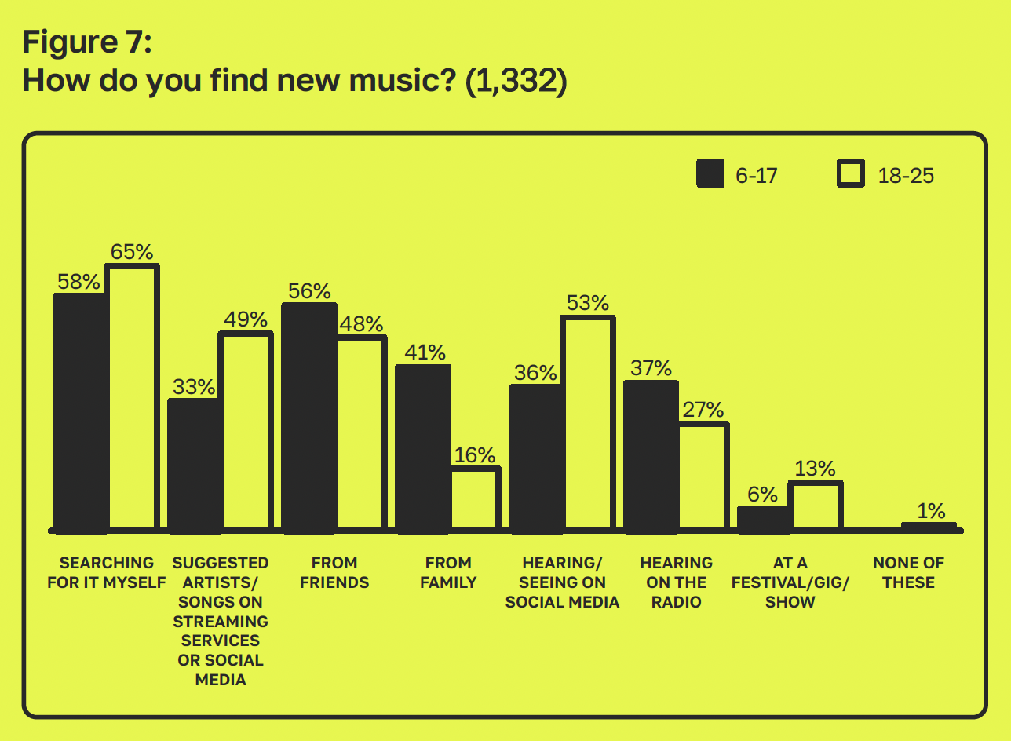

FUTURE

Will Genre Still Exist?
37% of young people feel that genres aren’t relevant anymore.
“Genre is important but sometimes like, the genre kind of becomes a little bit irrelevant (…) all new music is kind of just an amalgamation of, like, lots of different genres or different sounds of different artists or different inspirations.” - Jennifer, young creative
With half of Gen Z (49%) using TikTok to listen to music, it’s not surprising that genre boundaries are being stretched across social media:
“With the rise of short form content, like TikTok and Reels (...) I feel like the genre is not really at the forefront anymore”. - Lucas, Young creative
“So I think, yeah, to an extent, [genre] doesn’t necessarily matter for a musician standpoint, but from an industry standpoint, it’s how we categorise you.” - Natalie, young creative
The consumption and production of music is an intensely personal experience. The young people we spoke to shared that whilst genre can be a useful process of categorisation, it also runs the risk of dividing audiences and even typecasting artists and areas.
“I don’t think they’re that important because it puts up boundaries.” Kemmi, young creative
“Genre-wise, like, we’re [Bradford] very known for our bassline. Our bassline heritage, our bassline roots, and our garage, y’know, and our house music. But there’s so much soul in Bradford, rap, RnB, y’know? There’s even people on the country flex, there’s people on the techno. There’s so many different types.” Kemmi, young creative
How are the industry and live music adapting?
“You see it in the line-ups of festivals and you see it in the genres of current artists as well (...) it’s very, like, postmodern in that way. It’s like a mix of all the genres and it’s like aesthetically, they look like one.” Alex, young creative
What does the future of music categorisation look like?
“It’d be interesting if somehow there was a new way of categorising music but I mean, often when I get asked like, what kind of music do I make… Instead of saying genres I say it’s kind of like this artist or like this band, instead of a genre because I base it more on like, my inspirations.” Jennifer, young creative
However we choose to classify different styles of music, the future should include access to and appreciation of a multitude of influences. Music is its own universal language, to be interpreted and reshaped by all.
“You’re just giving it a label so that someone knows what it is, what’s involved. The same way if you’re getting food (…) I wanted this type of item, I found this is that type of item, but it’s got a whole different bunch of ingredients in it as well - I didn’t even know about this ingredient. So it’s kind of the same with music.” Jago xyen, young creative

Fast Food Music
76% of young people listened to music through a phone or tablet within the past week. The most popular streaming services:
- 54% - Spotify
- 39% - YouTube
- 37% - TikTok
With social media now firmly in the mix as a music discovery destination, the ingredients to achieving chart success continue to evolve. More than half (53%) of young people told us they think music has to go viral to be successful.
But could these new fast and bite-sized consumption habits carve out a future where music is increasingly disposable?
“Some of these technological things make it seem so false and so synthetic. The terminology I used is ‘A fast food generation of music’, because it’s so easily accessible, it’s so easily created, and then it so easily gets thrown away. After people have, y’know, listened to it for a bit and they’re sick of it, they move onto the next one, y’know?” Kemmi, young creative
Musical culture is always evolving. Whilst music is more disposable now than in previous generations, this gives way to exciting new possibilities.
“The way music is created and consumed has changed so much over the last hundred years. Who would have thought back in the 1940s when popular music was about dance halls and radio broadcasts, that somebody would pay money to sit and listen to an album? There’s lots of really interesting music being made today. And it doesn’t, in order to be artistic, have to conform to an old-fashioned format. Plus if the whole format of making and consuming music is changing, you can’t expect to make money out of it the way you used to. Look at what’s happened with broadcast television: as consumption behaviours have changed, the way businesses and professional individuals make money out if has had to change too.” – William

Will Robots Take Over?
“Digital versus acoustic is a false dichotomy. When you get to a certain depth of practice in either realm, it becomes clear that each can be used to support the other.” – Ben
Our findings point towards a generation of young people that are both optimistic about the future and adept at navigating technological evolutions to express themselves creatively.
47% of young people felt that most music in the future will be made by Artificial Intelligence (AI). This chimes with our recent research, which found that 2/3rds of 16-24-year-olds were embracing AI to assist them in their creative process. (22)
We found that AI was being used to augment – not replace – the creative process. It removes financial and time barriers for young people who are looking to break into the music industries. At this stage in their lives, young people are often working multiple jobs, studying, or producing music with limited financial means. So, it’s no wonder they’re early AI adopters.
New technologies can significantly enhance access to music. It’s given rise to accessible instruments like the Clarion , which can be played with any part of your body, including your eyes. (23) It also helps to break down geographical boundaries, broadening opportunities in remote areas. Through the Metaverse and Augmented Reality, aspiring jazz musicians in Cumbria can collaborate with musicians from New Orleans or South London, without ever leaving their living room.
Whilst the emergence of AI continues to revolutionise popular culture, established artists and executives have rightly expressed concerns regarding its long-term impact on the music industries. There are still important questions to be addressed around the monetising of AI and the ownership of content, for example.
In terms of teaching and learning music, our research suggests that e-learning or robots won’t replace music teachers any time soon. In fact, there has been no increase in children and young people using the internet to learn an instrument.
Young people expect a future of music-making in which the presence of AI and other technological developments are working with us, not against us. And only a quarter felt that music made by AI will be better than music made by humans.
Rather than worry about changing traditions and looking backwards, it’s time to reimagine a new future together.
“You have to look at how people are consuming now and create for that. We are seeing more and more people putting music together in new ways, with new technologies, and it will evolve, and there’ll be exciting new formats that comes out of that. As long as they’re given the education and resources, people will always find ways to create great music.” – William

A Word From Our Co-Chairs
“Young people have told us that music remains at the top of their leisure interests – yet they feel less musical and more isolated in their musical enjoyment. As the opportunity to access music both in and out of school is squeezed, we urgently need investment in our national music infrastructure that includes grassroots provision, an inclusive curriculum and a focus on work-based skills to ensure that the next generation can thrive and grow.
Whilst how music is discovered and consumed continues to evolve, the importance of music to young people in their representation, connections and happiness remains high. Our recommendations acknowledge this appetite and suggest how it can best be met.” Charlotte Edgeworth
“This report shows that life is tough for young people, but music is a powerful tool. In a world where listening to music tops the list of activities that young people today turn to, it is vital that it’s available to everyone - not just the listening part, but making it and learning about it too. According to our findings, it provides a deep sense of happiness. It is clear we are living through difficult times, but wherever there is darkness, there is an opportunity for light. Music can provide that light and hope for all who have access to it, so this is what we must continue to fight for.” - Guvna B

THREE RECOMMENDATIONS FOR A THRIVING UK MUSIC SECTOR

#1
The UK Government needs to invest in a long-term music strategy for growth that includes grassroots youth and community music.
- Build a national strategy and funding plan for the long term, building on UK Music’s Manifesto for Music and the National Plan for Music Education. (24)
- Recognise and fund the vital work of the grassroots youth and community sector.
- Address the current mismatch in how the industries are funded, to create a diverse talent pipeline.
- Foster greater collaboration across the music ecosystem, learning from other sectors.

#2
Education providers and policymakers must re-imagine the music curriculums to improve access, relevance and progression.
- Reprioritise music and creativity in the school curriculum, to reverse the decline caused by current education policy.
- Decolonise, progress and embed youth voice in music education curriculums, to be more inclusive for young people from all backgrounds.
- Develop careers advice so it’s more relevant to current and future industry jobs.
- Address skills shortages by designing music curriculums with a greater focus on marketing, enterprise, technical skills, teaching and digital.

#3
Industry must prioritise inclusion and safeguarding cultures.
- Proactively tackle discrimination, raise standards and reform practices, working with the new Creative Industries Independent Standards Authority (CIISA).
- Protect young people taking steps into the music industries by integrating safeguarding processes and structures.
- Funding bodies to hold funded organisations accountable for inclusion and safeguarding and improve awareness of whistleblowing procedures.
- Listen to the views and lived experiences of young music professionals, and recognise the increased prejudice faced by those with intersectional barriers

Appendix

With thanks to

Kemmi Gill, Femi Labad, Lucas Assagba, Lauren Southgate, Candice Bia, Natalie Greener, JAGO XYEN, Jennifer Morgan, Tee Peters, Carli Adams, Hedydd Ioan, Livvy K, Janessa Rhys Jones, Louise Goulden, Sarah Jordan, Sushila Barton-King, Julie Whiting, Ross Elliott, Ebou Touray, Ben Sellers, Alex Lowe, Kate Lowes, William Higham, David Crichton

Interviews

Young people
Kemmi Gill, Femi Labad, Lucas Assagba, Lauren Southgate, Candice Bia, Natalie Greener, JAGO XYEN, Jennifer Morgan, Tee Peters, Carli Adams, Hedydd Ioan, Livvy K

Industry Experts
Ebou Touray - African Night Fever, Ben Sellers - MEHEM UpRising!, Alex Lowe - MAC Makes Music, Kate Lowes - Brighter Sound, William Higham - Next Big Thing, David Crichton - IE Brand

Parents
Janessa Rhys Jones - The Together Project, Louise Goulden - The Together Project, Sarah Jordan - The Together Project, Sushila Barton-King

Methodology
This independent research was conducted by Humankind Research and Youth Music. We surveyed a nationally representative sample of 2,100 children and young people, aged 0-25, (via their parents for the youngest age ranges) across England, Scotland, Wales and Northern Ireland in March 2024. Fieldwork took place between 5th - 12th March 2024; sample was sourced by STRAT7 ResearchBods.
Parents answered on behalf of children aged 0-5, and co-completion by parent and child was an option for all children aged 6-15; parental permission was provided for all participants aged under 18.
We worked with three industry experts, as well as qualitative discussions with young people and parents to help interpret the findings.

Survey participant demographics
The sample comprised of three subgroups: parents of Early Years (aged 0-5), 6-17 year olds and 18-25 year olds.
Parents or guardians answered on behalf of children aged 0-5, and cocompletion by parent and child was an option for all children aged 6-15; parental permission was provided for all participants aged under 18

Parents of Early Years: 500

Age:
- 16-24: 4%
- 25-34: 54%
- 35-44: 36%
- 45-54: 4%
- 55-64: 3%
Gender identity of parent:
- Female: 68%
- Male: 32%
- Gender fluid: 0.2%
Gender identity of child:
- Female: 48%
- Male: 51%
- Non-binary: 0.2%
- Gender fluid: 0.4%
- Prefer not to say: 0.2%
- Don’t know: 0.2%
Child’s age:
- 0-2: 48%
- 3-5: 52%
Ethnic group/ background of child:
- White: 71%
- Mixed/multiple ethnic groups: 9%
- Asian/Asian British: 9%
- Black/African/Caribbean/Black British: 9%
- Other ethnic group: 1%
- Prefer not to say: 1%
Region:
- North East: 4%
- North West: 11%
- Yorkshire: 8%
- East Midlands: 8%
- West Midlands: 9%
- East of England: 10%
- South East: 14%
- South West: 7%
- London: 13%
- Scotland: 8%
- Wales: 5%
- Northern Ireland: 3%

6-17 year olds: 1,100
Age (of young people and parents/ guardians combined):
- 16-24: 2%
- 25-34: 18%
- 35-44: 43%
- 45-54: 28%
- 55-64: 9%
Gender identity of parent:
- Female: 61%
- Male: 39%
- Prefer to self-describe: 0.1%
- Prefer not to say: 0.1%
Gender identity of child:
- Female: 51%
- Male: 49%
- Non-binary: 0.1%
- Prefer not to say: 0.3%
- Don’t know: 0.2%
Ethnic group/ background of child:
- White: 82%
- Mixed/multiple ethnic groups: 6%
- Asian/Asian British: 7%
- Black/African/ Caribbean/Black British: 5%
- Other ethnic group: 1%
- Prefer not to say: 1%
Region:
- North East: 4%
- North West: 11%
- Yorkshire: 8%
- East Midlands: 7%
- West Midlands: 9%
- East of England: 9%
- South East: 14%
- South West: 9%
- London: 12%
- Scotland: 9%
- Wales: 5%
- Northern Ireland: 2%
18-25 year olds: 500
Age:
- 16-24: 87%
- 25-34: 13%
Gender identity:
- Female: 52%
- Male: 46%
- Non binary: 1%
- Gender fluid: 0.2%
- Prefer to self-describe: 1%
- Don’t know: 0.2%
Ethnic group/ background:
- White: 68%
- Mixed/multiple ethnic groups: 6%
- Asian/Asian British: 12%
- Black/African/Caribbean/Black British:9%
- Other ethnic group: 1%
- Prefer not to say: 4%
Region:
- North East: 4%
- North West: 11%
- Yorkshire: 9%
- East Midlands: 8%
- West Midlands: 9%
- East of England: 9%
- South East: 13%
- South West: 9%
- London: 14%
- Scotland: 8%
- Wales: 5%
- Northern Ireland: 2%

References
1. Youth Music and Ipsos Mori. The Sound of the Next Generation: A comprehensive review of children and young people’s relationship with music. 2019.
2. Wilkinson, Chiara. Ezra Collective: ‘There’s something so powerful about saying: ‘‘I have rehearsals tomorrow’’’. s.l. : TimeOut, 2023.
3. Independent Society of Musicians. 12.5% Decline in GCSE Music . 2023.
4. —. A-Level Results: Music Entries . 2023.
5. Youth Music and Livity. A Blueprint for the Future. 2020.
6. UK Music. Workforce Diversity Report. 2022.
7. Social Mobility and ‘Openness’ in Creative Occupations since the 1970s. Orian Brook. Andrew Miles, Dave O'Brien, Mark Taylor. 4, s.l. : British Sociological Association, 2022, Vol. 57.
8. Hibberd, James. ‘Nepo Baby’ Among 500 New Words Added to the Dictionary. s.l. : The Hollywood Reporter, 2023.
9. House of Commons, Women and Equalities Committee. Misogyny in music. 2024.
10. Youth Music. Reshape Music. 2020.
11. Musicians Union, Help Musicians and Come Play with Me (CPWM). LGBTQ+ Musicians Insight Report. 2024.
12. Black Lives in Music, Attitude is Everything. Unseen. Unheard. 2023.
13. [Online] https://ciisa.org.uk/.
14. Youth Music. Young People Rely on Lyrics to Aid Wellbeing. 2023.
15. World Health Organisation. WHO launches commission to foster social connection. 2023.
16. UK Music. A Manifesto for Music. 2023.
17. Arts Professional, Neil Puffett. Local authority funding survey 2024: preliminary findings. 2024.
18. YMCA England & Wales. Devalued: A decade of cuts to youth services. 2022.
19. Youth Music. Exploring the Funding Crisis Threatening Grassroots Music. 2023.
20. British Phonographic Industry. All About The Music. 2023.
21. The Guardian. Wagwan? Why are more and more Britons speaking Multicultural London English? 2022.
22. Youth Music. Generation AI: How Young Musicians are Embracing AI. 2023.
23. [Online] https://www.openupmusic.org/clarion.
24. HM Government. National Plan for Music Education. 2022.

