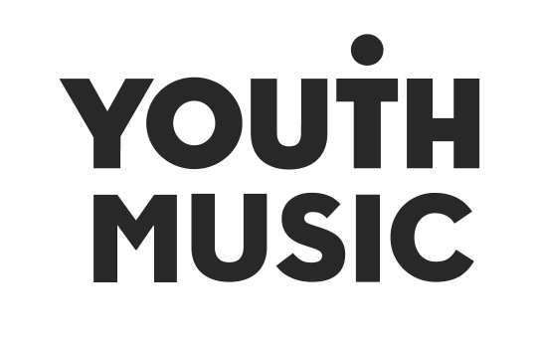

PR ASSISTANT JD

About the Youth Music Awards 2024
The Youth Music Awards in association with Hal Leonard Europe represents the future of music. It celebrates the most forward-thinking projects and people making, learning and earning in music.
From artists and entrepreneurs to grassroots projects and young leaders, the event recognises an exciting range of trailblazers from across the scene.
are open to anyone who has been directly funded via the NextGen Fund or has taken part in a Youth Music funded project since January 2019.
Learn more here - https://youthmusic.org.uk/awards

About this role
We’re looking for a friendly, organised, enthusiastic and versatile individual who can remain calm under pressure, deal with multiple tasks and think on their feet.
In the run up to the event, you’ll work closely with our PR agency, gaining hands-on experience in bringing a communications campaign to life. As part of this, you’ll spend time shadowing the account team through the planning stages and be allocated specific tasks to lead on yourself.
At the awards, you’ll help the agency and our Communications team run the live press office. Your responsibilities could include:
- Finding and taking the winners and other key guests for photography/filming
- Hosting journalists and ensuring they have what they need
- Capturing quotes from attendees as required
This is a freelance contract role for someone seeking paid experience to build a career in the music industries.

Key Timings
- Wednesday 16 October: Youth Music Awards at Troxy, London. (You will need to be available on this day between the hours of 10am – 11pm – exact times tbc.)
*You will also be required to attend a half day training with an industry professional around social media. Date tbc.

Fee
£300 plus travel expenses

Experience and qualities we’re seeking
Essential
- Considering or already pursuing a career in PR or journalism within the music industries.
- A fan of music and culture, whatever your favourite genre.
- Ability to juggle a few tasks at a time and know how to prioritise.
- Able to work to deadlines and communicate if any issues within plenty of time.
- Good problem-solving skills.
- Be a team player.
- Confident, energetic, personable, and calm under pressure.
- Excellent communicator, listener, and confident speaking with a range of people.
Desirable
- Previous experience working at events.
- Previous experience working in a PR/Communications role.
Youth Music aims to support young people in the early stages of developing creative careers, therefore we would particularly like to encourage applications from those aged 25 or under.

Diversity and equitability
Youth Music is an equal opportunities and Living Wage employer. We are committed to attracting, recruiting and retaining diverse candidates. It’s important that our team reflects the communities we serve. All our staff are members of an inclusion, diversity, equality, and access (IDEA) working group to stimulate, inform and platform good IDEA practice at Youth Music.
We especially welcome applications from people from under-represented groups and are committed to making adjustments that would support you in applying for or carrying out the role. We are currently under-represented by people from within the Trans community, people from the LGBTQ+ community, Disabled people and people from the Global Majority. If you are Disabled and your application meets the minimum criteria for the post, we will offer you a guaranteed interview.
Please contact constance.dingri@youthmusic.org.uk if you have a disability and/or access requirements or if you wish us to consider any other reasonable adjustments to ensure the interview process is fully accessible.

Application timeline
- Deadline for applications: Sunday 4 August 2024, 11:59pm.
- Notification of outcome: Week beginning 19 August 2024.
Due to the high number of applications we expect to receive, we regret that we may not be able to offer in-depth, individual feedback to applicants not invited to interview.

How to apply
As part of the application process, you are required to do the following:
- Complete and submit the application form online at:

- Complete an anonymous equal opportunities form:

About Youth Music
We’re the UK’s leading young people’s music charity. We believe that every young person should have a chance to change their life through music. Yet our research shows that many can’t because of who they are, where they’re from or what they’re going through.

Through our insights, influence, and investment in grassroots organisations, we make sure more young people aged 0-25 can make, learn and earn in music nationwide.

Youth Music is a national charity funded thanks to the National Lottery via Arts Council England, players of People’s Postcode Lottery and support from partners, fundraisers, and donors. Find out more about our work on the Youth Music Website and read more about our funding programmes on the Youth Music Network.

