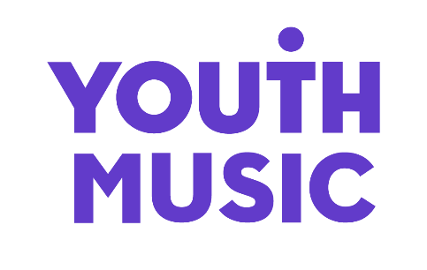

Application Form

When completed, the form should be emailed with your Applicant Details Form by the closing date stated in the advertisement to jobs@youthmusic.org.uk including the job title in the subject line.

1 | Application for the post of: (enter below)

Please complete this form and if there is insufficient space for your information, continue on a separate sheet. Please note that during the recruitment and selection process your application will be assessed against the selection criteria for the role. You are therefore advised to address these in your application.

2 | Work Experience
Duration of Employment (e.g. March 2022 – January 2023) |  | Name and address of employer (please indicate voluntary roles) | Position held and brief description of duties

3 | Supporting Statement  Tell us why you are applying for this job and how you meet the criteria outlined in the person specification. Please keep your supporting statement to 2 sheets of A4 or less.

Do you consider yourself to be Disabled? Yes ☐ No ☐
We ask this question because candidates who are Disabled and meet the minimum criteria for the post will be offered a guaranteed interview.

Have you completed the anonymous Equal Opportunities Form? Yes ☐ No ☐

Equal Opportunities Form - https://survey.alchemer.eu/s3/90317662/393bb71a1fdd

Diversity & Equal Opportunities

Youth Music is an equal opportunities and Living Wage employer. We are committed to attracting, recruiting and retaining diverse candidates. It’s important that our team reflects the communities we serve.

We especially welcome applications from people from under-represented groups and are committed to making adjustments that would support you in applying for or carrying out the role. We are currently under-represented by people from within the Trans community, people from the LGBTQ+ community, Disabled people and people from the Global Majority. If you are Disabled and your application meets the minimum criteria for the post, we will offer you a guaranteed interview.

Please contact constance.dingri@youthmusic.org.uk if you have a disability and/or access requirements or if you wish us to consider any other reasonable adjustments to ensure the interview process is fully accessible.

THE NATIONAL FOUNDATION FOR YOUTH MUSIC
STUDIO LG01, THE PRINT ROOMS
164-180 UNION STREET, LONDON, SE1 0LH
REGISTERED CHARITY NUMBER: 1075032
LIMITED COMPANY NUMBER: 03750674

