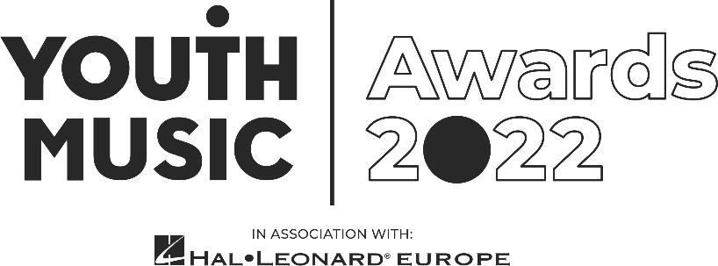

PR Runner Application Pack
Youth Music Awards

Intro
We are looking for an enthusiastic individual seeking paid experience to build a PR/media career in the music industries. This is a freelance contract role to work with our Communications team and PR agency at the Youth Music Awards, in association with Hal Leonard Europe.
- Fee: £300 plus travel expenses (plus potential for an additional day’s work at our PR agency for an additional £150 – to be confirmed).
- Application deadline: 11:59pm Sunday 7 August 2022

Required availability:
- Sunday 25 September: Attend a briefing day with all staff working the event.
- Wednesday 19 October: live event at Troxy, London. (You will need to be available on this day between the hours of 10am – 11pm – exact times tbc.)

About the Youth Music Awards 2022
The Youth Music Awards in association with Hal Leonard Europe represents the future of music. It celebrates the most forward-thinking projects and people making, learning and earning in music.
From artists and entrepreneurs to grassroots projects and young leaders, the event recognises an exciting range of trailblazers from across the scene.
The awards are open to anyone who has been directly funded via the NextGen Fund or has taken part in a Youth Music funded project since January 2017.
Learn more https://youthmusic.org.uk/awards

Youth Music’s Approach to Recruitment
We are committed to operating a fair and open recruitment process. Shortlisting of applications is always carried out by at least two people. As part of the application process candidates are invited to anonymously complete an equal opportunities form, which is used for monitoring purposes only by the HR department, it does not inform selection decisions.

Who we’re looking for
We’re looking for a friendly, organised, enthusiastic and versatile individual who can remain calm under pressure, deal with multiple tasks and think on their feet.
In the run up to the event, you’ll work closely with our PR agency, gaining hands-on experience in bringing a communications campaign to life. As part of this, you’ll spend time shadowing the account team through the planning stages and be allocated specific tasks to lead on yourself.
At the awards, you’ll help the agency and our Communications team run the live press office. Your responsibilities could include:
- Finding and taking the winners and other key guests for photography/filming
- Hosting journalists and ensuring they have what they need
- Capturing quotes from attendees as required

Experience and qualities we’re seeking
Essential
- A fan of music and culture, whatever your favourite genre
- Considering or already pursuing a career in PR or journalism within the music industries
- Ability to juggle a few tasks at a time and know how to prioritise
- Able to work to deadlines and communicate if any issues within plenty of time
- Good problem-solving skills
- Be a team player
- Confident, energetic, personable and calm under pressure
- Excellent communicator, listener and confident speaking with a range of people
Desirable
- Previous experience working at events
- Previous experience working in a PR/communications role

Youth Music aims to support young people in the early stages of developing creative careers, therefore we would particularly like to encourage applications from those aged 25 or under.
We value all kinds of experience and want to engage people from a variety of backgrounds. We are keen to diversify our team and are currently underrepresented by Disabled and neurodivergent people, people from Black, Asian and minority ethnic backgrounds, and members of the LGBTQ+ community.

How to apply
As part of the application process, you are required to do the following:
- Complete and submit the application form online
- Complete an anonymous equal opportunities form (via the online application form)

Application timeline
Deadline for applications: 11:59pm Sunday 7 August 2022.
Informal phone call: Week commencing 15 August 2022.
Notification of outcome: Week beginning 22 August 2022.
If you do not hear from Youth Music after the stated notification date, please take this to mean you have not been successful on this occasion. Due to the high number of applications we expect to receive, we regret that we may not be able to offer in-depth, individual feedback to applicants not invited to interview.

Further information

Questions
If you wish to have an informal chat about the role, please email creatives@youthmusic.org.uk to schedule a phone call.

Accessibility
If you require any reasonable adjustment to be made to the application or interview procedures for this post, please contact creatives@youthmusic.org.uk or telephone 020 7902 1060 to have a chat.

Please note: if you need any information in a different format, please contact us by emailing creatives@youthmusic.org.uk or by phoning 020 7902 1060. We will be happy to extend the application deadline accordingly if it takes time to accommodate your request.

Diversity and equitability
We are especially welcoming of under-represented groups and are committed to making adjustments that would support you in applying for or carrying out the role.

Data protection
Youth Music will use the information you provide to assess and process your application. If you are contracted for services, your information will be held on our databases and systems. Unsuccessful candidates’ information will be held for six months before being destroyed. We will store your data in line with the General Data Protection Regulations 2018 (GDPR).

About Youth Music
We believe that every young person should have the chance to change their life through music.
Yet our research shows that many can’t because of who they are, where they’re from or what they’re going through.
Our insights, influence and investment in grassroots organisations and to young people themselves means that more 0–25-year-olds can make, learn and earn in music.
Youth Music is a national charity funded thanks to the National Lottery via Arts Council England, players of People's Postcode Lottery and support from partners, fundraisers and donors.
Learn more at https://youthmusic.org.uk/

