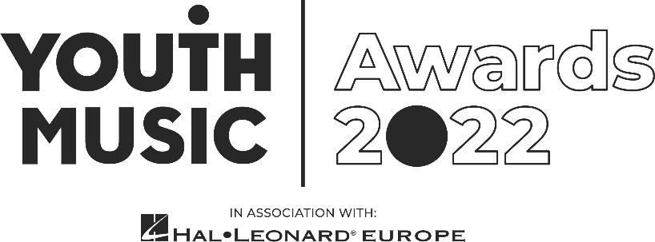
Live Illustration Artist Application Pack
Youth Music Awards

Intro
We are looking for a live illustrator to create an on-the-spot, bespoke piece of hand-drawn art during the Youth Music Awards, in association with Hal Leonard Europe.
- Fee: £150 plus travel expenses
- Application deadline: 11:59pm Sunday 7 August 2022

Required availability:
- Sunday 25 September: Attend a briefing day with all staff working the event.
- Wednesday 19 October: live event at Troxy, London. (You will need to be available on this day between the hours of 10am – 11pm – exact times tbc.)

About the Youth Music Awards 2022
The Youth Music Awards in association with Hal Leonard Europe represents the future of music. It celebrates the most forward-thinking projects and people making, learning and earning in music.
From artists and entrepreneurs to grassroots projects and young leaders, the event recognises an exciting range of trailblazers from across the scene.
The awards are open to anyone who has been directly funded via the NextGen Fund or has taken part in a Youth Music funded project since January 2017.
Learn more https://youthmusic.org.uk/awards

Youth Music’s Approach to Recruitment
We are committed to operating a fair and open recruitment process. Shortlisting of applications is always carried out by at least two people. As part of the application process candidates are invited to anonymously complete an equal opportunities form, which is used for monitoring purposes only by the HR department, it does not inform selection decisions.

Who we’re looking for
We’re looking for a live illustration artist, who can capture the buzz of the Youth Music Awards in real time.
There is a possibility we would like to print or sell the final piece of work. If selected, we will discuss these options with you after the event.
We are flexible on the style of art, and the piece could be based on a specific moment on the night, or a more abstract piece based on a theme from the event. There will be live performances and speeches across the night that you can take inspiration from.
We will provide all drawing/painting materials.

Experience and qualities we’re seeking
Essential
- A fan of music and culture, whatever your favourite genre
- Experience illustrating live or under time pressure (paid or unpaid)
- Have your own artistic style
- Able to work to deadlines
- Be personable and friendly
Youth Music aims to support young people in the early stages of developing creative careers, therefore we would particularly like to encourage applications from those aged 25 or under.
We value all kinds of experience and want to engage people from a variety of backgrounds. We are keen to diversify our team and are currently underrepresented by Disabled and neurodivergent people, people from Black, Asian and minority ethnic backgrounds, and members of the LGBTQ+ community.

How to apply
As part of the application process, you are required to do the following:
- Complete and submit the application form online
- Complete an anonymous equal opportunities form (via the online application form)
Application timeline
Deadline for applications: 11:59pm Sunday 7 August 2022.
Informal phone call: Week commencing 15 August 2022.
Notification of outcome: Week beginning 22 August 2022.
If you do not hear from Youth Music after the stated notification date, please take this to mean you have not been successful on this occasion. Due to the high number of applications we expect to receive, we regret that we may not be able to offer in-depth, individual feedback to applicants not invited for phone calls.

Further information

Questions
If you wish to have an informal chat about the role, please email creatives@youthmusic.org.uk to schedule a phone call.

Accessibility
If you require any reasonable adjustment to be made to the application or interview procedures for this post, please contact creatives@youthmusic.org.uk or telephone 020 7902 1060 to have a chat.

Please note: if you need any information in a different format, please contact us by emailing creatives@youthmusic.org.uk or by phoning 020 7902 1060. We will be happy to extend the application deadline accordingly if it takes time to accommodate your request.

Diversity and equitability
We are especially welcoming of under-represented groups and are committed to making adjustments that would support you in applying for or carrying out the role.

Data protection
Youth Music will use the information you provide to assess and process your application. If you are contracted for services, your information will be held on our databases and systems. Unsuccessful candidates’ information will be held for six months before being destroyed. We will store your data in line with the General Data Protection Regulations 2018 (GDPR).

About Youth Music
We believe that every young person should have the chance to change their life through music.
Yet our research shows that many can’t because of who they are, where they’re from or what they’re going through.
Our insights, influence and investment in grassroots organisations and to young people themselves means that more 0–25-year-olds can make, learn and earn in music.
Youth Music is a national charity funded thanks to the National Lottery via Arts Council England, players of People's Postcode Lottery and support from partners, fundraisers and donors.
Learn more at https://youthmusic.org.uk/

