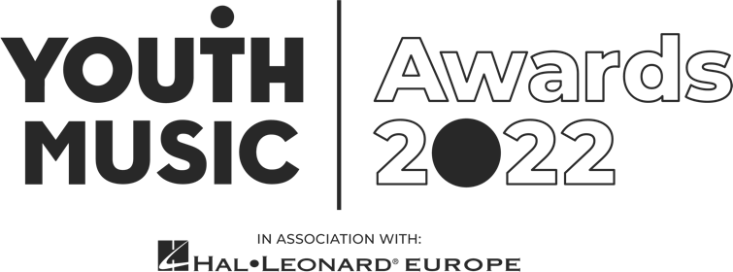
Freelance Video Editor Application Pack
Youth Music Awards 2022
We are looking for a talented video editor and motion graphic designer to create branded visuals for the Youth Music Awards 2022, in association with Hal Leonard Europe. This is a freelance contract role for someone seeking paid experience to build a career in the music industries.
- Pay rate: £2,500
- Required availability:
  - Briefing Mid-May.
  - Editing across June-August on a part-time, freelance basis.
- Application deadline: 10am Wednesday 6 April 2022.

About Youth Music
We believe that every young person should have the chance to change their life through music.
Yet our research shows that many can’t because of who they are, where they’re from or what they’re going through.
Our insights, influence and investment in grassroots organisations and to young people themselves means that more 0–25-year-olds can make, learn and earn in music.
Youth Music is a national charity funded thanks to the National Lottery via Arts Council England, players of People's Postcode Lottery and support from partners, fundraisers and donors.
Learn more at https://youthmusic.org.uk/

About the Youth Music Awards 2022
The Youth Music Awards in association with Hal Leonard Europe represents the future of music. It celebrates the most forward-thinking projects and people making, learning and earning in music.
From artists and entrepreneurs to grassroots projects and young leaders, the event recognises an exciting range of trailblazers from across the scene.
The awards are open to anyone who has been directly funded via the NextGen Fund or has taken part in a Youth Music funded project since January 2017.
Learn more https://youthmusic.org.uk/awards

Youth Music’s Approach to Recruitment
We are committed to operating a fair and open recruitment process. Shortlisting of applications is always carried out by at least two people. As part of the application process candidates are invited to anonymously complete an equal opportunities form, which is used for monitoring purposes only by the HR department, it does not inform selection decisions.

About the role
We’re looking for a video editor to create engaging short-form videos to showcase shortlisted nominees of 12 award categories. These will be shown on a large screen on the night to a live audience.
Working closely with our Communications team, the video editor will be required to:
- Input into a brief for nominees to send in video content.
- Build a short mood/storyboard in response to a brief.
- Work with motion graphics (adobe illustrator / after effect files) developed by our designer to brand the videos.
- Edit, grade and mix a series of short-form videos using user generated-nominee content, of which the quality may vary.
  - One video per award category (12).
  - A 2-minute video to introduce the awards.

Experience and qualities we’re seeking
Essential
- Able to think creatively and work with content from multiple sources
- Confident and skilled use of Adobe Suite (in particular Premiere Pro, Illustrator and After Effects).
- Experience editing video and audio
- Experience interpreting and applying brand guidelines
- Great storytelling skills
- Able to work accurately and to deadlines
- Willingness to respond to feedback
Youth Music aims to support young people in the early stages of developing creative careers, therefore we would particularly like to encourage applications from those aged 25 or under.
We value all kinds of experience and want to engage people from a variety of backgrounds. We are keen to diversify our team and are currently underrepresented by Disabled and neurodivergent people, people from Black, Asian and minority ethnic backgrounds, and members of the LGBTQ+ community.

When the work will take place
- Mid-May: Receive brief, draft storyboard and feed into nominee video submission brief
- Early June: All video content received and ready to begin editing process
- June to Mid-August: editing period

How to apply
As part of the application process, you are required to do the following:
- Complete and submit the application form at https://youthmusic.org.uk/apply-video-editor-role-youth-music-awards-2022
- Complete an anonymous equal opportunities form (via the application form)

Application timeline
- Deadline for applications: 10am Wednesday 6 April 2022
- Informal phone call: Week beginning Tuesday 19 April 2022
- Notification of outcome: Week beginning 25 April 2022
If you do not hear from Youth Music after the stated notification date, please take this to mean you have not been successful on this occasion. Due to the high number of applications we expect to receive, we regret that we may not be able to offer in-depth, individual feedback to applicants not invited to interview.

Further information
Questions
If you wish to have an informal chat about the role, please email creatives@youthmusic.org.uk to schedule a phone call.
Accessibility
If you require any reasonable adjustment to be made to the application or interview procedures for this post, or if you need the information in a different format, please contact creatives@youthmusic.org.uk or telephone 020 7902 1060 to have a chat.
We will be happy to extend the application deadline accordingly if it takes time to accommodate your request.
Diversity and equitability
We are especially welcoming of under-represented groups and are committed to making adjustments that would support you in applying for or carrying out the role.
Data protection
Youth Music will use the information you provide to assess and process your application. If you are contracted for services, your information will be held on our databases and systems. Unsuccessful candidates’ information will be held for six months before being destroyed. We will store your data in line with the General Data Protection Regulations 2018 (GDPR).

National Foundation for Youth Music ©2020
9 Tanner St, London, SE1 3LE
Registered charity No. 1075032.
Limited company No: 3750674.

