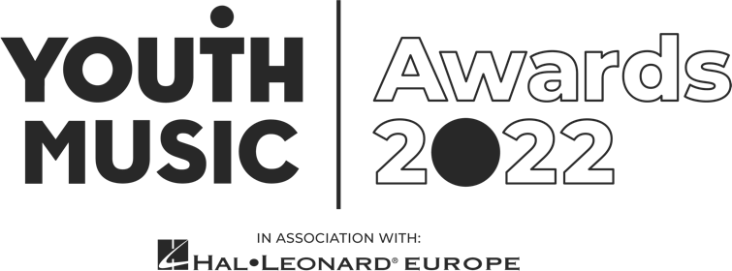

Freelance Presenter Application Pack
Youth Music Awards 2022

Intro

We are looking for two enthusiastic presenters to interview guests on camera at the Youth Music Awards, in association with Hal Leonard Europe.

Working closely with our video production team, you’ll interview nominees, winners, performers, sponsors and other special guests throughout the event. We would also like you to conduct online recorded interviews with six shortlisted nominees prior to the event that will be used in video content on the night.

You can apply for this role as an individual (we will pair you with someone) or as a pair. This is a freelance contract role for someone seeking paid experience to build a career in the music industries.

- Pay rate: £400 plus travel expenses.
- Required Availability:
  - June: Interview 6 shortlisted nominees (20-30 mins each) via zoom.
  - August-October: Attend monthly meetings with the team and rehearse with your co-presenter.
  - September: Attend a briefing day with all staff working the event.
  - Wednesday 19 October: live event at Troxy, London. (You will need to be available on this day between the hours of 2pm – 11pm – exact times tbc.)
- Application deadline: 10am Wednesday 6 April 2022.

About Youth Music

We believe that every young person should have the chance to change their life through music.

Yet our research shows that many can’t because of who they are, where they’re from or what they’re going through.

Our insights, influence and investment in grassroots organisations and to young people themselves means that more 0–25-year-olds can make, learn and earn in music.

Youth Music is a national charity funded thanks to the National Lottery via Arts Council England, players of People's Postcode Lottery and support from partners, fundraisers and donors.

Learn more at https://youthmusic.org.uk/

About the Youth Music Awards 2022

The Youth Music Awards in association with Hal Leonard Europe represents the future of music. It celebrates the most forward-thinking projects and people making, learning and earning in music.

From artists and entrepreneurs to grassroots projects and young leaders, the event recognises an exciting range of trailblazers from across the scene.

The awards are open to anyone who has been directly funded via the NextGen Fund or has taken part in a Youth Music funded project since January 2017.

Learn more https://youthmusic.org.uk/awards

Youth Music’s Approach to Recruitment

We are committed to operating a fair and open recruitment process. Shortlisting of applications is always carried out by at least two people. As part of the application process candidates are invited to anonymously complete an equal opportunities form, which is used for monitoring purposes only by the HR department, it does not inform selection decisions.

About the role

Working closely with our video production team and the other presenter, you’ll interview nominees, winners, performers, sponsors and other special guests throughout the event. This footage will be edited and distributed across Youth Music channels to engage a wider audience with the Youth Music Awards.

We would also like you to conduct online recorded interviews with six shortlisted nominees that will be used in video content on the night.

You’ll bring energy, enthusiasm and professionalism to every take. Viewers will see your personal passion for music, and your belief in its power to change young people’s lives.

We’re looking for someone who can speak confidently with guests and make them feel comfortable being interviewed on camera. The successful applicant will be fully briefed on our campaign story, then bring this to life in their interviews.

Experience and qualities we’re seeking

Essential
- Experience presenting and interviewing on camera
- Confident, energetic, charismatic, personable and calm under pressure
- Excellent communicator, listener and confident speaking with a range of people
- A fan of music and culture, whatever your favourite genre
- Considering or already pursuing a career in presenting or journalism within the music industries

Desirable
- Journalism experience
- Writing scripts

Youth Music aims to support young people in the early stages of developing creative careers, therefore we would particularly like to encourage applications from those aged 25 or under.

We value all kinds of experience and want to engage people from a variety of backgrounds. We are keen to diversify our team and are currently underrepresented by Disabled and neurodivergent people, people from Black, Asian and minority ethnic backgrounds, and members of the LGBTQ+ community.

How to apply
As part of the application process, you are required to do the following:
- Complete and submit the application form https://youthmusic.org.uk/apply-be-presenter-youth-music-awards-2022
  - Please note as part of the application, you will need to upload and link to a short unlisted YouTube video of yourself explaining why you are suitable for the role (max 3 minutes). If you do not upload a video your application will not be considered.
- Complete an anonymous equal opportunities form (via the online application form)

Application timeline
Deadline for applications: 10am Wednesday 6 April 2022
Informal zoom interview: Week beginning Tuesday 19 April 2022
Notification of outcome: Week beginning 25 April 2022

If you do not hear from Youth Music after the stated notification date, please take this to mean you have not been successful on this occasion. Due to the high number of applications we expect to receive, we regret that we may not be able to offer in-depth, individual feedback to applicants not invited to interview.

Further information
Questions
If you wish to have an informal chat about the role, please email creatives@youthmusic.org.uk to schedule a phone call.

Accessibility
If you require any reasonable adjustment to be made to the application or interview procedures for this post, please contact creatives@youthmusic.org.uk or telephone 020 7902 1060 to have a chat.

Please note: if you need any information in a different format, please contact us by emailing creatives@youthmusic.org.uk or by phoning 020 7902 1060. We will be happy to extend the application deadline accordingly if it takes time to accommodate your request.

Diversity and equitability

We are especially welcoming of under-represented groups and are committed to making adjustments that would support you in applying for or carrying out the role.

Data protection

Youth Music will use the information you provide to assess and process your application. If you are contracted for services, your information will be held on our databases and systems. Unsuccessful candidates’ information will be held for six months before being destroyed. We will store your data in line with the General Data Protection Regulations 2018 (GDPR).

National Foundation for Youth Music ©2020
9 Tanner St, London, SE1 3LE
Registered charity No. 1075032.
Limited company No: 3750674.

