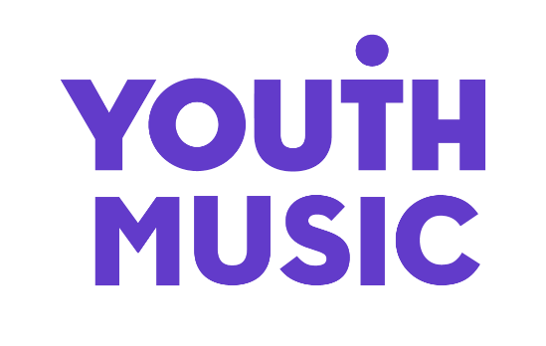

Marketing Internship
Application pack 2021

What we do

We believe that every young person should have the chance to change their life through music.

Yet our research shows that many can’t because of who they are, where they’re from or what they’re going through.

Our insights, influence and investment in grassroots organisations and to young people themselves means that more 0–25-year-olds from can make, learn and earn in music.

Youth Music is a national charity funded thanks to the National Lottery via Arts Council England, players of People's Postcode Lottery and support from partners, fundraisers and donors.

Find out more: www.youthmusic.org.uk

Youth Music’s Approach to Recruitment

We are committed to operating a fair and open recruitment process. Shortlisting of applications is always carried out by at least two people. As part of the application process candidates are invited to anonymously complete an equal opportunities form, which is used for monitoring purposes only by the HR department, it does not inform selection decisions.

COVID-19

All Youth Music staff have been working from home since March 2020. We are currently adopting a flexible approach to returning to the office whilst COVID remains a concern. We have a comprehensive health and safety office plan in place and are able to accommodate individual requests to work from the office on a case by case scenario.

Youth Music has adopted a new Flexible Working Policy that will support all employees to work up to 3 days from home whilst working a minimum of 2 days in our London Office.

Diversity and equal opportunities

Youth Music is an equal opportunities and Living Wage employer. We are committed to attracting, recruiting and retaining diverse candidates, as it’s important that our team reflect the communities we serve at every level within the charity.

We especially welcome applications from people from under-represented groups and are committed to making adjustments that would support you in applying for or carrying out the role. We are currently under-represented by people with lived experience of Disability and neurodivergent people, people from Black, Asian and minority ethnic backgrounds, and people from the LGBTQ community.

Our office is not fully accessible for wheelchair users at present - we are working with our landlord to address this issue. We apologise and will make alternative arrangements if you are unable to access our office. For any access requirements please contact Leigh Halifax on 020 7902 1060 or email leigh.halifax@youthmusic.org.uk.

Salary and benefits

Salary: £10.85 per hour (real living wage)

Contract: six months, 25hrs per week

Location: Bermondsey SE1, London. Staff are currently working from home and will be expected to work in the office for at least two days per week once we return

Holidays: 25 days plus public holidays (pro-rated for part time) and additional days over the Christmas period when the office closes

Additional benefits: Cycle to work scheme, Critical Illness Cover, flexible working, Income protection which includes the help@hand app, offering easy access to four key support services: Remote GP, Second Opinion, Mental Health Support and Physiotherapy, Staff Values committee, and continued learning and development.

About the role

We’re looking for a Marketing Intern who’ll play a key role in bringing our newly defined brand to life amongst a variety of audiences. With support and guidance from the Youth Music team, you’ll help make the most of exciting marketing opportunities.

You’ll help create stories; developing written, visual and video content across Youth Music’s website and social media channels to demonstrate the impact of our work and increase audience engagement.

Key areas of responsibility

You’ll be supporting the work of the communications team by maintaining Youth Music's content plan, writing and coordinating content for different audiences, managing our inbox and allocating tasks appropriately. You’ll also be carrying out research on competitors and peers and excitingly, you will be co-ordinating our new TikTok channel.

What you'll learn

The role will give you the opportunity to develop an understanding of how marketing and communications works within the charity sector. You'll learn how to plan, create and share content as part of a campaign and how to bring a brand to life through communication. You'll gain experience in understanding different marketing skills that you could choose to specialise in, such as Social Media, Copywriting, Email Marketing and PR.

About you

You don't need any prior experience to apply, but we are looking for creativity, enthusiasm, and a desire to learn.

A passion for social media is a must, with good written and verbal communication skills. Basic IT skills would be beneficial but training will be provided.

You should be passionate about young people, music and social justice.

Training, qualifications and support

You will be part of a group of four interns at Youth Music. You’ll receive regular training and networking to help you devlop in your role and think about your next steps in employment.

Throughout your employment you will have both a line manager and a mentor that will support you through the contract. Leigh Halifax, Youth Music's Office Manager, will be your line manager. Leigh will support you through the contract, engaging you in training activities that will give you a deeper understanding of the sector, the role, expectations and employability skills. You will also have weekly catch ups with your fellow kickstarters to discuss what you've learned, what your tasks are and how best to action and achieve whats on your to-do list.

Your mentor will be Jasper Morvaridi, Youth Music’s Digital Marketing Executive. Jasper will guide you on how to perform your role to the best of your ability, offering on the spot coaching to teach you the processes and systems that Youth Music uses and shaping your working week.

Youth Music is committed to ensuring that all employees feel supported in their role and encourage training and development opportunities that will further help their career.

How to apply

As part of the application process you are required to do the following:
- Complete and submit the application form online.
- Complete an anonymous equal opportunities form (available via the application form).

Interviews will take place online: details of the interview will be sent to candidates via email.

- Deadline for applications: 10am Monday 2 August
- Interviews: w/c 9 August tbc
- Start date: w/c 16 August tbc

Please note that this is a readvertisement and we recommend that recent applicants do not re-apply.

Accessibility

Youth Music is committed to ensuring that every step of the application/interview stages can be made accessible for everybody interested in the role.

If you require any adjustment to be made to the application or interview procedures for this post, please let us know in the applicant details form and/or contact us by email leigh.halifax@youthmusic.org.uk to have a chat.

