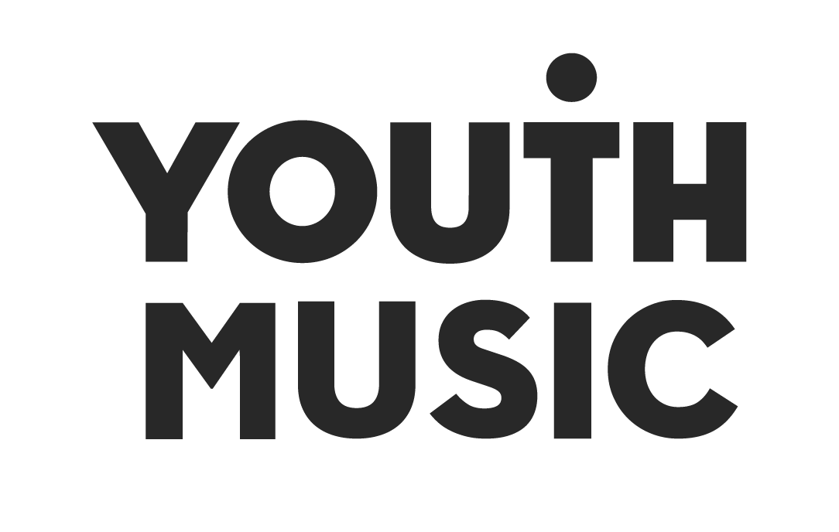

Youth Music NextGen Fund
Applicant Guidance Notes v1
Round 1 - June 2021

About Youth Music
We believe every young person should have the chance to change their life through music. Yet our research shows many can’t because of who they are, where they’re from or what they’re going through.

Our insights, influence and investment in grassroots organisations and to young people themselves means that more 0–25-year-olds can make, learn and earn in music.

Youth Music is a national charity funded thanks to the National Lottery via Arts Council England, players of People's Postcode Lottery and support from partners, fundraisers and donors.

What is Youth Music NextGen?
Youth Music NextGen is our community for young creatives who aspire to build and work in the music industries of the future.
It offers access to talent development and job opportunities, industry expertise and grant funding. Join the community here.

What is the Youth Music’s NextGen Fund?
The Youth Music NextGen Fund offers young creatives grants of up to £2,500 to make their ideas happen.

We’ve launched the NextGen Fund to help emerging musicians and behind the scenes creatives take a step forward in participating and changing the music industries.

Built for creatives with a stack of ideas but a lack of finance, the fund is open to 18–25-year-olds (and under-30s who identify as Disabled). Successful applicants will use the money to launch a creative project, idea or business.

We want to support the future of the music industries. Singers, Rappers, Songwriters, Producers, DJs, A&Rs, Managers and Agents, right through to roles that have yet to be defined.

We would especially like to hear from people who have never applied for funding before.

The Youth Music NextGen Fund has been made possible thanks to generous support from TikTok and players of People’s Postcode Lottery.

1. What is this fund for?
This fund is about supporting people to take their first steps into the music industries.

You can apply to develop a project that you can run and deliver yourself. Here are some examples of ideas:

A creative music project: a Single, EP or contribution towards an album campaign.
The music can be already made or in the process of being created.

A music-based business: starting a record label or music platform.

A platform that supports underrepresented voices and perspectives:
Supporting leaders that build communities and help facilitate others in pursuing their creative goals

As well as funding time for you to pursue your idea, we can also cover costs linked to:
- Career development – Training, Mentoring and Networking
- Audience development or marketing
- Equipment and Software
- Business development
Please note we are not funding any projects including live events or touring in this first funding round. We hope that we can fund these in future rounds depending on the situation with COVID-19.

All projects need to be released within a year of being awarded the funds, and ideas that aren’t accessible to the general public cannot be funded. For example, it couldn’t fund a training course with no project outcome.

2. Who is this fund for?

People working towards a career in the music industries, but lack key contacts, resources and insights. They might be:
- Musicians, Producers, Engineers, DJs, MCs, Rappers, Songwriters
- Managers, Promoters, A&Rs, Agents
- Activists and campaigners who are transforming the music industries.

In our funding decisions, we will prioritise:
- People who do not have the financial means to invest in themselves to get their ideas started.
- People that are too early stage to be funded by larger grant programmes like Arts Council England and PRS Foundation
- Those who might be discriminated against, for reasons that could include Gender, Race, Disability, location or other characteristics.
- People who are creative, entrepreneurial and are multi-disciplinary - even if they don’t recognise themselves as such.

3. Who is this fund not for?

We welcome all to participate in our workshops, but if you already have the financial means to deliver your project please don’t apply. This will allow more people who don't to have access to financial resources to apply to the fund.

- Signed Artists. If you are signed to a record label, publisher or management company, again you are welcome to participate in our sessions, but we want to keep this open to people who aren’t at that stage yet.

- People in full time employment in the music industries already. This specifically means working in the area of the industry you want to progress in. For example, we won’t exclude someone who works at a major music venue at the bar, but we would if you were already an A&R at a major record company.

- Groups and collectives. The recipient of the grant will be one individual and we would like to know about how this grant will support your career development and your ideas. If you are intending on working with others as part of your project that is fine, but we want this grant to primarily support you as an individual.

4. How can I get help with my application?
Youth Music is an open organisation, and we welcome questions via email. We will publish frequently asked questions on our website and socials.
You can also contact us to arrange a call with one of our team. 30 Minute slots are available Wednesdays 4pm-7pm and Fridays 3pm-5pm while the fund is open.
Please email creatives@youthmusic.org.uk to arrange this.
We want to encourage people to go through the process of applying for funding for the first time and have put in place a program of guidance and support. Everyone who submits a project idea will get some feedback, even if they don’t get funded.

We will be running a series of online workshops that will stimulate ideas, give you more information about the current and future of the industries and help you with budgeting your project.

Online Workshops: Click here to book your place on Youth Music’s Eventbrite

Tuesday 8th June 7pm | Introduction to Youth Music NextGen with Elijah & Domenica
Tuesday 15th June 7pm | How to get paid: an introduction to PRS for Music
Tuesday 22nd June 7pm | Hooversound Recordings: Starting a record label during a pandemic with Naina
Tuesday 29th June 7pm | Becoming self sufficient as a creative with Andy Musgrave (Founder of Supernature and Manager of AJ Tracey)

5. When is the application deadline?

The application deadline for Round 1 is 17:00 on Friday 9 July 2021.

There will be future application rounds so if you aren’t ready to apply yet, or you’re trying to rush through your application to meet the deadline, it’s better to wait and give this your best shot.
There will be one more funding round later in 2021 and three funding rounds in 2022.
To give as many people an opportunity as possible, if you apply in Round 1 and aren't successful, you won't be eligible to apply for Round 2. You will be welcome to apply in Round 3 in 2022.

6. What can I spend the funding on?

This grant can go towards a project that already exists, or work as part of an overall budget. The grant could act as half of overall costs, with other sources of finance involved. You don’t have to have any existing funding already to apply. We recommend allocating money to each section, as we are unlikely to fund ideas that have all the money spent in one place (e.g. only spending money on time to create).

Time to Create – A contribution towards your time spend on this project. This might be time needed to be off work or other responsibilities (e.g. childcare) to focus on the project. We want to make sure that creatives are paid appropriately for the activities we support and therefore encourage you to use the real Living Wage rates to budget your time.

Project Expenses - Any costs associated with producing the work. For example:
- Recording and Production costs - Studio, Mixing and Mastering
- Session Musician Fees at the Musicians Union rate
- Manufacturing
Equipment - £500 maximum - Hardware and software necessary to completing the project to a high standard, that will be also an asset to you with future projects.

Training - £200 maximum - Affordable training that will help you develop your skills needed to deliver the project and or level up your skill set for future employment potential. For example, a conference ticket or online course.

Marketing - Attainable targets for audience development. Example spends:
Sponsored social media posts, PR and content creation.

Travel - £200 maximum - For this funding Round, we expect this to be low, due to the current covid restrictions in place. We encourage remote work and online collaboration where possible.
Other
List any other spending for your activity that is not included elsewhere that is related to your project. You can include an amount for unexpected costs – this is known as “contingency”.
Access
If you identify as Disabled, we can provide extra funding to help you make your application and to run your project:
- Personal Access Budget
If you have any personal access costs you need to run your project, you can include these on top of the £2,500 maximum grant. This might include costs for British Sign Language interpreters, personal assistants, support workers or other access costs. If you want to apply for a personal access budget please get in touch with Youth Music in advance of submitting your application to discuss your requirements.
- Support with making your application.
You can also apply for support with the costs of making an application via Youth Music’s Access Funds. This is a separate process so don’t include costs related to planning and submitting your application within your budget.
- Access to Work
Some Disabled applicants or those with health conditions may be entitled to get money for personal support and equipment from the Government’s Access to Work scheme. More info on this can be found here: https://disabilityarts.online/atw/

7. How to apply
You will need to complete an online application form on Youth Music’s website this will cover:
- Who you are and your previous work
Tell us your contact details and provide some examples of your previous work. This can be done via document upload or providing links to recordings, videos or your strongest social media account that best represents your work.
- Your project
This is the main section of the application form. You have the option to answer these three questions using text (1000 words max), a presentation deck (8 slides max) OR video (6 mins max).
- Tell us about the last year or two of your progression as an artist or music professional (250 words max)
Please include
- What you do and where you are in your career now.
- Your proudest musical/professional achievements so far.
- Any challenges you're facing in your journey in music.
- Tell us what you’d like to achieve over the next year through your project, and how the funding will make a difference (250 words max)
Be realistic about your goal, we're interested in progression so it's completely valid to say you just want to grow your audience. Don't feel like you need to tell us you'll be headlining Glastonbury within a year!
Please include:
- What you've already been doing to work towards this goal (we’re very interested in what you’ve already made happen on your own).
- Why you need this funding and how it will help you to progress your career.
- Outline your project plan, what you're going to do, and how you're going to do it. (500 words max).
Please include:
A detailed plan of your project including timescales. Be specific and break it down - we want to know how you are going to deliver your project. You can upload a one page timeline or project plan to support this below.
We want to fund people who can deliver strong projects that are:
- Interesting, innovative, or original (for you or your audience).
- Realistic and deliverable within a year.
- Well planned, timelined and clearly budgeted.
Please remember in this round we are not able to fund live events. We hope to support these in future rounds depending on the situation with Covid-19.

- Budget
Here you’ll need to tell us what you’re going to spend on your project. Your total budget must be between £1000 - £2500 and there are some limits on how much you can spend on certain items. We would like you to focus your grant spend on your creative project and making something happen rather than using it to just buy equipment.

- Reference
We will ask for the name of someone who can act as a referee. We will only contact them if your application is successful. This should be a professional connection who knows you and your work as a creative. For example, someone you’ve worked with on a previous project or a Music Leader from a course or programme you’ve participated in.
- Monitoring
Lastly, we’ll ask you to complete some optional monitoring and equal opportunities questions to help us gather some information about who is applying for this fund. This will help us ensure we are equitable and representative in our approach and our funding decisions.

8. How we’ll make decisions

We expect to receive a large number of high-quality applications for this fund but will only be able to fund a limited amount of applications in each funding round. This means we will have to make some difficult decisions. The strength of your application will be assessed alongside the other applications we receive by a group of assessors. A final shortlist will go then through to an expert judging panel.

Your application will be assessed on the following criteria:
Eligibility check: We will conduct an initial check to ensure your application is eligible. It will need to contain enough detail and information for us to make a full assessment. If you have not included supporting documents or links that you refer to, we will not be able to assess your application.

- The strength of your project
Strong applications will be focused on creating something new or making something happen. Projects should enable you to develop your skills and explore new ground. Strong project ideas should be interesting, exciting or innovative. But remember to make sure it is realistic and achievable too.
- The potential benefit to you and your career

We want you to have a clear idea about where you’re going in your career and how your project will help you get there. We also want to have confidence that you’ll be able to deliver the project to a high standard, and that it will enable you to take your career forwards.

- The strength of the project plan

Strong applications will be well planned. They’ll have an accurate and reasonable budget. They will be clear about what will happen and how. We need to know when things will take place and who will be involved. Timescales will be realistic and achievable in 12 months.

Ensuring we fund fairly
We will ensure that we fund a diverse range of applicants. To do this we use a wide variety of data to help guide our decision making and help us to balance our funding. This will enable us to invest across a range of projects, genres, individuals and geographical areas.

9. What happens if I am successful?

You will be informed by email and sent an offer of funding. To accept the offer you will need to:
- Sign a funding agreement.
- Send us proof of your bank details and proof of your identity.

Once we have approved these documents, you will receive a payment for around 85% of your grant money. This will normally arrive in around 6 Weeks of signing and returning your funding agreement.

At the end of your project you’ll need to complete a short reporting form detailing how the money was spent and how it has impacted you. You will receive the remaining funding for your grant when you submit your final report.

We’ll encourage you to share your final work with us, and to present this back in a way that best suits your work, and will be most useful for you in the future. This could be a recording, video, slide deck, blog post, photos.

10. What happens if I am unsuccessful?
We expect demand for the NextGen funding to be very high. We will not be able to fund all the applications we receive.

Each applicant will get one or two points of brief feedback and you will be directed towards online group feedback sessions that we’ll be running. These will focus on different elements of creating a strong funding proposal.

To give as many people an opportunity as possible, if you apply in Round 1 and aren't successful, you won't be eligible to apply for Round 2. You will be welcome to apply in Round 3 in 2022.

11. Do’s and Don’ts

- Ensure your online presence is up to date
We’re going to look at your social media, web links, so make sure they reflect your most recent or strongest activity
- Keep it simple
Don’t over complicate your idea, doing one thing well is better than trying to do lots of loads of different things. Our assessment will look at whether we think you can deliver the project.
- Be clear
You don’t need to use complicated language to communicate with us. Bullet points often help where there is limited word count.

- Don’t assume knowledge
Assume no one knows about you, your previous work or your project idea - get someone to read it before you submit it.

- Check out Youth Music’s website
We have gathered some good resources on our website to help people starting a career in music or applying for funding for the first time.

12. Terms and Conditions
To apply you must:
- Be aged 18 to 25 at the point of the application deadline. If you identify as Disabled you can be aged 18 to 30. This is because the impact of barriers faced by Disabled people can impact them further into their careers
- Be living in England, Scotland, Wales - we are working to open this fund to Northern Ireland for future rounds.
- Have a UK bank account in the exact name you are applying under.
- Be able to start your project within 3 months of hearing your project has been funded.

What we can’t fund
Youth Music is not able to fund the activities or items listed below. Please read through this section thoroughly. Your application will be declined if you include any of the following:
- Applications relating to loss of income because of the COVID-19 pandemic.
- Applications including live events or touring. We hope that we can fund these in future funding rounds depending on the situation with COVID-19.
- Applications from people who are not aged 18 to 25 (or aged 18 to 30 if Disabled).
- Activities, goods or services that have already been bought or taken place before a your project begins.
- Applicants who are already receiving financial backing.
- Activities that are not music or career development focused
- Individuals can apply to start a new business idea but we can’t accept applications from existing organisations or businesses.
- Overheads. E.g. rent, utilities and insurance.
- Activities that promote a political or religious view.
- Opportunities already funded by Youth Music. E.g. you are being funded through an Incubator Fund project.
- If you have been funded before by this fund then you are not able to apply again

13. FAQs

Will I need to pay the money back?
No, but you will need to complete an evaluation form on completion of the project to receive the full amount.

Am I allowed to make profit?
Yes. We want to support your journey to building a sustainable career or revenue stream for your creativity. You won’t need to report this to us, but you will need to check what taxes you may need to pay on these.

I have been releasing music for several years, but feel as if I haven’t got a break yet, can I apply?
Yes. We will not penalise experience, but if you have already had record and or publishing deals, high profile performances and press this fund is not for you.

How are decisions made?
A team of assessors are brought in which will have knowledge of your genre or location and will judge on the criteria listed. This will be a mix of people from different ages, experiences and backgrounds.

Can someone else write the application on my behalf?
We strongly encourage you to write it yourself, and attend our workshops leading up to the deadline. The experience of putting it together will help you long term with your creative ideas and we will not be judging on language used or grammar. If someone else is writing for you because of access reasons, that is completely fine.

Will there be future rounds of this fund?
Yes. So, if you aren’t ready to apply yet don’t rush through your application to meet the deadline. It would be better to wait and give this your best shot. There will be 2 rounds in 2021 and 3 in 2022.

Do I need match funding, or money to put into the project myself?
No. We especially welcome people who cannot fund projects themselves. Your ability to add extra funding won’t be a decision making factor.

I’m a British Citizen but I’m not currently based in the UK, can I apply?
No. Activity must be based in England, Scotland or Wales. We intend to open it up to Northern Ireland in future rounds.

Can my project be based or include work overseas?
No. Activity must be based in England, Scotland or Wales. We are not encouraging any non-essential travel in 2021.

