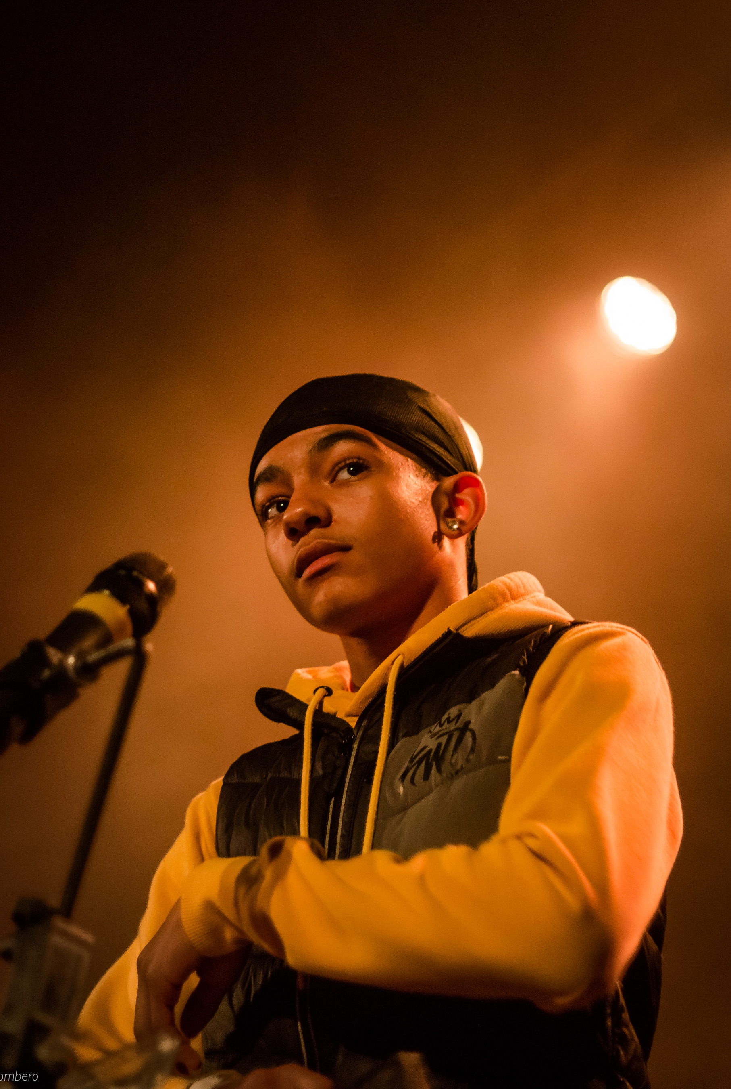

Video Editor Pack 2021

Youth Music Awards Video Editor application pack
We are looking for a talented video editor and motion graphic designer to create celebratory, professional, branded visuals for our second Youth Music Awards, in association with Hal Leonard Europe.
Contract details: Freelance position
Pay rate: £2000
Time commitment: Editing across June-July on a part-time, freelance basis.
Application deadline: 10am Friday 30 April 2021

About Youth Music
Youth Music is the UK’s largest young people’s music charity. Equality, diversity and inclusion drive our vision and mission. We want to equalise access to music: we focus on people who miss out because of who they are, where they live, or what they’re going through.
We work with babies through to young adults, harnessing the power of music to support musical, personal, and social development. As a funder, we invest in more than 300 projects each year, reaching around 80,000 young people and over 4,000 people in the workforce.
We campaign alongside young people to drive change in the music industries and education, making it more inclusive, diverse and creative
For further information about our charity please visit: www.youthmusic.org.uk and for information about our grants programme please visit: www.youthmusic.org.uk/network

About the Youth Music Awards 2021
The second annual Youth Music Awards, in association with Hal Leonard Europe, take place on Wednesday 20 October 2021 at Troxy, London.
The show celebrates the achievements of young people taking part in the projects we fund, who are making music in all genres, all over the country, every day. They also recognise the organisations and music leaders that are tirelessly working on the frontline, going above and beyond to help the next generation progress personally, socially and musically.
As part of Youth Music Next Gen, we are hiring a team of young people from all across the UK to support the Youth Music Awards.
Note: Due to the current COVID-19 crisis, we are carefully monitoring Government advice and may adapt the show to take place online, dependent on restrictions. As this role is required to work only in advance of the event, it will not be impacted by this decision.

Youth Music’s Approach to Recruitment

As part of our commitment to a fair and open recruitment process Youth Music anonymises all applications we receive before shortlisting candidates for selection. As part of the application process candidates are invited to anonymously complete an equal opportunities form, which is used for monitoring purposes only by the HR department, it does not inform selection decisions.
Once a vacancy has closed, the applicant details are separated out by the HR team, and only the completed application forms are shared with the shortlisting panel. Shortlisting of applications is always carried out by at least two people.

Who we’re looking for
We’re looking for a video editor to create engaging short-form visuals to showcase shortlisted nominees and announce winners of 12 award categories. These will be shown on a large screen in the venue (or via live stream).
Working closely with our Communications team, the video editor will be required to:
- Co-create a self-filming brief for nominees to create User Generated Content (UGC)
- Build a short mood/storyboard in response to a brief
- Develop and design motion graphics based on our new brand guidelines, to accompany each edit.
- Edit, grade and mix a series of short-form videos using UGC, of which the quality may vary

Experience and qualities we’re seeking
We’re looking for a video editor with the following skills and experience:
Essential
- Able to think creatively and work with content from multiple sources
- Confident and skilled use of Adobe Premiere Pro (or alternative high quality editing software)
- Experience editing video and audio
- Experience interpreting and applying brand guidelines
- Great storytelling skills
- Able to work accurately and to deadlines
- Willingness to respond to feedback
Youth Music aims to support young people in the early stages of developing creative careers, therefore we would particularly like to encourage applications from those aged 25 or under.
We value all kinds of experience and want to engage people from a variety of backgrounds. We are keen to diversify our team and are currently underrepresented by Disabled and neurodivergent people, people from Black, Asian and minority ethnic backgrounds, and members of the LGBTQ+ community.

When the work will take place

- Mid-May: Receive brief, draft storyboard and co-create nominee video submission brief
- Early June: All video content received and ready to begin editing process
- June-July: editing period

How to apply
As part of the application process you are required to do the following:
- Complete and submit the application form
- Complete an anonymous equal opportunities form at https://survey.alchemer.eu/s3/90317662/dd28cc97c276

Application timeline
Deadline for applications: 10am Friday 30 April 2021.
Notification of outcome: Week beginning 17 May 2021.
If you do not hear from Youth Music after the stated notification date, please take this to mean you have not been successful on this occasion. Due to the high number of applications we expect to receive, we regret that we may not be able to offer in-depth, individual feedback to applicants not invited to interview.

Further information
Questions
If you wish to have an informal chat about the role, please email creatives@youthmusic.org.uk to schedule a phone call.
Accessibility
If you require any reasonable adjustment to be made to the application or interview procedures for this post, please contact creatives@youthmusic.org.uk or telephone 020 7902 1060 to have a chat.
Please note: if you need any information in a different format, please contact us by emailing creatives@youthmusic.org.uk or by phoning 020 7902 1060. We will be happy to extend the application deadline accordingly if it takes time to accommodate your request.
Diversity and equitability
We are especially welcoming of under-represented groups and are committed to making adjustments that would support you in applying for or carrying out the role.
Data protection
Youth Music will use the information you provide to assess and process your application. If you are contracted for services, your information will be held on our databases and systems. Unsuccessful candidates’ information will be held for six months before being destroyed. We will store your data in line with the General Data Protection Regulations 2018 (GDPR).

