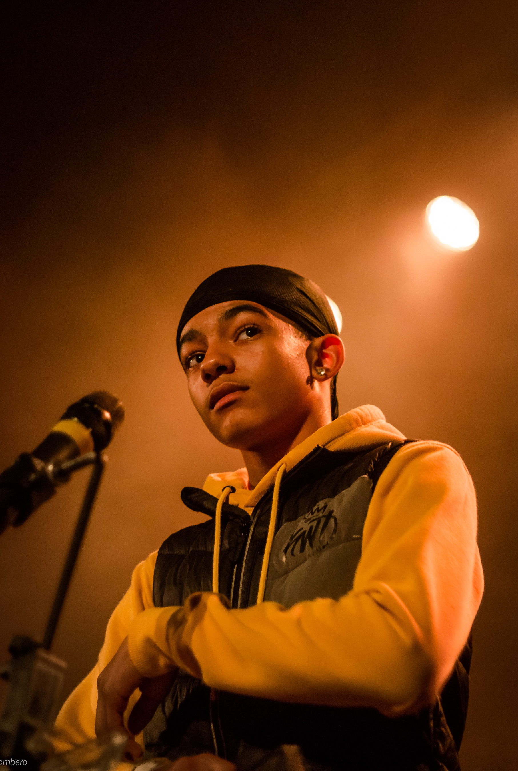

Award Hosts Pack 2021

Youth Music Awards Hosts application pack
We are looking for two music-loving hosts to present the Youth Music Awards on the night, introducing the nominees, performers, announcing the winners and keeping the guests engaged throughout the evening.
Contract details: Freelance position
Pay rate: Negotiable
Time commitment: Wednesday 20 October 2021 or, if pre-recorded, Sunday 26 September 2021. Plus approximately 1 to 2 days of rehearsal time in the two week period before the event.
Application deadline: 10am Friday 30 April 2021.

About Youth Music
Youth Music is the UK’s largest young people’s music charity. Equality, diversity and inclusion drive our vision and mission. We want to equalise access to music: we focus on people who miss out because of who they are, where they live, or what they’re going through.
We work with babies through to young adults, harnessing the power of music to support musical, personal, and social development. As a funder, we invest in more than 300 projects each year, reaching around 80,000 young people and over 4,000 people in the workforce.
We campaign alongside young people to drive change in the music industries and education, making it more inclusive, diverse and creative.
For further information about our charity please visit: www.youthmusic.org.uk and for information about our grants programme please visit: www.youthmusic.org.uk/network

About the Youth Music Awards 2021
The second annual Youth Music Awards in association with Hal Leonard Europe take place on Wednesday 20 October 2021 at Troxy, London.
The Youth Music Awards celebrate the achievements of young people taking part in the projects we fund, who are making music in all genres, all over the country, every day. They also recognise the organisations and music leaders that are tirelessly working on the frontline, going above and beyond to help the next generation progress personally, socially and musically.
As part of Youth Music Next Gen, we are hiring a team of young people from all across the UK to support the Youth Music Awards, prior to and on the night.
Back-up plan: online/pre-recorded event
This event was originally scheduled for Wednesday 21 October 2020 and has been rescheduled for the safety of our guests. Due to the current COVID-19 crisis, we are carefully monitoring the situation and government’s advice in regard to the restrictions taking place in the UK.
Depending on what the Government guidelines are during the time of the awards:
- the total number of attendees may vary, or
- the hosts and performers will film a pre-recorded show on Sunday 26 September at Omeara, London Bridge, that will be aired on Wednesday 20 October 2021.
We will notify all roles of any changes to the live event in June 2021.

Who we’re looking for
We are looking for two music-loving hosts to present the Youth Music Awards on the night. The hosts will need to provide a seamless flow throughout the evening, linking between live performances and 12 award categories, keeping guests engaged and the energy in the room high.
Our hosts must be confident in front of a large crowd, have a passion for music, and will ideally have experience in broadcasting, live events, or both! There will be a party atmosphere at the Youth Music Awards, with a diverse audience of around 600 people (subject to covid restrictions): including nominated participants and music leaders from Youth Music projects, and music professionals from across the industry.
Our hosts will need to create a fun and exciting atmosphere, while also being able to stick to timings, deal with the unexpected, and keep the evening moving.
Please note you can apply separately or as a pair.

Experience and qualities we’re seeking
We’re looking for hosts with the following skills and experience:
Essential
- Being a confident and clear communicator
- Able to keep with the timings of the event
- Able to handle a large crowd
- Works well under pressure
- Happy to take instructions on board
- Willing to put the preparation work in before the event i.e. rehearsals leading up to the event
- Enjoys feeding off the energy of others
- A lover of music!
Desirable
- Experience of presenting/hosting

At Youth Music, we aim to support young people at the beginning stages of their career. Therefore, we strongly encourage applications from young people aged 18-25.

We value all kinds of experience and want to engage people from a variety of backgrounds. We are keen to diversify our team and are currently underrepresented by Disabled and neurodivergent people, people from Black, Asian and minority ethnic backgrounds, and members of the LGBTQ+ community.

When the work will take place

- Rehearsals (You will need to be available two weeks before the live date, or two weeks before the pre-recorded show date)
- Live Event date: Wednesday 20 October 2021. (You will need to be available on this day between the hours of 10am – 11pm – exact times tbc.)
- Pre-recorded event date (if the event can’t go ahead live): Sunday 26 September 2021 (You will need to be available on this day between the hours of 10am – 11pm – exact times tbc.)

How to apply
As part of the application process you are required to do the following:
- Complete and submit the online application form at https://youthmusic.org.uk/apply-be-host-youth-music-awards-2021 Please note as part of the application, you will need to upload and link to a short unlisted YouTube video of yourself explaining why you are suitable for the role (max 3 minutes). If you do not upload a video your application will not be considered.
- Complete an anonymous equal opportunities form online at https://survey.alchemer.eu/s3/90317662/bc0b3a019564

Application timeline
Deadline for applications: 10am Friday 30 April 2021.
Notification of invitation to interview: Week beginning 17 May 2021.
Informal Zoom interviews: Week beginning 24 May 2021.
Notification of interview outcome: Week beginning 31 May 2021.
If you do not hear from Youth Music after the stated notification date, please take this to mean you have not been successful on this occasion. Due to the high number of applications we expect to receive, we regret that we may not be able to offer in-depth, individual feedback to applicants not invited to interview.

Further information
Questions
If you wish to have an informal chat about the role, please email creatives@youthmusic.org.uk to schedule a phone call.
Accessibility
If you require any reasonable adjustment to be made to the application or interview procedures for this post, please contact creatives@youthmusic.org.uk or telephone 020 7902 1060 to have a chat.
Please note: if you need any information in a different format, please contact us by emailing creatives@youthmusic.org.uk or by phoning 020 7902 1060. We will be happy to extend the application deadline accordingly if it takes time to accommodate your request.
Diversity and equitability
We are especially welcoming of under-represented groups and are committed to making adjustments that would support you in applying for or carrying out the role.
Data protection
Youth Music will use the information you provide to assess and process your application. If you are contracted for services, your information will be held on our databases and systems. Unsuccessful candidates’ information will be held for six months before being destroyed. We will store your data in line with the General Data Protection Regulations 2018 (GDPR).

