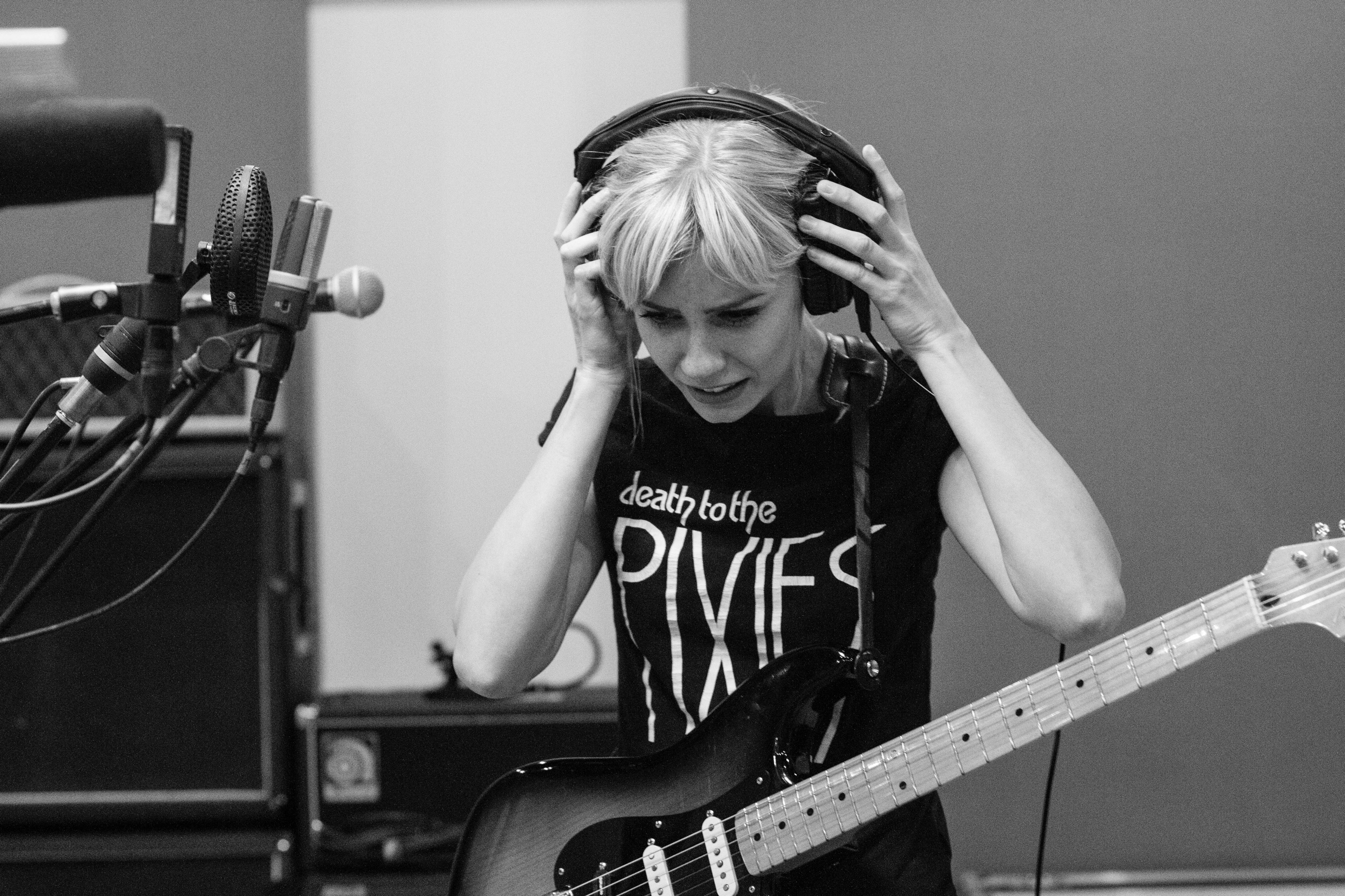
Contributing writer
(freelance)

Application pack

Intro

We’re looking for budding music journalists to write about music, culture and the industry for our website.

Youth Music aims to support young people in the early stages of developing creative careers, therefore we would particularly like to encourage applications from those aged 18-25. You don't need to have taken part in a Youth Music project to get involved.

Contract details: Freelance position, remote

Fee: We pay a flat fee of £90 per article.

Time commitment: Writers will be commissioned to produce a minimum of four articles during their four-month appointment.

Application deadline: 10am Friday 12 March 2021

Start date: 3 May 2021– 31 August 2021

About Youth Music

Youth Music is the UK’s largest young people’s music charity. Equality, diversity and inclusion drive our vision and mission. We want to equalise access to music: we focus on people who miss out because of who they are, where they live, or what they’re going through.

We work with babies through to young adults, harnessing the power of music to support musical, personal, and social development. As a funder, we invest in more than 300 projects each year, reaching around 80,000 young people and over 4,000 people in the workforce.

We campaign alongside young people to drive change in the music industries and education, making it more inclusive, diverse and creative.

For further information about our charity please visit: www.youthmusic.org.uk and for information about our grants programme please visit: www.youthmusic.org.uk/network

Youth Music’s Approach to Recruitment

As part of our commitment to a fair and open recruitment process Youth Music anonymises all applications we receive before shortlisting candidates for interview. As part of the application process candidates are invited to anonymously complete an equal opportunities form, which is used for monitoring purposes only by the HR department, it does not inform selection decisions.

Once a vacancy has closed, the applicant details forms are separated out by the HR team, only the completed application forms are shared with the shortlisting panel. Shortlisting of applications is always carried out by at least two people.

About the role

We’re looking for budding journalists to write at least 1 article a month for our website, on topics including:

- Spotlighting emerging artists and local music scenes where Youth Music funds projects for young people
- Demystifying the music industries through interviews with industry professionals
- Social justice issues impacting the music sector
You will be given briefs to write to by the Digital Content Editor, but you will also have the opportunity to pitch your own article ideas.

Who we’re looking for

You’ll be an avid music fan who stays up to date on the latest music news and trends. You can spot a story and find a unique angle to tell it. You’ll be a highly skilled writer who is confident speaking with a range of people. You don’t need to be an expert on issues facing the music industries, but you’ll be willing to research and learn.

Experience and qualities we’re seeking

Essential

- Excellent content writing, editing and proofing skills
- Ability to put your own voice on a topic
- Confident speaking with and interviewing people of all ages, from various backgrounds and cultures
- Ability to work independently and to write to deadlines
- Passionate about music and music culture
- Basic research and fact checking on a subject
- Knowledge of what Youth Music does
- Highly motivated self-starter
Desirable
- Previous experience writing online e.g. blogs, websites, online magazines
- Knowledge of SEO and CMS’s

What support is given

You will be given regular feedback on your writing as well as proofreading from the Digital Content Editor.

Our offices are currently closed. If we require people to travel to the office in future (to attend training, for example) then expenses would be covered.

Application timeline

Deadline for applications: 10am Friday 12 March 2021

Telephone interviews: Week commencing Monday 22 March 2021

Induction and training: Week commencing 3 May 2021 depending on your availability. Please note that the induction and training activities are compulsory.

Start date: 3 May 2021 – 31 August 2021

How to apply

- Complete our online form: https://youthmusic.org.uk/apply-contributing-writer-freelance-role
- Complete an anonymous equal opportunities form online, that can be accessed at https://survey.alchemer.eu/s3/90317662/6605e1c40c04

Further information

Questions?

If you wish to have an informal chat about the role, please contact Kalisha Patel at creatives@youthmusic.org.uk to schedule a phone call.

Accessibility

If you require any reasonable adjustment to be made to the application or interview procedures for this post, please contact creatives@youthmusic.org.uk or telephone 020 7902 1060 to have a chat.

Please note: if you need any information in a different format, please contact us by emailing creatives@youthmusic.org.uk or by phoning 020 7902 1060. We will be happy to extend the application deadline accordingly if it takes time to accommodate your request.

Diversity and equitability

We are especially welcoming of under-represented groups and are committed to making adjustments that would support you in applying for or carrying out the role.

Data protection

Youth Music will use the information you provide to assess and process your application. If you are contracted for services, your information will be held on our databases and systems. Unsuccessful candidates’ information will be held for six months before being destroyed. We will store your data in line with the General Data Protection Regulations 2018 (GDPR).

