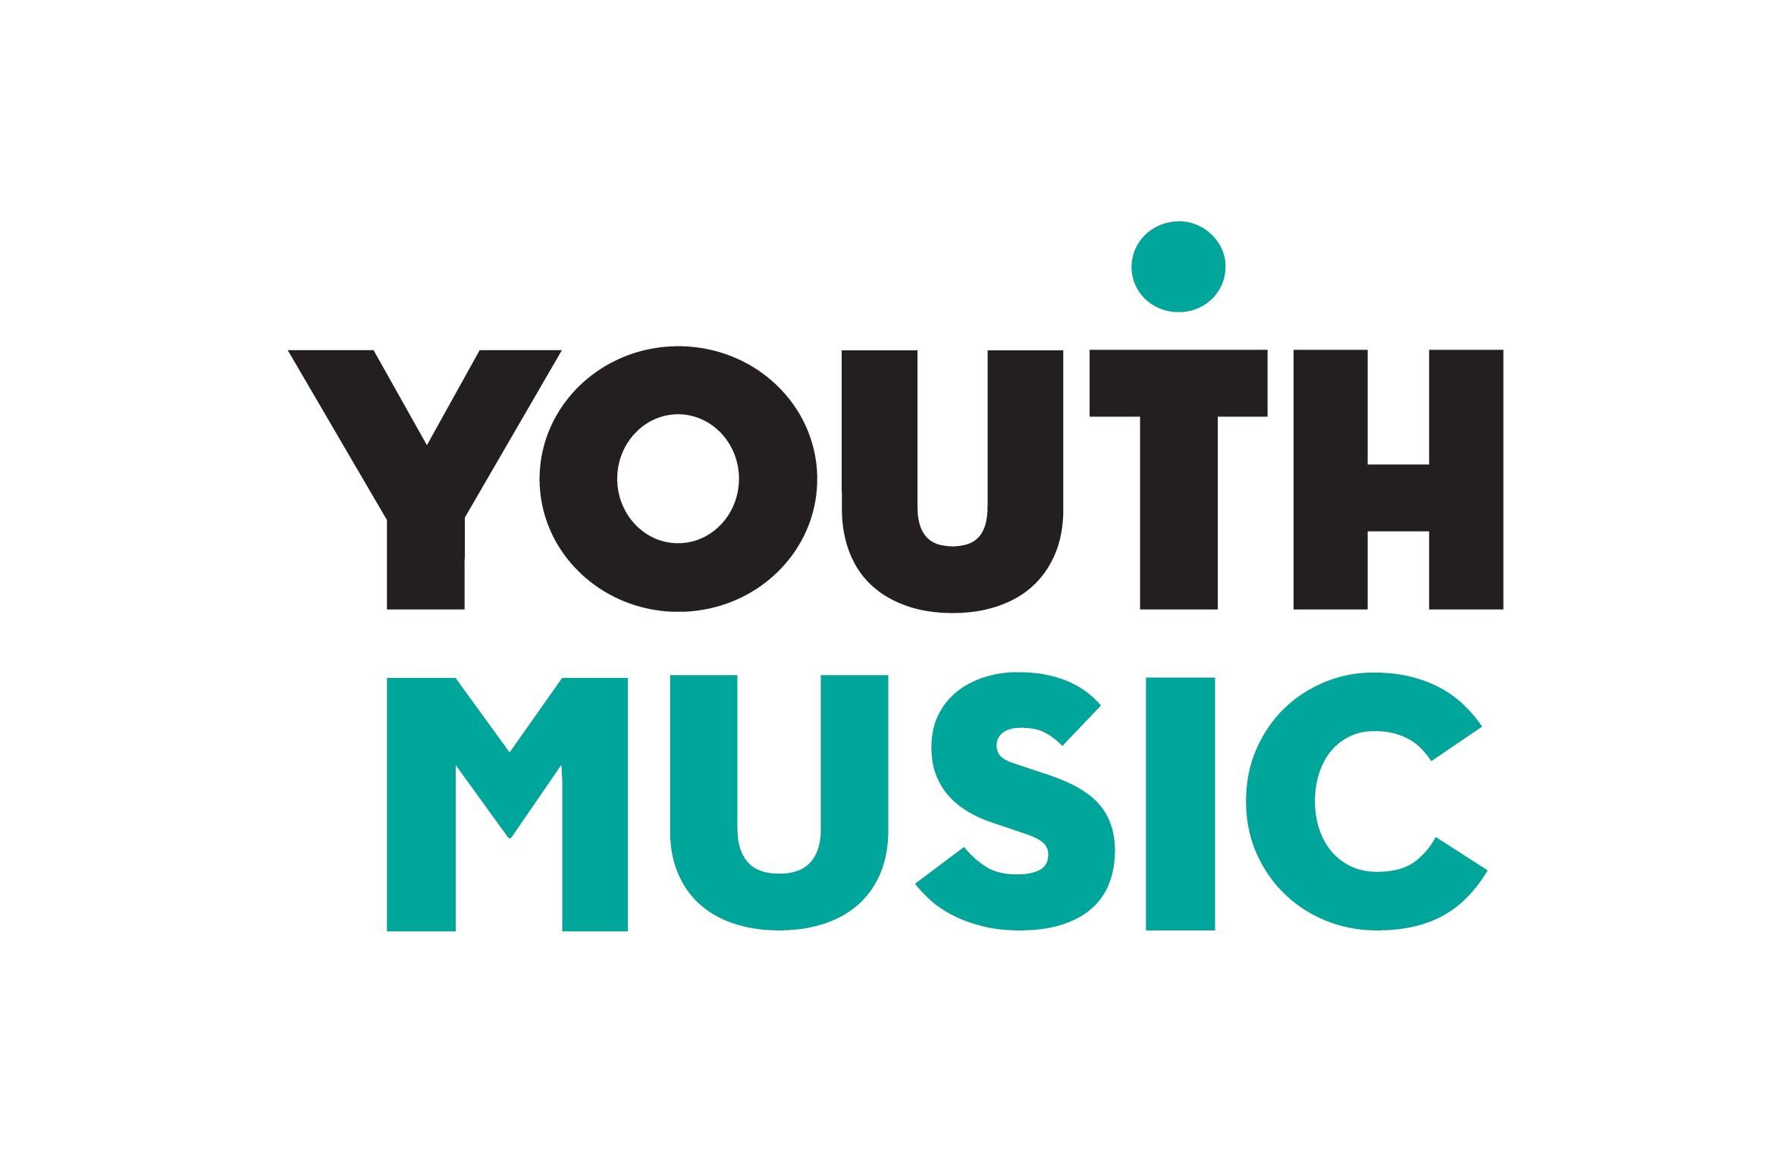

Incubator Fund

Application form template
Round 2, December 2020

This template form is provided for information purposes only. All applications need to be made through our online portal available at https://grants.youthmusic.org.uk/

Application form template

This template form is provided for information purposes only. All applications need to be made through our online portal available at https://grants.youthmusic.org.uk/

Section 1: Organisation and contact details

Details of main contact

Question field | Notes
Forename(s)
Surname
Position
Email address
Telephone number
Second authorised signatory name | This is the person who would countersign the funding agreement and must have been assigned the relevant authority to do so by your organisation or be involved in the programme in some capacity.
Second authorised signatory position
Second authorised signatory email address

Your organisation

Question field | Notes
Organisation name (commonly known as)
Organisation legal name
Are you applying on behalf of a consortium? | If you are applying on behalf of a consortium, you are required to list the other organisations in the consortium.
Are you a sponsor organisation applying on behalf of an informal collective? | If you are applying on behalf of an informal collective, you’ll need to complete the following additional questions and declaration:  Name of collective _________  Collective website (if applicable) ______  Collective social media handles _____  Describe what the collective does (maximum 50 words) _______  Declaration – I understand that if I am successful in this grant application, my organisation is legally responsible for fulfilling the grant requirements and holding the funds. (tick box)
Company address
Telephone number
Website address
Social media handles (all channels that you use)
Organisation type
Charity number if applicable
Company number if applicable
When was your organisation set up? | This should be:  - Sole traders – the date you registered with HMRC.  - Charities – the date of registration with the Charity Commission.  - Limited Companies – the date you incorporated with Companies House.  - Constituted voluntary group / unincorporated association – then the date you signed your constitution.  - Community benefit societies – the date of your registration with the FCA.
Organisation location (local authority area in which you are based)
Where will your project take place? | You will be required to list the local authority areas and/or regions your project will take place in (totalling 100%)
How many staff do you have on payroll (full time equivalent)?
Please describe what your organisation does and who you work with (maximum 50 words)
What was your total income in the last financial year?
Are you regularly funded by Arts Council England, Arts Council Wales or Creative Scotland? | Arts Council England Y/N  Arts Council Wales Y/N  Creative Scot Y/N
Are you currently in receipt of a Youth Music grant? Y / N

Attachments
You are required to upload the following attachments with your application:

- Accounts for the last financial year. This should show both the profit and loss (statement of financial activities) and the balance sheet. If you do not have a full set of accounts yet, then attach a signed income and expenditure/profit and loss summary for your last year of operation, or upload your latest management accounts (as per below).
- Your most up to date management accounts (everyone should upload this, even if you have uploaded your financial statement / audited accounts above). This should show your forthcoming year.
- A recent business account bank statement, in the name of your company.
- Unincorporated associations only (voluntary groups). A copy of your signed and dated constitution.

Section 2: The programme

Project overview | Notes
Please tell us the title of the project you intend to deliver
Please provide a description of the programme you want us to fund (maximum 50 words)
Programme start date | This should be between 31 May 2021 and 2 August 2021.
What is the duration of your programme in months? | Projects should be a minimum of 3 months in duration.
How many 18-25s will you be working with?
A key aim of the Incubator Fund is to support people from underrepresented backgrounds into the music industries. Please tell us about how you intend to do this, your answer should cover:  - Who you are looking for and why  - Your recruitment plans and any referral partners you are working with  - How you’ll make decisions about who is successful.  (Maximum 300 words) | Even if you have an idea of who you want to work with, we’ll expect you to run an open recruitment process and advertise on our opportunities board, to create fair access.
Tell us how many 18-25s you anticipate will be involved in each of the following activities:
- Receiving a grant
- Employed
- Commissioned as a freelancer

Please tick the box if you intend to offer:
- Access to a coach or mentor
- Access to education or training
- Access to workspace
- Access to professional networks
- Access to peer networks
- Conferences, workshops, seminars
- Business development support
- Artist development support
- Support in developing a freelance or 'portfolio' career
- Support accessing funding
- Other
Programme overview (upload)  Provide an overview about the programme in one of the following formats:  - A written document (maximum 2 sides)  - A presentation deck (maximum 8 slides)  - A video (maximum 4 minutes in length via private YouTube link) - see the next question  You can upload .docx .pptx and .pdf files or provide us with a link. | This will be assessed by our panel of 18-25s and should cover following key information:  - Background about your organisation  - Information about the opportunity (including remuneration) and information about what the young people will be doing  - Partners or people involved  - How to apply  - How you will offer support and development  - Anything else you think is relevant.
Timeline  Please give outline of what will happen over the course of the programme, broken down by quarter (or by month if your project is six months or under), please be specific where possible so we can fully understand the scope of your programme. (maximum 400 words)  November June  December July  January August | For example:  Q3 2020/21  - Project Manager appointed – November 2020  - Mentor recruitment – Nov to Dec 2020  - All staff diversity training – Nov 2020  - Advert live – Nov 2020  - Selection of 18-25s – December 2020  Q4 2020/21  - Induction – Jan 2021  - Mentoring begins – February 2020  - Monthly networking events begin - February 2020  Q1 2021/22  - Monthly networking events  - Monthly mentoring sessions  - Creative commission – June 2021
In what ways does COVID-19 affect your programme and how have you planned for this in your proposal? Please include how you would deliver the programme in another full lockdown. (200 words)
What people and/or organisations (“partners”) are you working with to add value to your programme? Outline what they will be doing (maximum 150 words) | This should not include other organisations in your consortium, if applicable, who should be detailed in the first section of the application.
How many partners will you be working with in total?
How will your programme equip those you work with for careers in the music industries? (maximum 150 words)

Section 3: Track record and values

NB: If you are applying as the sponsor organisation on behalf of an informal collective then answer these questions about the collective.

Tell us why you’re seeking a grant for this work and why you are unable to fund it yourself. (maximum 100 words)
Please tell us why you think you are best placed to deliver this work. (This could reference previous similar projects your company has delivered and/or the skills and experience of the staff who will be involved.)

How will your programme contribute to long-term change towards diversity in your own organisation and the wider music industries? (maximum 150 words)

Section 4: Budget – what do you want to spend the grant on?

You’ll be required to download and complete a budget spreadsheet when submitting the application.

Grant budget (please round each item to the nearest whole pound)

Budget for 18-25s
These must be a minimum of 50% of the total you’re requesting from Youth Music
Budget line | What costs does this cover? | Amount £
Payroll |  | N.B. Max £5,000
Commission fees |  | N.B. Max £5,000
Micro grants |  | N.B. Max £1,000
Access costs
Other
Organisational and delivery costs
These should be maximum 50% of the total you’re requesting from Youth Music
Budget line | What costs does this cover? | Amount £
Staffing
Support package
Marketing/promotion
Overheads
Other
Total programme costs (automatically calculated)
Should be a maximum of £30,000 or £15,000 for sole traders
Description |  | Total £
Budget for 18-25s
Organisational and delivery costs
Total

Your contribution

Question field | Notes | Notes
Are you making a cash contribution to the programme? Y / N  (If No, please tell us why this is not possible) | What costs does this cover? | Amount £
Are you or your partners giving you anything in-kind to support this work?  (If No, please tell us why this is not possible) | Nature of in-kind support | Estimated value £
If you are projecting to raise additional income as a result of this work, how will you re-invest some or all of it to support 18-25s? (maximum 150 words).

Kickstarter scheme

The government’s Kickstart Scheme provides funding to employers to create job placements for 18 to 24 year olds on Universal Credit. Jobs must be at least 25 hours per week and run for a total of 6 months. The Government will pay 100% of the National Minimum Wage (depending on age of participant), and associated National Insurance and pension contributions.

If you intend to access Kickstart funding as part of your Incubator Fund project, and your roles meet the eligibility criteria, please provide further information below.

You can use Youth Music's Incubator Fund and Kickstart together - this should be used to top the wage up to the real Living Wage, and you could increase the employment hours from 25hrs a week and/or make the job last longer than 6 months.
Are you applying for Kickstart funding as part of your Incubator Fund project (Y/N)

How many roles are you applying for?
Please list the job titles

YouTube Support
In 2021 the Incubator Fund is being supported by YouTube who will be offering their expertise to successful applicants in the form of masterclasses and mentoring.

The pandemic has forced the creative industries to rethink the way they connect with audiences, and it’s never been more important to understand how to harness digital to operate and grow successfully online.

Please let us know how your organisation has been using YouTube to date, and if there are any areas you are looking to develop or grow that YouTube could help with? This might relate to channel optimisation, content strategy, audience building, livestreaming, monetisation etc, or could be specific to your Incubator Fund project. [150 words]
Please note, this question does not form part of our decision making and will only be used to shape our support offer.

Section 5: Diversity monitoring

Question field | Notes
Are 51 per cent or more of your senior management team and board are made up of people who are/define as:  - Black, Asian or Minority Ethnic; Yes, No, Not specified  - Disabled; Yes, No, Not specified  - Female; Yes, No, Not specified  - Non-binary; Yes, No, Not specified  - LGBTQ; Yes, No, Not specified  - From a working class background; Yes, No, Not specified  - Neurodiverse; Yes, No, Not specified  - Collectively, a mix of the above; Yes, No, Not specified | Read more on why we collect this data.
Do you self-define as having a diverse leadership team based on the background of key strategic decision makers within the organisation?; Yes, No, Not Specified

If you answered yes, please outline why (maximum 25 words) _____

Section 6: Declaration and data protection
Check the box to confirm the following:

1. You (the main contact named in this application form) are authorised to apply for a grant from Youth Music on behalf of your organisation.
2. You understand that if you make any seriously misleading statements (whether deliberate or accidental) at any stage during the application process, or knowingly withhold any information, this could make your application invalid and you could be liable to repay any funds to Youth Music.
3. You have read the eligibility criteria and can confirm that your organisation is eligible to apply to this Youth Music fund.
4. Your organisation has the legal power to set up and deliver the work described in the application form.
5. You understand and accept Youth Music's obligations under the Data Protection and Freedom of Information Acts as set out on the http://network.youthmusic.org.uk/Funding/policy-and-procedures.
6. You will take all necessary and reasonable steps to provide a safe and secure place for anyone who takes part in your programme.
7. You confirm that the activities detailed in your budget are not already covered by other revenue funding.
8. You are aware that Youth Music will use any personal information provided in this application (including the contacts) to consider the application and, if successful, administer and monitor the grant, and in accordance with its ‘Grantholder and Applicant Privacy Notice’ which can be found here: https://network.youthmusic.org.uk/grantholderapplicant-privacy-notice

