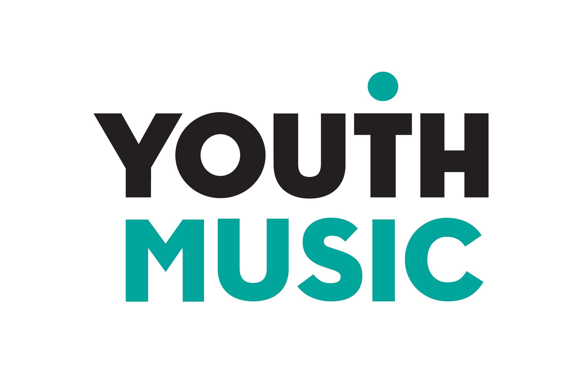

Incubator Fund

Applicant guidance notes
Round 2, December 2020

Contents
1. About Youth Music 3
2. Fund summary 3
3. Overview 3
The research 4
*The music industries 4
The people we want to support 4
Your programme 5
Recruitment and selection 6
Launching soon: Youth Music grants 6
COVID-proofing 6
YouTube 7
4. Eligibility summary 8
We will fund organisations that: 8
We won’t fund: 8
5. Budget guidelines 9
Budget for 18-25s 9
Organisational and delivery costs 9
Your contribution 10
Making profits 10
6. Application process and key dates 10
Questions and support 11
Access support to make an application 11
Access fund - support for Disabled applicants to make an application 11
7. Examples of Incubator Fund programmes 13
Reform Radio - Rhythm Lab Records: Career Starter 13
The Crib x AEI - Desire Paths Creative Development Programme 13
Young Guns Network x AWAL - Artist Marketing Collab 14
Palm Bay Music – Next Level 14
8. Kickstart Scheme 15

About Youth Music
We’re a national charity supporting young people’s lives in music. Equality, diversity and inclusion drive our vision and mission. We want to equalise access to music: we focus on people who miss out because of who they are, where they live, or what they’re going through.

We work with babies through to young adults, harnessing the power of music to support musical, personal and social development. As a funder, we invest in more than 300 projects each year, reaching around 80,000 young people and over 4,000 people in the workforce.

We also work directly with young adults, and with forward-thinking music businesses, to unlock the full potential of next generation talent, imagining new possibilities for the future of the industries.

We are grateful to players of People’s Postcode Lottery and YouTube for making this new fund possible and enabling us to expand our work into Scotland and Wales; we are also grateful for our vital support from the National Lottery via Arts Council England.

Fund summary

Grants of £5,000 to £30,000 are available to businesses, collectives, and not-for-profits working in the music industries*.

The fund is designed to:
- Help open up access to sustainable careers in music for people aged 18-25, particularly those who are underrepresented.
- Support creative employers to innovate and incubate new and diverse talent.

Full details about the fund are available in this document and on the Youth Music website. Applications are made through our online portal available at https://grants.youthmusic.org.uk/

The deadline for Round 1 applications is 5pm on Friday 5 February 2021. You will be notified of the decision on or around Friday 30 April 2021. There will be a third round of funding in Summer 2021.

Existing Youth Music grantholders are eligible to apply to this fund but we ask that you contact us first to discuss your application.

Overview

The focus of the fund is on the mutual benefit gained from bringing fresh thinking, creative and entrepreneurial new talent into your workplace or network, while giving 18-25s the opportunity to deliver their own projects and receive support from your organisation through incubation, training, mentoring and networking.

Companies, collectives, sole traders and not-for-profits in the music industries* across the UK are eligible to apply. We’re particularly interested in micro-businesses (between 1-9 employees) and small-scale enterprises (10-49 employees); or groups of these working together as partners (consortiums). See Section 4 for more information on eligibility.

As we enter a new era for the industries following significant world events – COVID-19 and the Black Lives Matter movement – there is a desire to create a fairer and more diverse system. This fund will help enable the change, providing the opportunity for businesses to harness the energy, creativity and insight of young people for business and creative development.

In order to address issues of underrepresentation in the industries, people from less advantaged backgrounds need to be paid fairly, and they may require extra support to participate. At least 50% of any grant funding must be paid to the 18-25s. The full budget guidelines for this fund are on pages 9 and 10.

The research

In developing this fund, Youth Music spoke to over 100 stakeholders (young people, organisations, funders) and surveyed over 1,300 young adults (aged 18-25) in a wide-ranging series of consultations. The guidance and application form is based on what we heard, and the findings have also informed a research report: A Blueprint for the Future. The research will give you a fuller understanding of the context for this fund and we recommend that you read it in conjunction with this guidance.

*The music industries

We use the term ‘music industries’, not ‘the music industry’ to reflect the full range of large and small companies, not-for-profits, sole traders and collectives who generate employment, revenue and audiences through music. From musicians to their management teams and touring crews, to the craftspeople and coders who make musical instruments and music-making software, to the people who work in PR, distribution and licencing and legal teams, as well as trade bodies, unions and federations, teachers and education providers.

The people we want to support

We want to back dynamic and innovative businesses and not-for-profits within the music industries who can offer genuine work opportunities, led by well-networked people who believe in supporting the next generation and have a genuine desire to open up access to the industries. We’re looking for companies for whom Youth Music investment could seed-fund more permanent ways of supporting talent from diverse backgrounds.

The focus of your support will be 18-25s who are currently under-represented in the music industries: this includes both musicians and those who want to work in wider industry roles.
Several pieces of research have highlighted the increased barriers faced by the following groups (although this is not an exhaustive list):
- Women
- Black, Asian and Minority Ethnic people
- Disabled people
- Those from less advantaged socio-economic backgrounds
- Those located outside major cities – suburban, rural, small towns
- Neurodivergent people
- Trans and non-binary people
- Non-graduates

At least 50% of the grant must go directly to the 18-25s as a wage, commission or bursary. The remainder can pay for costs incurred by the organisation in staff time and other associated costs. This fund is designed to provide positive action to support 18-25s to gain and sustain employment in the music industries, in recognition of the additional barriers they face and in line with Youth Music’s charitable objectives. This is particularly important at this moment in time as 18-25s are likely to be amongst those most negatively affected by forthcoming economic challenges.

Your programme

To make a meaningful impact we want to see programmes that offer sustained and intensive support. Programmes should last for between three and 24 months and do not need to work with high numbers of people. (We expect that the majority of organisations will work with between two and 10 young people.)

Your programme should be co-designed with 18-25s. The activities should cover ALL of the following core strands, which we have devised in collaboration with employers and 18-25s:

- Creative project or brief

A strand whereby 18-25s can plan and execute a real project, developing project management skills and building up a track record and portfolio for future employment. We will prioritise our investment in work that gives people autonomy to make decisions and lead.

The funding can be used to employ, commission or grant money to 18-25s (contracted according to what works best for you and them). You will help to incubate their business and creative ideas. For more inspiration see our project examples at the end of this document or check out case studies of 18-25s transforming the industries through running their own independent projects.

We want to reflect the diverse range of careers in the music industries, including those not focused on becoming a musician or performing artist.

- Career development support

A career development support package delivered by you or through a partner.
The support offer should have an element of flexibility to respond to individual need. We expect your offer to incorporate some or all of the elements in the list below, which is based on the feedback from the consultations and our research:

- Access to skilled mentors and coaches (in particular from people with experience navigating the current industries rather than those who gained their experience at a different time).
- Access to a network and/or opportunity to learn from peers.
- Strengthening regional and suburban networks and provision for music careers (particularly outside of London).
- Support in developing and maintaining a portfolio career or a ‘side hustle’, including:
  - opportunities to generate revenue
  - business skills such as financial management, monetising products and applying for funding.
- Developing communication skills, in particular for networking, business communication, pitching and interviews.
- Developing entrepreneurial skills, a ‘brand’ and a social media presence.
- Sharing knowledge about the different jobs that exist within the music industries and the pathways to get into them.
- Time and space to learn, develop, and create.

- Holistic support

You should consider the emotional, financial and access needs of the people you’ll be working with and account for these in your budget and programme. We believe it is essential to offer holistic support alongside professional development, to help build resilience and to embed good health and wellbeing practices from the start of a person’s career.

As you will want to attract candidates from diverse backgrounds, consider what’s required for them to be part of your programme, and build the costs into the budget. This might involve giving additional funding to support people to participate but it might also be about your own organisational development and ensuring your workplace is welcoming and inclusive for people from different backgrounds. Read more about improving inclusion and diversity in our guidance for music industry organisations.

Recruitment and selection

We’ll expect you to adhere to best-practice recruitment and employment principles in order to attract candidates from diverse backgrounds, and ensure they have a positive experience. We recommend you look at the inclusion and diversity guidance on our website for more information. Even if you have an idea of who you want to work with, we’ll expect you to run an open recruitment process and advertise on our opportunities board, to create fair access. Further advice and support for organisations and 18-25s is available from the Youth Music team.

Launching soon: Youth Music grants
We will soon be launching a new fund where 18-25s can secure funding directly from Youth Music for their creative and professional development. We hope that you will signpost and support 18-25s to access these grants. Watch this space for the forthcoming guidance.

COVID-proofing

While we don’t yet know what the new normal will look like, we do know that business-as-usual is unlikely to return for the music industries anytime soon. When planning your programme, allow for maximum flexibility to enable you to adapt if necessary, and consider the types of jobs and revenue streams that are likely to grow in the future. The team at Youth Music is here to help so please get in touch and we’ll do our best to support you to think this through.

YouTube
In 2021 the Incubator Fund is being supported by YouTube who will be offering their expertise to successful applicants in the form of masterclasses and mentoring.

The pandemic has forced the creative industries to rethink the way they connect with audiences, and it’s never been more important to understand how to harness digital to operate and grow successfully online.

As part of the application process we’ll ask how your project might benefit from this support, and how you have been using YouTube up to this point. This question does not form part of our decision making and will only be used to shape our support offer.

Eligibility summary

We will fund organisations that:

- Are based in the UK and operate in Scotland, England or Wales.
- Have a business bank account.
- Can provide a recent set of financial accounts (if you/the organisation doesn’t yet have a set of accounts, then we’ll accept a spreadsheet that tracks your income and expenditure to date, or your most recent set of management accounts).
- Have a legal status (i.e. registered with Companies House, Charity Commission, FCA or HMRC or have a constitution) – the following are all eligible:
  - Sole traders (please note that the maximum grant size for sole traders is £15,000)
  - Unincorporated associations (voluntary group with a constitution)
  - Registered charity
  - Charitable Incorporated Organisation (CIO)
  - Company limited by guarantee
  - Company limited by share capital**
  - Community Benefit Society
  - Collectives: if you are a collective with no formal legal status (an ‘informal collective’) then another organisation can apply on your behalf (a ‘sponsor organisation’). This can be:
    - a member of your collective who is a registered sole trader (please note that the maximum grant size for sole traders is £15,000)
    - another partner organisation.
If successful, the sponsor organisation or sole trader would be required to enter into the funding agreement with Youth Music. A robust partnership agreement should therefore be in place between the sponsor organisation and the collective.

**Companies limited by share capital
While we will fund profit-making enterprises, we won’t give money to organisations we think should be paying for the proposed project themselves, or who have created an opportunity purely to secure additional income. We will judge this from a combination of factors assessed through the application e.g. scale, profit and loss, balance sheet, annual budget, the nature of the proposal.

We won’t fund:

- Unpaid internships.
- Work where people are paid below the Real Living Wage.
- Activities that promote party political or religious beliefs.
- Costs incurred in making your application or retrospective costs.
- The purchase of land or buildings.
- VAT costs that can be recovered.

5. Budget guidelines

Organisations can apply for between £5,000 and £30,000 under this programme. Sole traders can apply for a maximum of £15,000.

Budget for 18-25s

At least 50% of your project grant should go directly to 18-25s. We expect this portion of the funding to be spent on wages, fees, grants and/or access costs.

Key criteria:
- People must be paid at the rate of the real Living Wage (currently £9.50/hr or £10.85/hr in London).
- The maximum Incubator Fund contribution that can be spent on wages or fees is £5,000 per person.
  - This is not a wage replacement programme; we expect wages or fees to be topped up where possible by the host organisation.
  - Individuals can’t receive payment in both wages and fees. However, they can receive a grant and access costs on top of any wage or fee payments.
  - If eligible, wages can be topped up with funding from the Government’s Kickstart Job Placement Scheme for 18 to 24 year olds. See section 8 of this guidance for more information.
- The maximum that can be given out as a grant is £1,000 per person.
- There is no maximum amount that can be allocated to access costs.

Type of payment | Purpose | Maximum Incubator Fund contribution per person
Wages | Salary costs (the take-home amount) where people are employed on the payroll. | £5,000
Fees | Where people are commissioned as a self-employed contractor, for example to deliver a creative brief. | £5,000
Grants | To support professional development or for someone to deliver their own creative project. | £1,000
Access costs | To enable people to participate in the programme or attend an interview. This might include travel, childcare costs, accommodation, equipment, or living expenses. | No maximum

Organisational and delivery costs

The remainder of the grant (up to a maximum of 50% of the total request) should be spent on the support package and organisational costs required to deliver the programme. This includes:
- Support package to cover career development activities (mentoring, network sessions etc.) and holistic support (to cover wellbeing needs or help the host organisation to be more inclusive).
- Staff and support costs to cover the management of the programme. This can include payroll on-costs such as tax, National Insurance and pension contributions.
  - Note: if you are creating new staff roles such as a Project Manager role to run the programme and will be recruiting someone 18-25 then this can be included in the 18-25s budget section.
- Marketing and promotion to recruit to the programme or market products that are created through it.
- A proportion of overheads such as office space, utilities, finance/admin, equipment, insurance, training etc.

Your contribution

We expect you to make a financial contribution if you can. We will assess this based on the size of business, the turnover, balance sheet and other factors. If you are unable to make a cash contribution, we’d be looking to see how else you could add value to the project through ‘in kind’ support such as providing access to working space, studios, software, networks, people or other non-monetary support.

Making profits

If the activities delivered as part of this programme earn your business a profit, we expect that:
- You will re-invest some or all of the profits in similar programmes, either in your own organisation or by making a donation to Youth Music.
- You will create an ethical contract with the 18-25s you’re incubating that includes clauses on intellectual property. See our guidance for more information.

6. Application process and key dates

1  Application | 2  Decision and funding agreement | 3  Payment | 4  Communication | 5  Reporting
Submit your application by 5pm on Friday 5 February 2021. | We’ll aim to notify you within 12 weeks of your application being submitted. If you’re successful we’ll issue a funding agreement for signing and return. | The payment should clear in your bank account within 5 weeks of Youth Music receiving your signed funding agreement. | You’ll have a dedicated Grants Manager at Youth Music who will check in with you.  We’ll ask you to post the Incubator Fund jobs on our website and then signpost the 18-25s you’re working with to register on our Incubator Fund database. | We’ll ask you to fill in an online report after the grant comes to an end.

Selection process
We contract a group of 18-25s Advisors to help us make decisions on applications. We’ll aim to back a diverse range of programmes from across the country that will make a real difference to the people they’re working with. We’ll be looking for organisations who are genuine about supporting new people into the industries, who share our commitment to diversity and who are driven by values as much as profit.

Questions and support

We’re really keen to support new applicants to this fund, particularly those who are new to making funding applications. We invite you to phone or email Youth Music’s Grants and Learning Team to arrange an informal chat about your plans, to check whether it is a good fit for the programme and answer any initial questions. Please check our FAQs page which will be continually updated with new information.

If you’d like to speak to us, please email grants@youthmusic.org.uk in the first instance to arrange a chat. If you can’t access email, then telephone 020 7902 1060.

Access support to make an application

Youth Music is committed to offering a clear and accessible grant-making process that is open to everyone.

We use an online application system. This system does not currently meet Web Accessibility Guidelines. We know that the system may be inaccessible to some people. It is not optimised for use with accessible technologies such as screenreaders. You can download sample application forms in Word and pdf formats from this page to review in advance.

We are aware that our application may make it difficult for some users to access our funding. We are working hard to remove barriers to make our application processes more accessible. If you have difficulty making an application, please contact us to discuss how we can help. Please email us on grants@youthmusic.org.uk or call 020 7902 1060.

Access fund - support for Disabled applicants to make an application

If you identify as Disabled and require additional support to enable you to make an application to Youth Music, you can apply to our Access Fund. We offer funding of up to £900 to cover any additional access costs that might be required for you to make an application.

How to apply for access funding

There are three ways you can make an application for access funds. Pick whichever option best suits you.

As part of the application we ask you to send us a copy of a recent bank statement, no more than three months old. If your application is approved we will pay the funds directly into this account.

Option A

Complete a short application form on SurveyMonkey and attach a recent current account statement.

Follow this link to go to the access fund application form (Survey Monkey).

Option B

Download the access fund questions in Word and pdf formats from this page, and email your answers to finance@youthmusic.org.uk.

Please remember to attach a copy of a recent current account statement.

Option C

Download the access fund questions in Word and pdf formats from this page, record your answers as a video or voice note and then email the file to finance@youthmusic.org.uk.

Please remember to attach a copy of your organisation’s most recent current account statement.

What happens next

We will get back to you with a decision within 5 working days of receiving your application. We will aim to transfer the payment into your bank account within 2 weeks of approving your application (although we recommend that you allow for 3 weeks in your planning).

Contact us

If you need further support, or if you have any questions, please contact the Grants & Learning Team by emailing grants@youthmusic.org.uk or calling 020 7902 1060.

7. Examples of Incubator Fund programmes

The following programmes were funded in the first round of the Incubator Fund.

Reform Radio - Rhythm Lab Records: Career Starter

Reform Radio is a Manchester-based online community radio station broadcasting the best in music, arts and culture 24/7. They use the radio platform to support local young people into employment through creative workshops and industry-focused training. Their Career Starter programme offers 5 young people the chance to grow and develop Reform’s new independent label Rhythm Lab Records for 6 months. Their programme was designed in consultation with early career artists and informed by Youth Music’s Blueprint for the Future research.

Recruitment is run through referral partners embedded in the Greater Manchester community. Their referral partners help them reach people from a diverse range of demographics. This includes people from less advantaged socio-economic backgrounds; from suburbs; women; transgender and non-binary people; Black, Asian and ethnically diverse artists; disabled and neurodivergent artists. Applicants don’t need to have any prior qualifications. Instead, they need to demonstrate a track record as an independent artist, together with a passion for working within the industry and a commitment to collaboration. Applications can be submitted in written, filmed or audio format.
The 18-25s will be assigned label roles and work together to sign, develop and release tracks from five new artists. They’ll receive support from industry professionals, and supervision from the Music Executive and Project Leader. Trainees will also gain insights into developing their own music, via talks/ tutorials from established artists. They will have full access to employment support (including CV writing, branding, networking, interview skills) and access to in-house mental health support. Any income generated from the tracks will be split 60/40 in favour of the recording artists, in line with Rhythm Lab Records’ ethical policy.

The Crib x AEI - Desire Paths Creative Development Programme

The Crib is a community project in Hackney that aims to support and empower local young people. AEI Group manages several high-profile electronic music brands and events such as UKF and DnB Arena as well as running new creative workspace ‘The Halley’ in East London.
The Crib and AEI are collaborating to create the Desire Paths Creative Development Programme which aims to support five local young, emerging creative practitioners to get into and progress in the music and creative industries. Hosted at The Halley, participants will be supported in developing their individual portfolios, as well as devising and producing new work delivering to creative briefs set by AEI. Participants will get all round experience of what it takes to manage artists, labels, brands and events.
The programme is specifically targeted at those who are unemployed and facing barriers to gaining employment in the creative industries. The programme lasts for six months and pays each creative practitioner £10.75 an hour for 25 hours a week. To top up wage payments beyond the Incubator Fund contribution, they have applied for additional support from the government's Kickstart Scheme. Participants will be supported by mentors and work with Clock Your Skills to accredit their portfolio and professional development. Additional support includes access to counselling, workshops and masterclasses, and 24 hours of one-to-one mentoring.

Young Guns Network x AWAL - Artist Marketing Collab

Young Guns Network (YGN) was created to offer a diverse, accessible and updated professional networking experience, focused on the 18-30 age group to provide them with inspiration, insight and opportunities. The network is made up of entrepreneurs, executives, artists and ambitious young people working in music. Those who join are seeking access to the latest information and opportunities from music industry brands, organisations and employers.
The Artist Marketing Collab was born in response to 43% of YGN members wanting jobs in marketing, media, labels and/or distribution. The programme is provides an opportunity for five young people from anywhere in the UK. Once recruited, YGN matches young people up with an artist and other music professionals, which will help them build skills, portfolio of experience and contacts. They will develop a real marketing and promotion campaign for an independent artist and to learn how to develop artists with support from the marketing team at AWAL (AWAL stands for A World Artists Love and the organisation supports independent artists with funding, creative support, synch and licencing, and digital and physical distribution). Other partners include Small Green Shoots, The Cat’s Mother and Giant Artist Management. Advice is also available from experts in PR, Radio and TV promotion.
Participants are paid a freelance fee and can work flexibly. They can access additional support for computer software, data or travel costs and have a small budget to spend.

In addition to the core programme, YGN will be running free monthly online events, benefiting up to 600 young people in total. They intend that the outcomes from this programme will help young people to either launch their own freelance promotions business, win freelance contracts and overall be better positioned to gain employment.

Palm Bay Music – Next Level

Palm Bay Music is a female-led boutique Record Label, Music Publishing and Production Company based in Ramsgate. They believe in a transparent, fair, and diverse future where creatives are valued, well paid, inspired and empowered. They aim to nurture and financially support creatives to thrive, not just survive. They understand the difficulties of navigating the music industry if you belong to a minority group, and believe that introducing fresh thinking new talent to their business will have an invaluable impact on their own growth as a company.

‘Next Level’ aims to nurture and elevate underrepresented young people to become the UK’s music leaders of tomorrow. 16 young people will lead on all aspects of the project to give them experience to secure future employment. Four song-writing camps will be planned and run by four young project managers covering A&R, artist liaison and administration. The camps will be accessed by young artists, writers, and producers, who are paid a fee plus expenses to attend the week-long intensive programme.

The song-writing camps give creatives the space to create at the same time as networking and receiving mentoring from established industry professionals. All the songs created will be pitched to industry professionals (music publishers, labels and managers) for feedback, Q&A and potential paid placements in film, games, tv and other future opportunities. They will be signed to Palm Bay’s publishing company on a fair, writer-friendly short-term deal.

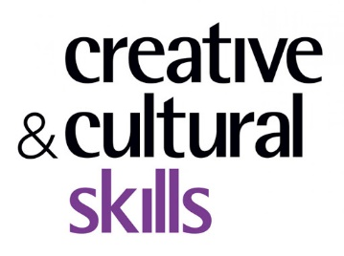

8. Kickstart Scheme

The Kickstart Scheme provides funding to employers to create job placements for 18 to 24 year olds on Universal Credit at risk of long term unemployment.
The funding will cover 100% of the National Minimum Wage (related to an employee’s age), and associated National Insurance and pension contributions. Employers will also be able to top up the wage (e.g. to the real Living Wage) if they wish.
To be eligible for funding all jobs created must be at least 25 hours per week and last for at least 6 months. Employees must be recruited through Jobcentre Plus.

To access this funding directly from the government, employers need to create at least 30 job placements. If you want to create less than 30 jobs you can access the funding a ‘Gateway’. This is an organisation who has successfully applied to funding and can act as a broker to employers creating 29 jobs or less.
Youth Music is working in partnership with Creative & Cultural Skills who are acting as a Kickstart ‘Gateway’ exclusively for the creative industries.
If your Incubator Fund roles meet the Kickstart eligibility criteria and you would like to access funding through Creative & Cultural Skills, you can inform us as part of your application. We will collect the details of the roles and pass them onto Creative & Cultural Skills to assess suitability.

The success of your Incubator Fund application will not guarantee access to Kickstart funding, as they are separate applications. So, if your Incubator Fund application is unsuccessful you can still apply to Creative & Cultural Skills for the Kickstart funding.

Supported by

Players of
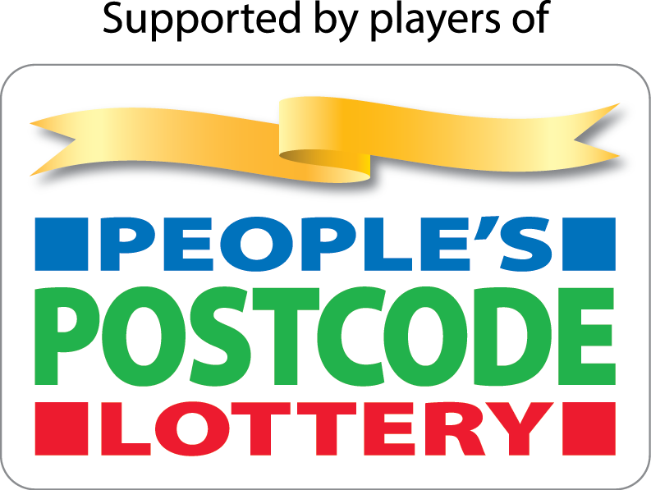

The National Foundation for Youth Music
Studios 3-5, Swan Court, 9 Tanner Street, London, SE1 3LE
Registered charity number: 1075032
Limited company number: 03750674

youthmusic.org.uk

