A Blueprint for the Future:
a new generation ready to transform the music industries.

Foreword by Matt Griffiths
For the past two decades Youth Music has worked tirelessly to equalise access to music for over three million young people across the UK. We’ve invested significantly in the national music education infrastructure, and used our influence to encourage greater diversity and inclusion in music making.
Alongside our partners we’ve committed to supporting the talent pipeline nurturing the energy, skills, and entrepreneurialism of the next generation. We love seeing this passion translate into determined ambitions to forge music industry careers. But time and again we’ve seen talent stifled and aspirations cut short by significant barriers.
We began this research in early 2020, aiming to better understand and explore the varied experiences of those trying to build a sustainable career in music. Who is succeeding and who isn’t? How and why? What is education and industry doing about it? How are young people managing to navigate their way around barriers? What can we learn from them, and how can we bring about more systemic change?
This report outlines – with evidence – the very real barriers preventing many young people today not only from getting a foot in the door of music industry jobs, but also crucially, from gaining meaningful experiences and staying employed. It showcases in stark terms why our industries are so lacking in diversity, and the many ways in which the professional talent development pipeline is not fit for purpose and urgently needs to evolve.
However, it also shines a light on the numerous and creative ways that these same young professionals, struggling to get in and get on, are working with peers to forge their own paths outside the system. Identifying gaps in the market and doing it for themselves. Closer to their clients and audiences, unafraid to try new things, unjaded, passionate and not stuck in old ways, they are building a fairer system from the bottom up. Yet too often this drive and creative entrepreneurialism is forced to operate in ad-hoc and siloed channels. There is a huge creative and commercial opportunity for our industries to better cultivate this talent and learn from these practices - particularly in times when fresh thinking is needed more than ever.
This report was written during transformational world events. COVID-19 and the re-energising of the Black Lives Matter movement have laid bare stark realities and entrenched inequalities across our societies. The uneven distribution of wealth and power is more glaringly obvious and less sustainable than ever before. Important and overdue conversations are taking place. Business models and hierarchies in all industries and companies are under scrutiny.
This seminal moment presents us with a real opportunity not only to reflect but to act. The music ecosystem is tilting on its axis in this period of economic transition and its future is up for grabs. It’s widely acknowledged across the sector that the current model is broken and there’s a deep desire for transformation. Music has always been a force for inclusion and revolution, helping us imagine a better future. By working together, individually and collectively, we can create the change that’s being loudly called for.
That’s why, alongside this report, we are launching a new £2 million new Incubator Fund*, designed to help music industry organisations - particularly micro-businesses and SMEs - to harness the skills and creativity of diverse young talent. We are inviting the industries to work with us in partnership to build a new and better sector as we emerge from the current turmoil.
We’re offering a blueprint for the future, one based on real-life examples and lived experience. Our Incubator Fund will enable an entrepreneurial generation to bring their ideas into the sector to help create new models, norms and practices. We can offer guidance, brokerage, and resources. Young people can offer skills, insights, passion and enthusiasm. We’re ready to connect you and explore the ways we can all collaborate.
But to achieve systematic change, we need the wider UK music industries to join us. Committing to action, re-positioning, and building back better to create a more ethical, values-driven model that works to promote a healthier, more diverse and more sustainable ecosystem.
So this is a call-to-action - to all those working in the music industries - to step up, to commit to making real change, and to listen to, learn from and collaborate with the next generation.

*This funding has been made possible thanks to players of People’s Postcode Lottery. We’re also hugely grateful for the support we receive from National Lottery via Arts Council England and from other donors and partners.

Methodology
In partnership with youth marketing agency Livity, we surveyed 1,300 young adults looking to start careers in music (aged 18-25) from across England, Scotland and Wales, ensuring we heard from those from a range of locations, genders, ethnicities and social groups.
We carried out a week-long digital immersion into the lives of 10 young people nationwide, and held a series of qualitative online workshops with 13 additional young people: 10 of whom were aspiring towards particular careers in the sector, and three who have already successfully broken into the music industries.
The survey was carried out before the COVID-19 measures were announced, and the digital immersion and workshops were carried out during the early weeks of lockdown.
The work was supported by two young researchers - Pippo Khalwa, 25 and Nate Agbetu, 24 - who led the discussions, explored existing music industry insights, and analysed the quantitative and qualitative research data.
Throughout the report Black, Asian, Mixed and Minority Ethnic ethnicities have been grouped together as BAME due to sample sizes, though we recognise that individual experiences vary, and that this term is imperfect. Likewise, social grade has been grouped into ABC1 (higher income) and C2DE (lower income) groups due to sample sizes. Sufficient samples were collected for gender (male and female) although the sample size for non-binary people was too small to be significant.
It was not possible within the scope of this research to reach sufficient samples of disabled young people, although it is recognised that this is a key area of consideration when thinking about the music industries. Research looking specifically at access for disabled musicians is currently being undertaken by Youth Music.

A note on the ‘music industries’
Throughout this report we use the term ‘music industries’ not ‘the music industry’ to highlight the diverse ecosystem which generates employment, revenue and audiences through music.
It’s made up of large and small companies, charities, sole traders and collectives who deliver a wide range of functions. From musicians and their management teams to the craftspeople and coders who make musical instruments and music making software; the people who work in PR, distribution and licencing and legal teams; as well as trade bodies, unions and federations, teachers and education providers.
The success and sustainability of this ecosystem relies on each component’s ability to thrive and work symbiotically. Those that benefit from the health of the overall ecosystem should in turn support and nurture it, ensuring it does not become imbalanced.

The new generation
Throughout Blueprint for the Future you’ll get to meet a number of music-obsessed, hardworking, enthusiastic entrepreneurs and future leaders, and to hear about their projects.
They’ve entered adulthood under austerity, in a tense political era, and COVID-19 has only added to a climate of uncertainty. But the circumstances of their upbringings make them entrepreneurially-minded, capable of developing innovative ideas on shoestring budgets. They’re passionate, learning through trial and error, adapting and building new audiences on new platforms.
However, this ability to pursue DIY and portfolio-career pathways can have a short shelf-life for those requiring financial stability and security. Many start brightly but have to drop out due to low pay, lack of opportunities, or the impact of tough working conditions on mental health. The loss of this young talent, energy and fresh thinking is a huge own-goal for the music industries.

Introducing some of the interviewees
Mei-Li, 21, London - Aspiring songwriter and performer
“There are not enough opportunities provided for young people in the music industry: it is vital that we encourage their pursuits, especially as many turn to music as a form of escapism. It would make a world of difference in many young lives.”
Clair, 22, Gloucestershire - aspiring guitar teacher
“I don’t really like thinking about not having a career in music as that’s where I want to be.”
Caitlin, 23, Glasgow - aspiring music journalist
“There should be mental health support due to the competitive and pressurising nature of the industry.”
Courtney, 19, Luton - aspiring songwriter
“There are opportunities out there, including funding projects and companies willing to aid young musicians, but I didn’t know about that until doing quite deep research. How are we making sure everyone knows and has access to this?”
Jess, 24, London - DJ and radio producer
“You’ll be surprised at the beauty of DIY-ing and before you know it, the people you wanted validation from are gonna be coming to you for your opinions and ideas.”
Chirag, 24, Crawley - Aspiring data analyst
“I feel that a platform is yet to be developed with opportunities to learn, develop and understand the nuances of working in the music industry.”
Curtis, 24, Devon - aspiring TV plugger
“Young people bring untapped enthusiasm and energy to the workplace, both of which are invaluable resources to employers and, in turn, foster healthy competition within the industry.”
Mushfik, 20, Newcastle - aspiring DJ and music producer
“I know I can go to [friends] and see how they’re doing and not just learn from them but also build connections through them.”
Louis, 22, Hendy, Wales - aspiring events and music producer
“Working together brings more ideas to the table.”
Fred, 18, Edinburgh - aspiring music journalist
“Ideally, a mentor would be experienced enough (maybe 5 or 6 years professionally working in the industry) to guide someone, but not so old as to have entered in the industry when it was radically different.”

SECTION 1 - Closing the loop
Youth Music’s previous research Sound of the Next Generation (with Ipsos Mori) explored young people aged 7-17’s relationship to music and found it was their favourite interest, equal to gaming. In 2020, this passion for music was still very much alive in the 18-25-year-olds we spoke to: the most frequently-selected motivation (49%) behind respondents’ choice to pursue a career in music.
“I'd be heartbroken if I couldn't get a career in music because that’s all I’ve wanted to do. It's my passion.” - Jerome, 25, Manchester
The UK has a well-established music education sector, both in and outside schools, colleges and universities. Despite concerns about funding cuts and the de-prioritisation of creativity in the curriculum, it continues to successfully support vast numbers of young people to make music. But what if someone wants to build this passion for music into a career?
With five times as many 17- and 18-year-olds wanting to work in art, culture, entertainment and sport as there are jobs available compared with the projected demand in the economy, it’s vital the music industries pull together to channel this passion effectively.

Disconnected ecosystem
“I’ve always found the idea of knowing where to start quite overwhelming. I feel the stigma that surrounds the industry and paints it as a dream rather than a reality has prevented this structure and support for other careers. In an industry that is so competitive, more support and structure is needed.” - Courtney, 19, Luton - aspiring singer and songwriter
CMU’s Pathways Into Music report explores music education’s relationship to the music industry, stating that “while there are programmes and organisations that do regularly bring industry and education together, most people would agree that - day-to-day - these two linked sectors operate pretty autonomously from each other.”
Pre-pandemic, the commercial music industries in the UK were undergoing a period of growth, from £4.5 billion in 2018 to £5.2 billion in 2019. The rapid evolution of the industries has led the creation of a wide range of new roles which didn’t exist two decades ago. But many school leavers with an interest in working in music (as well as those some of those educating them) don’t necessarily know what these jobs are, let alone how to get into them.
“There is a lack of information available in the schools and HE system about how big the UK music industry is and the diversity of job roles within it. These institutions would benefit hugely from industry professionals coming to talk to staff and students.” Becky Ayres, MD, Sound City, Liverpool
These issues are endemic across the creative industries, with 84% of employers agreeing that young people are unaware of the breadth of career paths available in the sector. This is unsurprising when 62% of all students say they don’t receive adequate information about creative careers at school. Lacking the necessary guidance from parents and teachers, young people are now turning elsewhere, with a quarter of 13-16-year olds trying to contact celebrity role models on social media for career advice.

Oversupply of performer-creator pathways produces skills gap
The 18-25-year-olds we spoke to were twice as likely to be aspiring music creators or performing artists than any other role. When asked to envisage their long-term career in the music industry, most young adults saw themselves primarily creating music (33%).
“I need to love what I’m doing and when it comes to writing music I can do that endlessly and I love the challenge.” - Courtney, 19, Luton

Figure 1: What roles are you most interested in pursuing in the music industry?
Artist/performer | 574 | 44.1%
Music PR/marketing | 274 | 21.1%
Music teacher | 268 | 20.6%
Session musician or musician for hire (weddings, parties etc.) | 260 | 20.0%
Live events coordination and promotion | 257 | 19.8%
Music journalist | 250 | 19.2%
Sound engineer | 204 | 15.7%
Sync/production for film and adverts | 192 | 14.8%
Charity sector e.g. delivering music programmes | 178 | 13.7%
There is no role in particular I am most interested in | 33 | 2.5%
Other | 9 | 0.7%

It’s completely natural to want to turn what you love into a career, and performers are often the main people in the music industries visible to young people. But an Education and Employers report highlights, we need to have an honest conversation about the disconnect between the number of jobs available and the financial viability of these careers. The current system risks creating disappointment and wasted energy which will take significant effort to resolve.
“The demand for art and the supply for art are very imbalanced.” - Fred, 18, Edinburgh
A feedback loop has emerged where the supply of performer and creator-focused pathways proliferates based on demand.
“I see a lot of programmes for musicians but not for everyone else.” - Laurine, 20, London - aspiring music marketer
This is a huge missed opportunity when there are so many alternative career options that young people don’t know about and employers that are struggling to fill these roles. There needs to be much greater visibility of these off stage roles and a more diverse set of role-models in them.
“Before I got into a record label, I didn’t know how anything worked… even though I did a business management degree specialising in music, going into the label I was like ‘how have I not learnt anything?’” - Brooke, press assistant, major label

A widening void
Those we spoke to were finding out the hard way how their educational experiences had fallen short, and this was impacting their ability to navigate and succeed in the wider music industries. A report led by NESTA calls for future creative industry workers to be equipped with a fusion of creative, design, tech and entrepreneurial skills alongside transferable ‘skills for life’ (such as problem solving, interpersonal skills, agility, resilience and ability to relearn and adapt for change).
This call to ‘bridge the gap’ is not new but these flaws need addressing with new urgency for a post Covid-19 world. A co-ordinated and concerted effort from educators and employers is required to ensure we’re working in sync to equip the next generation with the skills needed for our future industries.

Music and talent development charities are papering over the cracks, but could do so much more
“Knowing how to break through is so tough. I know music, I know performing so that’s what I do, anything else, I wouldn’t know where to begin.” - Jerome, 25, Manchester
At Youth Music, we’re well aware of the consequences of this disconnection. [SA7] Through funding and supporting community charities, arts organisations and music development agencies, we do all we can to help people through these difficult points of transition, to address their experience or skills gaps and ensure those from all backgrounds get opportunities to pursue a music career.
“Working with young people is consistently inspiring and the amount of talent we see is staggering.” Kirsten Cree, MAP Charity, Leeds
The UK is home to some incredible organisations developing young talent, with highly skilled workforces. The best of them support and empower 18-25s, enabling them to create their own opportunities in music to gain relevant experience and knowledge. They then link them into paid work through relevant industry partnerships and within their organisations.
One of the biggest recent success stories is Reprezent Radio in South London. Facing closure in 2015, it has received sustained funding from Youth Music for the past five years. Reprezent’s model of youth-led radio has trained a cohort of DJs, producers and engineers now working at BBC Radio 1, 1xtra, Beats and Global, and even starting their own specialist radio stations like No Signal.
But the access to this kind of provision is patchy, and mainly concentrated in major cities. Youth Music’s (and others in the third sector’s) resources are limited. With arts and youth funding decreasing, we’re increasingly reliant on lottery players and ad-hoc donations to ensure the future talent pool is diverse and skilled. This imbalance in public and private funding needs to be addressed. There’s an opportunity to do so much more with greater support from the industries we’re investing in.
“Our mix of grant funding and brand partnerships is so fragile. To really support the grassroots we need bigger industry players to go beyond ad-hoc initiatives, invest funding more sustainably and work more proactively with us. When we have sustained funding over time the impact we can have is immense, both for the individuals and the industry.” - Adrian Newman, Station Manager, Reprezent
This two-way support isn’t just about funding. We’re calling for people power and brand power too. The issues we’ve presented are not insurmountable if we work together and play to our respective strengths. The future talent of our industries isn’t someone else’s problem to solve.
“Who are the people investing in the artists and workforce you might work with tomorrow? We set up Future Bubblers to be active in developing those people, especially from outside of London, and not just wait for them to fall into our lap.” - Amy Frenchum, Project Manager, Future Bubblers, Brownswood Recordings
With the music industries facing their biggest-ever crisis we urgently need to build a more sustainable and connected ecosystem. We’re calling for everyone involved - major players, independents, and education organisations - to more proactively inhabit each other’s worlds for the good of our future workforce.

Questions to ask ourselves
- The music industries are changing rapidly: who is upskilling our future workforce and are they equipping them with the skills we need?
- How can we increase collaboration within the ecosystem?
- What was your journey into the industry? How are others learning from this?

Case study: Jemma Tanswell, Reform Radio, Manchester

SECTION 2 - Who makes it through the bottleneck?
With an oversupply of people attempting to enter a limited number of roles in the music industries - both on and off stage - a bottleneck emerges in the pipeline around entry-level opportunities. This presents both barriers and opportunities for emerging talent and the industries.

Who is building a music career in music and how?

48% of our sample was already earning money from music. Over a third were earning through performing, and between 20-25% were earning from either composition, sessions, recording, teaching and/or non-music content creation.

Figure 2: How do you currently earn money from music?*
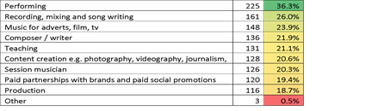
*These results were from January 2020 (pre-COVID-19 lockdown).
Earning from music correlated with career preference. The most popular role people want to pursue was Artist / Performer at 44.1% - more than double the popularity of the second most frequent choice: Music PR / marketing at 21%. 39% of respondents only had one role in mind but most (61%) would consider a variety of roles in the industries.

Adopting a portfolio approach is typical for musicians
One of the most viable career options for aspiring young musicians is to develop a ‘portfolio career’ – earning money from a number of different music-related roles: for example a mix of performing, running events, composing and teaching.

Indeed we found 60% of those earning money were doing so from more than one music-related role, with the number of roles increasing with age. However, less than a fifth of those surveyed were actually motivated to work in the music industries by the idea of having a portfolio career - only 17% of our total sample, and 17% of those already earning.

While some of this may be because those under the age of 25 may not identify with the term ‘portfolio career’ (the term was explained in the survey), the realities of the gig economy mean that for many this approach is likely to be born out of necessity not choice. And while this can work for those looking for independence and flexibility, it’s an incredibly tough pathway with high levels of competition for scarce work, limited earnings and precarious freelance employment.
“Freelancing is hard. But if I get a job - say in retail - it’s just going to hinder me from doing what I want to do.” - Seshie, Founder I AM NEXT

“I looked for funding but everything was for musicians… it’s crazy because I feel a lot of people are in my position, young freelancers.” - Laurine, 20, London - aspiring music marketer

Our qualitative research also indicated minimal understanding of the widespread nature of portfolio careers and freelancing in the arts, with most imagining themselves in one, well earning, role. This further emphasises the urgent need for better guidance at an earlier age, enabling people to make more informed choices.
A recent industry survey found that only a small percentage of people entering the music industries are able to earn sufficiently. 64% of musicians and 70% of industry professionals stated the top reason it is hard for them to pursue a career in the music industry was “insufficient earnings”. Our respondents were very aware of the challenges in pursuing a music career and were not expecting overnight success or vast riches. But they also recognised that a career in the music industries was much more viable for those from more socio-economically advantaged groups.

“If I had to support anyone else other than myself I just wouldn’t be able to do it at all.” - Curtis, 24, Devon, aspiring TV plugger

“That’s why I’m doing a degree in something else, so I can use my degree to help fund what I want to do” - Sarah, 19, England, aspiring composer

Nearly 1 in every 3 of the young people we spoke to (31%) were already considering careers in other industries such as finance, healthcare, HR and construction. It’s not uncommon for those aspiring to competitive careers to have a plan B, but it’s surely a sign of a broken system when aspiring composers are actively paying to study non-music subjects to earn enough to support a future music career.

Case study: Becca James, musician, Newcastle

‘Making it’ depends heavily on who you are and where you live
“It’s a long process of trial and error – emerging artists should expect it to take 7-10 years [to earn a living from music]. The ones who make it are often the most well networked and have had significant support from others.” - Amelia Ideh, artist development mentor and consultant
With pathways into the industry being perceived as opaque by many, the young people we spoke to had applied themselves in numerous directions to find a route in – and found no universal recipe for success. As large numbers of aspiring musicians and industry professionals compete for the limited roles available, we saw patterns, familiar to the industry, in who is and who isn’t making it through the bottleneck.

Figure 3: Pathways to earning through music

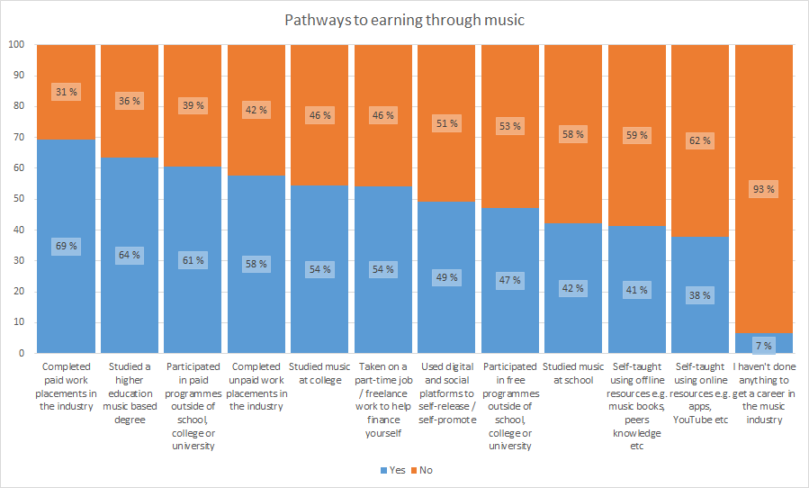

Strong social networks and connections, high levels of industry knowledge and practical experience are needed just to secure the lowest paying jobs. In that light, it is not surprising the UK government found 92% of jobs in the creative industries were done by people from advantaged socio-economic groups, compared to 66% in the wider UK economy.
Who you know, and whether a portfolio career or a long series of unpaid internships is financially viable for you, still seems to heavily dictate how likely you are to ‘make it’ into the music industries. Our findings show that this problem is then compounded by social, economic and geographic issues.

Figure 4: What do you think are the biggest barriers preventing you from successfully pursuing and sustaining a career in the music industry, if anything?
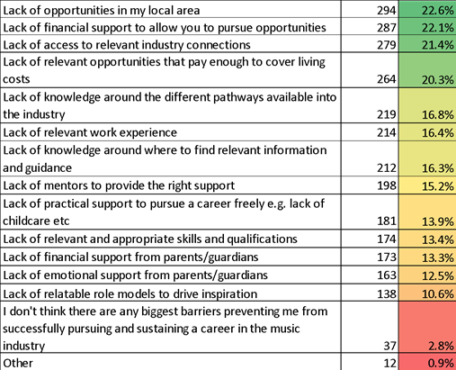

Social class is the biggest barrier
Social class was found above all else to influence young people’s chances of earning money through music. Those from lower income backgrounds were significantly less likely to be earning money through music than those from higher income backgrounds (figure 5). This disparity held even if they had both studied music at school, college or university. Comparisons between earners from lower and higher income backgrounds also revealed gaps between those who had completed both unpaid and unpaid work placements (figure 6).

Figure 5: Proportion currently earning through music
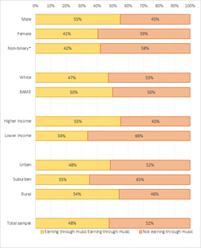
*Small base (n=31 ~ 2% of sample)

Figure 6: Currently earning through music - Higher vs lower income
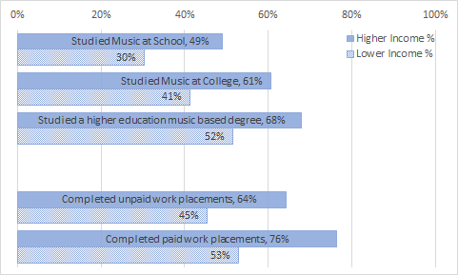

These discrepancies allude to barriers beyond education and experience. A lack of access to relevant industry connections was the third most significant barrier young adults identified as stopping them from breaking into the music industries (21.4%) regardless of social background.
This ‘who you know’ barrier is experienced even more acutely by those from lower income backgrounds who are nearly half as likely to access networking opportunities (10% vs 18%) and less likely to access mentoring (11% vs 17%).
“You need to know people in certain fields even to just see if there’s anything going.” - Jess Ajose, DJ and radio producer
We mapped out a range of the support young people had already accessed, and what they wanted access to (figure 7). Across the board access was low, but the gaps were particularly evident between those from lower and higher income backgrounds. Those from lower income backgrounds were less likely to have access to any type of support than those from higher income backgrounds, and more likely to want support.

Those from lower income groups were more than twice as likely to be unaware of funding schemes to support them (17%) than their higher income counterparts (7%). Beyond this, they were nearly twice as likely to report they haven’t had access to anything to help them achieve a career in the music industry than those from higher income backgrounds (14% v 8%).

Figure 7: Access to career support by income
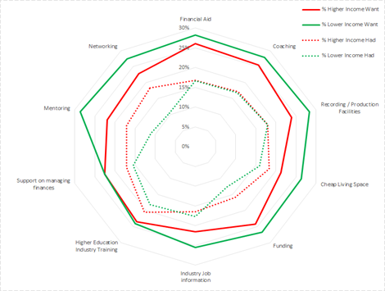

The gender gap is still stark
The gender gap in music has been well documented in recent years, and our research found the gap has not closed. Women were less likely to be currently earning than men (41% vs 55% - figure 5). Social class was also a huge determinant when analysing which women are earning from music. Those from lower income backgrounds were markedly less likely to be earning from music than men, and although women from higher income backgrounds fared better, they were still significantly less likely to be earning than their male counterparts (figure 8).

Figure 8: Earning through music by ethnicity, gender and income background
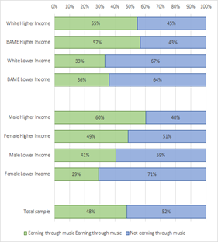
This held true regardless of what qualifications women held, either music or non-music related.

Figure 9: Proportion currently earning through music vs highest qualification held
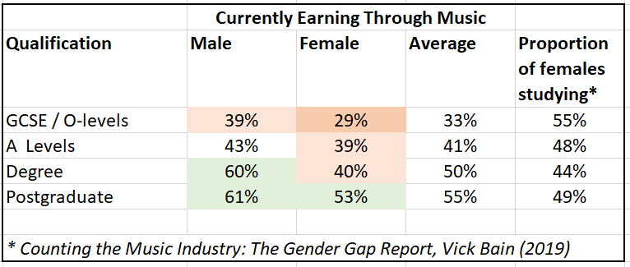

While we found women with A-Level qualifications are almost as likely to be earning through music as men, the divide grows significantly at degree level, with 60% of male graduates compared to only 40% of female graduates. Women with degrees are only one percentage point more likely to earn than those with A-Levels (figure 9). Even when women have studied music-specific qualifications they remain less likely to be earning than men holding the same level of music qualifications (figure 10).

Figure 10: Currently earning through music - Gender
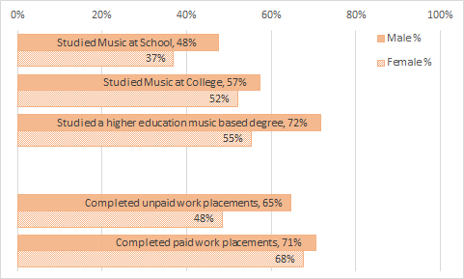
Gendered perceptions of roles within the industry could still be seen to persist in some areas, with men being nearly twice as likely as women to want to become a sound engineer (20% vs 11%).
Women were less likely to have completed unpaid work placements. They were more than twice as likely than men (13% vs 6%) to say they hadn’t had access to any support in order to help them achieve a career in the music industries.

Case study: Imogen Storey, Esche Haus Audio, Blackburn

Ethnicity reflects trends in social class
BAME respondents were recorded as being marginally more likely to be earning from music than white respondents (figure 5) and there were negligible differences between different ethnicities. The biggest distinction was between higher income and lower income people from BAME backgrounds, meaning social class remained the most consistent indicator as to whether people were earning money from music (figure 8).
BAME respondents were marginally less likely to have been earning through multiple roles (65% vs 62%). While the sample size was small, there was an indication that Black young people were more likely to be earning from multiple roles (n=45) than those from Asian or mixed ethnicity backgrounds (71% vs 61% vs 45%).
Barriers to gaining experience were found to be higher for those from BAME backgrounds, with less access to unpaid internships than those from white backgrounds (12% vs 19%). However, BAME respondents from higher income backgrounds were the most likely to be accessing higher education qualifications and courses in subjects related to music-industry day jobs (figure 11).

Figure 11: Proportion of respondents accessing higher education training in subjects related to music industry day-jobs (i.e. marketing, journalism, IT or similar)
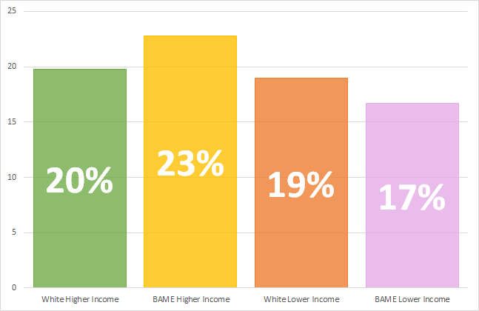

BAME respondents were also more likely to be considering a career in another sector (whether they were currently earning from music or not), with 42% of BAME respondents considering areas outside of music, compared with 27% of white respondents

There are a number of potential reasons behind this difference: we know that BAME people often have to navigate structural racism and inequalities within the industries, and there are significant imbalances - particularly in Black representation - between on stage and off stage roles. UK Music has highlighted an increase in BAME representation at entry level but not in senior positions, indicating that greater efforts are being made to diversify and widen talent pools, but not enough is being done to retain people.

The North and the suburbs are struggling

Our research found those from Greater London and the West Midlands were more likely than those from other regions to be making money. In England, there was a clear North-South divide, with those in the South more likely to be earning from music. On average, those in England were more likely to be earning from music than their Welsh or Scottish neighbours (figure 12).

Figure 12: Percentage earning from music by region/country
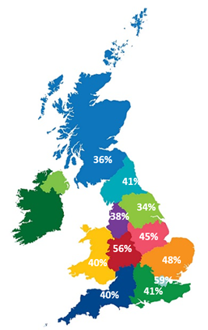

Those in rural areas were most likely to be earning through music, followed by those in urban and then suburban areas (figure 4). In rural areas 71% are earning via multiple routes, against 42% of those in suburban areas and 58% in cities.

Young people in suburban areas were hardest hit when it came to accessing opportunities, stuck between urban areas (where provision of opportunities is more comprehensive) and rural areas (where competition is potentially less fierce).

Young adults from suburban areas were less likely to find relevant opportunities in their local area compared with those from urban areas (28% v 21%) and they were less likely to be able to find opportunities that pay enough compared to those from rural areas (25% v 18%). Those that are not currently earning are more likely to perceive a lack of opportunities in their local area as a barrier (27% vs 18%).

Those responding from suburban areas were less likely to be from higher income backgrounds than those in urban and rural settings. Urban settings were the most ethnically diverse, followed by suburban and then rural locations. The combined effect of these demographic variations - taken alongside variation in access - was seen to exacerbate the situation for those in suburban areas.

Disability
“There’s a lot of negative stereotypes when it comes to disabilities, I do have the ability to play music! It shouldn’t matter whether I have a disability or not or how I present my music, I’m still a musician. I’ve just had to work around playing it a different way to everyone else.” - Jess Fisher, musician, content creator, educator

It was not possible within the scope of this research to reach sufficient samples of disabled young people. Youth Music is leading on a forthcoming piece of research which will explore the specific barriers faced by disabled musicians in detail.

However, we know from existing government statistics that disabled people are extremely underrepresented in the music industries: while 19% of the working age population consider themselves disabled, only 4% of the arts workforce and 1.8% of the music workforce self-define as disabled. Of the respondents to a survey of disabled people in the music industry by Attitude is Everything (AiE), 70% said they had kept their disability hidden because of worries it would damage a relationship with a venue, promoter or festival, while two thirds said they had to “compromise their health or wellbeing” to be able to perform live. Individuals we spoke to as part of this research highlighted that the industry still has significant work to do in creating more inclusive environments and workplaces for disabled people and musicians.

“There are many aspects of being a musician which can cause anxieties… More often than not, these things are more challenging for learning disabled people. There are also additional and more complicated practical considerations for learning disabled artists to work through.” Gareth Evans, senior producer, Carousel

The barriers compound each other
The extent to which someone’s background or gender affects their chances of entering a career in music made for all-too-familiar findings, adding to a wealth of existing insight and research with similar conclusions. We consistently found social class to be the key determinant influencing young people’s chances of earning money through music. Regardless of ethnicity or gender those in lower income groups were always 20 percentage points less likely to be earning from music than those from higher income backgrounds.
Like others, we also found that the disadvantage is highly amplified by intersectionality (although our sample sizes become small at this level of analysis): for example the chances of women from lower income backgrounds to earn from music diminish dramatically compared to higher income men (60% v 29%). This stark contrast correlates with our findings that women and those from lower income backgrounds were more than twice as likely than their counterparts to say they have not had access to any support.

“Playing the game” requires access to networks and knowledge
To stand any chance of progressing into their chosen careers, young people need to know the rules of the game. Yet without access to support from people in the industry it is very difficult for many to understand these unwritten rules. Our interviews with industry insiders described a set of job-seeking rules that differed to more official narratives, where investment in soft skills and shared social connections played a much bigger role. Industry professionals admitted this was not widely publicised or talked about, partly because it was assumed to be self-evident, but also because of a pang of discomfort; no-one liked to admit to having earned their place through knowing the right people or to question whether they were really qualified to be there, leading to this key ingredient being underplayed.
“Once you're inside, it's like being in an exclusive club and no one wants to admit that they've bluffed their way in.” Jamal Guthrie, Digital Media & Marketing Manager / Press Officer, Founder of Route
Those trying to get into the industry don’t know what they don’t know. Those who perhaps best understand how to navigate the barriers are those who may have recently overcome them, and are now establishing their careers. This could explain the huge growth in horizontal networking (explored in more detail in Section 3) and the desire from young people for mentoring from those who are not too far ahead of them in their careers.
It shows why increasing representation and role models in the industries is so important. But it’s another sign of a broken system when those who have already had the most difficult journeys into the industries then also have to shoulder the responsibility for supporting the next generation and designing new, more equitable, pathways.

Talent is preparing to leave. We need action, now more than ever
Those people facing more barriers can only keep trying to get in for so long, meaning we’re at risk of losing their ideas and perspectives forever. We asked our survey respondents: “If you were struggling to earn a sustainable income from working within the music industry in the next 5 years, how likely would you be to look for an alternative career outside of the music industry?” 2 out of every 3 (66%) said they would be very likely or likely to pursue another career.
We’re left in a situation where it’s only the people who last the longest who can make it, and there’s no evidence to suggest that these people are the best equipped, or have the best ideas. They are often just the people who are fortunate enough to have the necessary financial, practical and emotional support to stick around.
We can’t continue to ignore these issues and narrow the pool of young people who pursue careers in music. Our industries will become increasingly homogenised, without the diversity and ideas needed to take on the enormous challenges we face.
“Look at what kind of representation you have in your office. If the vast majority is white, male, well-educated and middle class, ask yourself if that's because that's the only kind of person talented enough to work for you?” - Jamal Guthrie, Digital Media & Marketing Manager / Press Officer, Founder of Route

Dr Dave O’Brien, the academic behind the influential 2018 project Panic! Social Class, Taste and Inequalities in the Creative Industries, has encouraged us to think pragmatically and urgently about how we shape the post-pandemic future in relation to diversity in the sector.
“COVID-19 will unquestionably make these issues worse… In particular, early career creatives will struggle… Depending on the scale of the crisis, this could be a generation of lost talent.”
Young people however, are sounding some more optimistic notes with 60% of those in Livity’s creative network feeling more positive about their future now, than they did before lockdown. We must channel that optimism, find new ways to work together and ensure we don’t let them down.
“I’m anxious about what is to come [post Covid-19] but I’m also excited because I have so many ideas and I’m honestly excited to put my plans into action post
lockdown”. - Survey respondent, 22

Questions to ask ourselves
- Who is being excluded?
- What impact is this having?
- How can we enable a diversity of perspectives to thrive, invigorating the music industries?

SECTION 3 - Change is coming

Fed up with excuses
The creative industries have been discussing these issues for decades. Arts Council England’s 2004 Race Equality Scheme talked of going beyond the ‘business case’ and their Creative Case for Diversity which launched in 2011 has gained traction over the last decade. Yet in 2019 they found their funded organisations were still “treading water” on diversity, particularly in relation to ethnicity and disability.
UK Music has been tracking diversity in the music industries since 2016, with their 2018 Music Industry Workforce Diversity Report finding BAME representation up slightly from 16% to 18%. The number of women in the industry grew from 45% to 49%, though there was still low representation of women aged 35 and above. Vick Bain’s more recent work on the gender gap found just 14% of the 12,040 writers represented by UK music publishers are women, while female artists only make up 20% of the rosters of acts signed to labels.
So why have things been so slow to change? Those we interviewed felt that companies were not prioritising diversity and inclusion. They were fed up with excuses and wanted real action, now.

“If it really means something to you then walk the talk.” - Chirag, 24, Crawley - aspiring data analyst

“If you want to be more diverse and inclusive, hire people from more diverse backgrounds!” - Sarah, 19, Birmingham, aspiring composer
When presented with findings that 86% of internships in the arts (including theatre and music) are unpaid there was also no equivocation from those we interviewed.
“I think it’s shameful.” - Fred, 18, Edinburgh
“There needs to be more paid placements. There has to be.” - Mushfik, 20, Newcastle
This new generation wants the music industries to step up and take on more responsibility when it comes to inclusion. If it doesn’t happen from the top down they’ll take matters into their own hands and build it from the bottom up.
One of the most positive findings during this research was the sheer number of incredible women-led collectives and gender equality initiatives in the music industries. There’s Keychange, SheSaidSo, Producer Girls, Saffron Records, Both Sides Now, Foundation FM, Women Connect, Selextorhood, Yorkshire Sound Women Network, Scottish Women Inventing Music, B.L.O.O.M, EQ50, Women are Mint, #NormalNotNovelty to name just a few! The list is inspiring and shows the real impact we can start to create when concerted action is taken around a specific issue.

Case study: Alexandra Ampofo, Women Connect, London
As René Kladzyk has pointed out, these kind of collectives are “creating their own rules and leading by example, using their collective power to force changes to venues, culture, festivals, and legislation rather than waiting for top down action to happen.”
And all the evidence suggests these informal collectives and forms of ‘horizontal networking’ only grow in importance as young women and people from under-represented backgrounds mature in their careers, providing mutual support and career scaffolding outside of formal industry structures.
“She Said So and Ladies Music Pub were an incredible outlet; hearing the experiences of how others navigated these types of situations benefitted me for years…. I’ve now started a run club for DJs and musicians, Tempo. That's worked wonders for bringing sport into my routine and creating a space for mental and physical wellbeing to be discussed amongst other young people who work in music” - Martha Pazienti Caidan, DJ, presenter and producer
It is so important that initiatives like this are given sufficient resources and investment across all areas of the industries, not just the most visible.
“It’s all well and good having talent development programmes creating a new generation of creative, forward-thinking, ground-breaking artists but if the same progression isn’t happening in the workforces of music businesses, we’re storing up huge problems for ourselves as an industry.” - Amy Frenchum, Project Manager, Future Bubblers, Brownswood Recordings
There is a clear business case for organisations who can nurture, develop and empower these kinds of collectives, building genuine two-way relationships with them. Companies that stand out to this generation are the ones that “care about people rather than just profit.”

Under 25s are demanding that the companies they buy from and work for are truly ethical, not just in intentions but in actions. 69% say brands need to promote more progressive values and play a more meaningful role in society. They want to work in places that share their visions for the future of the industry. Future talent will gravitate towards companies which clearly reflect back their values - not just through lip service, but clear demonstrable actions.
“[Companies need to] prioritise creating a work environment where staff feel listened to, can submit feedback and see tangible action taken. Understand the importance of mentoring and nurture your mentoring programme at work.” - Martha Pazienti Caidan, DJ, presenter and producer

DIY or DIE
“If I don’t do it myself who’s gonna do it for me?” - Seshie, Founder and Creative Director, I AM NEXT

Any pessimism towards the music industries we found in our research was matched by an even greater resilience and desire to make change. This is a generation looking to blaze new trails and sweep the relics of an older industry behind.

“I couldn’t find a role I wanted to apply to, and my thing was that I was going to make my own role within a company.” Shaiyann - music marketing and education consultant
Frustrated by a lack of opportunities, fed-up of competing for another minimum wage internship, and with large sections of the industries still fenced off, young people have started finding their own ways to do things. Through trial-and-error and a series of improvisations, they’re managing to thrive. Their entrepreneurial skills aren’t learned through formal education, but developed out of necessity and with a DIY mentality.

Case study: Seshie, I AM NEXT, London
When they’re building a new side hustle or developing a creative idea, this generation can tap into their informal networks, either in person or online. 50% now choose independent learning such as online tutorials and YouTube videos over traditional methods.

“I've had to be super creative with piecing my works together without having a large fund behind me to propel everything. I've also had to build a contact base full of people of different skillsets, like radio presenters to play my music, graphic designers to twinkle up my edited videos, and producers that match my songwriting style.” - Sarah Angel, Artist, Manchester

Impatient for change, this new wave has started cultivating their own grassroots movements. Increasingly, we’re seeing a generation take it upon themselves to be the change they advocate.

“Everyone does something, there’s always a videographer in the crowd or a photographer or someone willing to help you.” Mei-Li, 21, London - aspiring singer/songwriter

These authentic, DIY approaches feel energetic in comparison to the male, pale and stale sections of the established hierarchy. These are kind of movements and collectives that under 25s gravitate towards.

Case study: Holly Hollister, Selextorhood, Birmingham
Change is coming. Individually these things can feel small in scale, but collectively they reflect values held and change taking place at a much wider level.
Fail to nurture and develop the next generation and, regardless of successes at the top of the industries, companies lose their position in culture, lose audiences and eventually lose business too. Successful companies establish working cultures where young team members feel supported to succeed.

“Flexible working options for young people who have their own creative ventures outside of work usually end up being mutually beneficial, as your younger staff will feel creatively inspired, nourished and rested and can bring their best selves to work, - plus side hustles can plug you into the culture more authentically.” - Martha Pazienti Caidan, DJ, presenter and producer

Case study: Freddy Masters, Keep Hush, London

The organisations most likely to thrive throughout and post COVID-19 will be those who can adapt and make changes quickly to generate revenue in changing conditions. A younger workforce brings fresh perspectives that aren’t rooted in the past or present ways of doing things.

Young entrepreneurs have developed new working habits and improvised new ways to structure their careers. Yet while we celebrate their successes and explore the ways we can learn from them, it’s also important to remember that they only occupy a small part of the ecosystem, and their methods still only work for a minority - largely those who have the social networks and financial security to do it themselves - and their position is still precarious. They’re relying on an imperfect support system, and to work consistently they still want investment and direction.

Brands are supporting youth culture more than the music industries

Forward-thinking commercial brands are finding new ways to collaborate with these young innovators to their own advantage, and supporting lots of interesting work with young creatives. Their investment in emerging talent isn’t limited to creating ‘entry-level’ job opportunities like apprenticeships and internships. They use their leverage and networks to create the conditions for youth culture to flourish. They offer money, space, connections, brand power and then let them do their own thing. It’s about enabling, stepping back and only supporting when needed.

This formula can really work. But despite some notable exceptions it can skew towards short-term, ad-hoc investment, designed to raise a brand’s profile with a target audience, rather than building real infrastructure to benefit the grassroots.

Successful brands need to keep evolving. They know they need to play relevant and authentic roles in a new generation’s lives or they’ll be left behind. They’re already working on new ways to secure the young talent that can help them connect to their future consumers. They’re recruiting a generation who’ll end up bringing their ideas and energy to a different sector. Which seems like a missed opportunity, because these people grew up passionate about music, not necessarily about consumable goods.

What’s really needed is sustained investment, and sustained investment for music really needs to come from within music. Brands will come and go, and the third sector can only deliver until funding runs out. The music industries need to invest time, energy and money to secure their own future.

A new blueprint is needed post COVID-19
Times are tough and only about to get harder, even for the most established companies. The coronavirus pandemic has wreaked havoc across the music industries. Social distancing rules mean live events - one of the few reliable earners for musicians - will be one of the final components of pre-COVID-19 society to return.

But there were significant and widely acknowledged problems in the music industries before this. New technologies and changes in consumption habits have led to vast growth for a few - tech companies, major labels and those in the big festival business. This has led to dwindling royalties for those who create the music (especially outside of the mainstream) and precarious situations for the grassroots venues supporting young artists and the independent labels releasing their music.
Industry-wide campaigns from the Musicians’ Union, Music Venue Trust and the Ivors Academy have emerged to #KeepMusicAlive, #SaveOurVenues and fix the #BrokenRecord on streaming payouts. The music community has rallied around Bandcamp Fridays, Independent Venue Weeks and Record Store Days, but these alone can’t stem the tide.

It’s promising that following recent Black Lives Matter protests, many music businesses pledged to do more to support Black musicians and behind-the-scenes professionals. But the two Black women behind #TheShowMustBePaused were clear that it will take more than a day of reflection to remedy an imbalanced and top-heavy ecosystem riven with socioeconomic inequalities.

“I don’t think I’ve seen a moment like this before, where pretty much everybody acknowledges that it’s time that something was done,” ... “We have had many false dawns in terms of equality in the industry, let’s make sure that this is not another one.” - Keith Harris OBE, Former Chair of UK Music’s Equality and Diversity Taskforce

Empower young people’s entrepreneurial spirit to create a new future

We’ve reached a moment for systemic change at a larger scale. Not just for young people, but for musicians and our industries as a whole. The artist and writer Mat Dryhurst has argued we need to “jettison our romantic association with independence” in favour of working interdependently; finding new ways to “generate the collective bargaining power to insist on having a say in the technical and economic systems that impact our future.”
For the past two decades we’ve seen under 25s forge networks, inject new energy, and work together on solving big challenges. The ‘Power of Youth’ was Time magazine’s headline when it announced Greta Thunberg (then aged 16) as Person of the Year for 2019.

This generation has less of an economic stake in society than any before them. They will fare worst in an impending global recession, and it is their future that will be most affected by climate change. Many feel they have no choice but to create a better world. And they’re optimistic about achieving it; a UK survey of 1,500 young people during the COVID-19 pandemic found 92% said that this could be a moment to change society for the better.

We believe the next generation are a vital part of solving the biggest issues we face. But they can’t do it by themselves.

Questions to ask ourselves
- How are we connecting with our audience and future workforce? Is it a transaction or a dialogue?
- How can we better retain, nurture and enhance the creative energy in the ecosystem?

SECTION 4 - Creating the blueprint

Throughout this report, we’ve shared inspiring examples of young entrepreneurs and professionals taking matters into their own hands and driving change in the music industries. But we’ve also provided the evidence showing the barriers that many face to getting a foot in the door, or achieving sustainable careers.
In the final section of this report, we join the dots to help create a blueprint for the future: practical action to ensure that the music industries will become more joined-up with the education system, more inclusive, more collaborative, more creative and more successful.

Joining the dots
“Authenticity and integrity win over everything.” - Martha Pazienti Caidan, DJ, presenter and producer

Under 25s are passionate about the industry and keen to bring their ideas, networks and audiences, but the routes in are currently opaque and inaccessible. Like any sector, there is a need for people wanting to break in to have relevant, hands-on experience, but the financial implications of unpaid opportunities such as internships are a major barrier for many. They’re very aware of these issues, and what needs to be put in place to resolve them.

Figure 13: What do you want to have access to in order to help you achieve a career in the music industry, if anything?
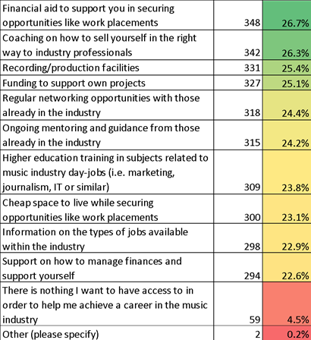

“If experience is such a big problem for getting into the industry, then give people the chance to show how they can work with a budget or work with other creatives.” - Jess Ajose, DJ and radio producer

The young people we spoke view charities and education providers - like those funded by Youth Music - as trusted allies with their best interests at heart. But while they were confident these organisations could offer advice and provide support, they don’t believe that it’s the responsibility of charities to create the change that is needed. They see music businesses as having a clear responsibility to take action in breaking down the barriers to entry.
However, they also said they see huge opportunities for collaboration. They felt it was crucial for music businesses to collaborate closely with charities and the wider music ecosystem to bring relevant expertise, credibility and to open up real pathways into paid work.
“I feel a brand through a charity would carry more weight and authenticity to give the correct image to the correct audience.” - Helen, 25, Pontypridd - aspiring songwriter
They were also clear that it was not the place of public funding to solve the endemic structural problems within the music industries. Although most of those consulted felt that financial aid to support opportunities like work placements would help them achieve a career in the music industry, they thought this should be covered by the employers themselves, especially the bigger players.

“I believe a top record label would be able to afford it financially.” - Jerome, 25, Manchester - aspiring producer
There are lessons to be learned from other sectors. Marketing agency Lucky Generals launched The Barracks, a three-month placement scheme which offers free accommodation, designed to attract people from less advantaged socioeconomic backgrounds - particularly those from outside London - and extend the sector’s talent pool.
"We want to create ideas that appeal to the whole population but how can we do that when our own diversity represents such a narrow section of the UK demographic? ...We need to understand the importance of investing both time and money - it's the old urgent versus important adage but I would argue that it's urgent as well as important." - Katie Lee, CEO Lucky Generals
In the digital design sector, Flipside - a training programme co-created by five agencies - gives young East Londoners the chance to break into the digital industry through a combination of hands-on experience and classroom learning. The programme is delivered in partnership with A New Direction’s Create Jobs programme, accessing public funding and employer contributions.

Case study: Andrew Thomson, Huntley + Palmers and Clyde Built Radio, Glasgow

Case study: Steve Mayall, Music Ally, London

Do-It-Together
It’s time to collaborate and learn from each other. Music businesses large and small, young entrepreneurs and collectives, charities, arts organisations and funders.
These collaborations need to be meaningful, long-term and well-resourced, with all partners treated with dedication and respect, and everyone open to feedback and growth.

We undertook this research to give voice to the next generation entering the music industries. We wanted to share their experiences and their challenges. But we also wanted to shine a light on the legitimate credentials of a generation of people whose ideas, skills and energy can offer rejuvenation at a time when there is widespread concern about the ‘#BrokenRecord’ of the industries.

The case studies in this report alone (and there are many more examples nationwide) demonstrate that this generation is helping to push the wider creative industries forward in new and innovative ways, and can help make sure businesses are ahead of the curve and prepared for the future.

For the music industries to thrive in a new world, we can only benefit from finding ways to work together with those who have the initiative to pursue the DIY route, and from nurturing and encouraging a talented new generation. It will be important to find new ways of working which fit the needs of businesses and the working culture of young people. For instance, a young digital marketer might provide an established business with a service for a few days a month, as part of their portfolio career. A young promoter could partner with more established labels or publishers to signpost new talent their way, or to showcase artists at events.

Businesses which don’t open themselves up to new talent may miss out on a wealth of fresh perspectives and dynamic energy that will keep the industry moving forward, with or without them. Those which embrace change and collaboration will thrive, those which ignore it will grow obsolete.

“We’ve got such a wide network of young people that criss-cross and work with each other, leading to so many different outcomes for us and them… you get these cultural crossovers where so many new things get made because [Reprezent] is such an incubator.” - Adrian Newman, Station Manager, Reprezent Radio

Youth Music’s Incubator Fund

“Young people need more tangible opportunities: we talk about it but we don't do it” - Alex Ampofo, Live Music Booker, Metropolis/Live Nation

Through Youth Music’s programmes we’ve worked with thousands of young people who are eager to begin careers in music. Right now, we believe that the music industries need young people more than ever before.

Our new £2 million Incubator Fund - co-designed with and targeted at SMEs - will connect music businesses to young people. Those applying will come up with innovative ideas to involve and support young people in their businesses, such as challenging young creatives to lead on a business problem, or offering them space to develop their own ideas. Young adults will build up their portfolio and the business will get support in solving a commercial challenge in return. There is great potential to make an impact in the lives of young adults, expanding their career options - and in turn, they’ll develop the core business of the host employer.

We hope to get everyone working closer together. The fund will help a generation of young adults bring their passions and their creative ideas to fruition, while also igniting new creative energy within established businesses. Through investment, we can help incubate and develop new ways of creating, promoting, teaching, sharing, distributing, performing and releasing music.

Youth Music, thanks to our funders, is able to provide investment and support to kick-start change. But it’s not a one-way street. Music businesses need to step up to the mark and create an environment where their relationship with the young people - and those supporting them - is a genuine two-way exchange. Furthermore, action around diversity and widening access cannot be the only only step taken. This has to be matched with real commitment to make workplaces more inclusive, or new recruits will soon drop out.

COVID-19 has demonstrated just how vulnerable the music industries have become, built on unequal and old-fashioned structures no longer fit for purpose. The next generation of talent - vital to the heart of the industry - has been the most impacted. We’re committed to playing our part in ensuring the industries return stronger, better bonded, more diverse and more collaborative.

We want to help young people build thriving music scenes of the future, representing a wider range of voices. Viable mini ecosystems that will get the wider sectors thriving again, where everyone can benefit.
This extraordinary moment is our opportunity to take individual and collective responsibility for change. It’s time to transform the music industries, with new energy and new ideas from a new generation. Together, let’s build a better future.

How you can work with Youth Music
Youth Music has a 21-year history supporting young people’s lives in music. Every year we invest in more than 300 music projects, reaching around 83,000 young people and over 4,000 people in the workforce. As we look ahead to increasingly challenging times, our work to equalise access to music and break down barriers is more urgent than ever.
We’re working alongside young people and our partners to use our influence, expertise, and resources to campaign for change and implement solutions based on evidence and experience. But we can’t do it alone. It’s only by investing and working together that we can tackle deep-rooted and systemic issues. So, whether you’re a music business that shares our vision, or a passionate individual looking to do something practical, there are all sorts of ways you can get involved.
Be part of the solution with our new Incubator Fund
Youth Music’s new Incubator Fund offers grants of between £5,000 to £30,000 to forward-thinking music businesses, collectives, and not-for-profits. The focus of the fund is on the mutual benefit gained from bringing fresh thinking, creative and entrepreneurial new talent into your workplace or network. It will give 18-25s who are underrepresented in the music industries the opportunity to deliver their own projects and receive support from your organisation through incubation, training, mentoring and networking. Application guidance for the fund can be accessed here.
Invest in the Next Gen
We have a trusted reputation for forward thinking grant-making in music. We have the infrastructure and expertise to invest equitably and impactfully across the country, with 83% of our funding spent outside London. However, right now, Youth Music can only invest in around 40% of the projects that apply to us for funding. Your donations will enable us to invest in more grassroots music projects and directly provide funding to the future artists, leaders and changemakers our industries need.
Partner and sponsor
You can Give a Gig by playing or streaming live to raise awareness and funds for our work. Previous supporters have included Bicep, Clean Bandit, Aurora and Nadia Rose. As well as donating the ticket sales from their gig, they have each given a young person the opportunity to be their opening act on the night.
Our annual Youth Music Awards celebrates the amazing talent of the young people and work of the organisations that we support every year. Your organisation can sponsor an award or offer a money-can’t-buy experience as a prize to an award winner.
Get in touch to develop a bespoke partnership with us: for example you could become a brand sponsor for a specific strand of our work, or donate a percentage from a new product or album to support our cause.
Contribute to our career resources bank
As outlined in this report, it is essential that the next generation can easily access relevant and practical career advice from those actually working in today’s music industries. To enable this we’ve launched a new careers page on the Youth Music website and are commissioning young creatives to talk to industry insiders to get advice, stories and other content. We’re building up this resource, and we’d love you to be involved! If you’d like to share your expertise via an interview, how-to guide, video, panel or by running a workshop, get in touch and we’ll connect you to a young creative to make it happen: creatives@youthmusic.org.uk
Join our networks
We want to connect you to the amazing organisations we work with and the huge pool of next gen talent that is out there! Use our Opportunities Board to advertise jobs, training, networking and mentoring opportunities, or get in touch with our team to discuss any ideas you have.
Got another idea of how you’d like to work with us?
Get in touch at partnerships@youthmusic.org.uk

The National Foundation for Youth Music
Studios 3-5, Swan Court, 9 Tanner Street, London, SE1 3LE
Registered charity number: 1075032
Limited company number: 03750674

youthmusic.org.uk

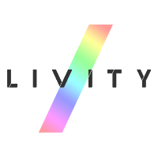
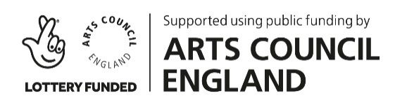
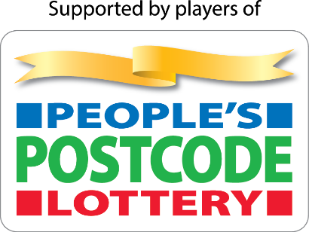

References Youth Music and Ipsos Mori - The Sound of the Next Generation: A comprehensive review of children and young people’s relationship with music (2019)
Education and Employers: Nick Chambers, Chris Percy and Martin Rogers - Disconnected: Career aspirations and jobs in the UK (2020)
CMU - Pathways Into Music (2020)
Creative and Cultural Skills - Building a creative nation: Current and future skills needs (2018)
Escape Studios - Young People Want Creative Jobs (2018)
The Institution of Engineering and Technology - Kids take to social media for advice from role models (2018)
Education and Employers: Nick Chambers, Chris Percy and Martin Rogers - Disconnected: Career aspirations and jobs in the UK (2020)
Creative Industries Policies and Evidence Centre led by NESTA - Skills, talent and diversity in the creative industries - Evidence synthesis and scoping: summary report (2019)
UK Music - Securing our Talent Pipeline (2018)
Department for Digital, Culture, Media & Sport - Official Statistics measuring the number of jobs in the Creative Economy (2015)
UK Music - Music Industry Workforce Diversity Report (2018)
Arts Council England - Making a Shift: Disability in the arts and cultural sector workforce in England (2018)
Attitude is Everything - Next Stage (2019)
Vick Bain - Counting the Music Industry: The Gender Gap (2019)
Dr Orian Brook, Dr David O’Brien, and Dr Mark Taylor - Panic! Social class, taste and inequalities in the creative industries (2018)
Written evidence submitted by Dr Dave O’Brien, Chancellor’s Fellow, Cultural and Creative Industries, University of Edinburgh - The impact of COVID-19 on the DCMS sectors: A submission to the Digital, Culture, Media and Sport Select Committee inquiry (2020)
Livity – Life on Lockdown (2020)
Arts Council England - Race Equality Scheme 2004-2007 (2005)
Arts Council England - Creative Case for Diversity (2019)
Arts Council England - Equality, Diversity and the Creative Case A Data Report 2017-2018 (2019)
UK Music - Music Industry Workforce Diversity Report (2018)
Vick Bain - Counting the Music Industry: The Gender Gap (2019)
Sutton Trust - Pay as you go? Internship pay, quality and access in the graduate jobs market (2018)
René Kladzyk - How to build the future music industry we want and need (2020)
Irregular Labs - The Irregular Report: Gender, Activism, and Gen Z (2019)
Spotify - Culture Next Trends Report (2019)
Protein Agency - The Youth Report (2018)
Music Week - UK Music launches diversity survey (2020)
Keith Harris - An Open Letter to the Music Industry (2020)
Mat Dryhurst - Interdependent music vs Independent Music (2020)
The Guardian, Mat Dryhurst - Band together: why musicians must strike a collective chord to survive (2019)
DMS Insights - Brands That Implement Social Responsibility Will Connect With Gen Z (2019)
Beatfreeks - Take the Temperature (2020)

